
Kirklees Creative Industries
Economic Impact Report 2026

Prepared for Kirklees Council by:
Iain Bennett, The Fifth Sector
Andy Goodwin and Simon Sprince, Unscrambled.world
Jon Bains, Obsolete.com

May 2026

Executive summary
This report presents our 2026 economic mapping update for the creative industries in Kirklees. It captures the real scale, structure and impact of a sector in measured, broad-based consolidation. In the two years since our last report, formal employment has grown modestly, the freelance and self-employed base has remained stable, and total workforce expansion has been steady across multiple sub-sectors.

A two-year retrospective: steady growth and consolidation
Between 2024 and 2026, the creative economy in Kirklees shows measured growth and broad-based consolidation. Three distinct evidence tiers tell a consistent story:
- Confirmed payroll employment (BRES): Creative industries employee jobs in official payroll statistics increased by 4% from 3,400 (2022 BRES data) to 3,535 (2024 BRES data). This is a census-based figure confirmed by ONS employer returns and represents the formally employed workforce only.
- Wider creative workforce (LinkedIn, corroborated by The Data City): LinkedIn identifies 10,305 creative workers in Kirklees in 2026, up 9.6% (from 9,405) in 2024. LinkedIn full- and part-time profiles (approximately 6,985) substantially exceed BRES payroll returns (3,535), indicating a significant additional creative workforce employed in micro-businesses, sole trader roles, and employment relationships below the PAYE threshold.
- Freelance and self-employed workforce: The independent creative workforce is stable at 3,320 people in 2026, compared with 3,485 in 2024, a consolidation of 4.7%. Independent practitioners operate at near-equal scale to the formal payroll workforce and contribute 42% of combined creative economy GVA.
- Sub-sector growth: Design and designer fashion (+39%) and Publishing (+48%) are the two fastest-growing sub-sectors by LinkedIn workforce count. Film, TV, video, radio and photography (+17%) shows solid, credible growth. Music, performing and visual arts grew modestly (+4.7%) and at 1,560 LinkedIn profiles is the fourth-largest sub-sector by workforce size, behind Advertising and marketing (2,580), IT, software and computer services (1,685), and Design and designer fashion (1,615).
- Active business base: Companies House (April 2026) evidence of 1,690 active creative firms across the district corroborates the scale of the enterprise base that employs and commissions this wider workforce. The total is 2.3% below the 2024 baseline of 1,730, a consolidation rather than contraction consistent with the stable employment and workforce picture above.

Real scale of creative GVA: addressing official undercounts
Standard national surveys systematically undercount local creative economies because they exclude the micro-businesses, sole traders, and freelancers who operate below VAT and PAYE thresholds. In Kirklees, where sessional and freelance working patterns dominate, relying on official payroll statistics alone leaves nearly half of our economic value invisible.
We estimate that the Kirklees creative economy generates between £243 million and £305 million in gross value added.
Figure 1: Kirklees creative economy, headline figures 2026
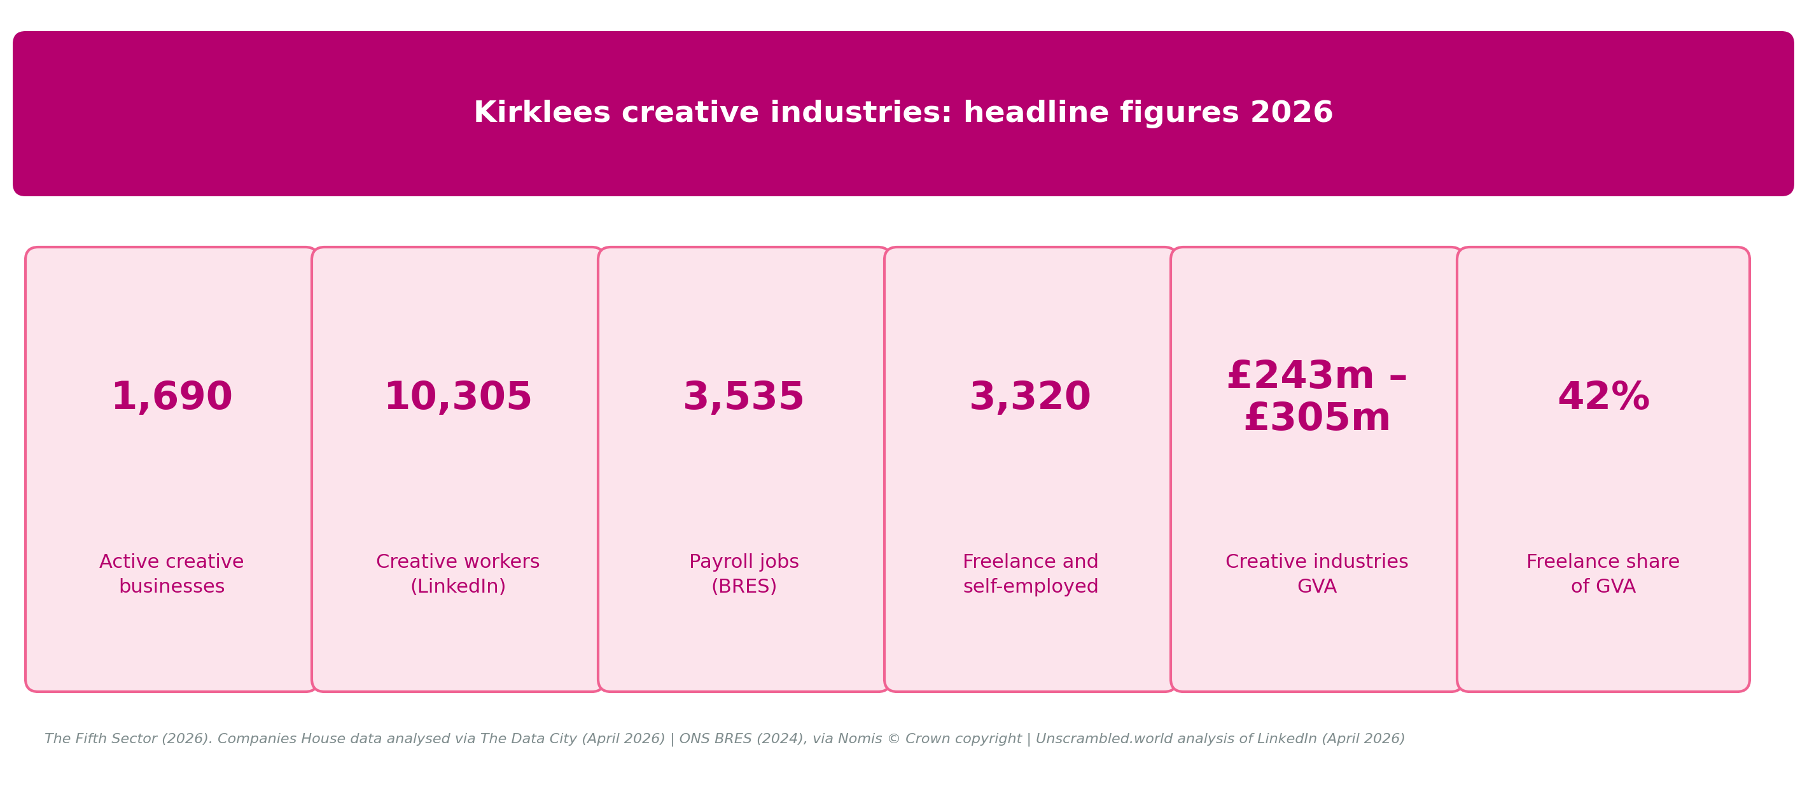
Formally employed creative workers account for 58% of that output; independent practitioners account for 42%.
We present two output figures because there is no index which provides GVA output totals for Creative Industries at local authority level. The £62 million range is the difference between output calculated using DCMS national sector averages and the same figure adjusted to take account of Kirklees' productivity relative to the national average. This is the productivity gap: the additional output the district's creative economy would generate if local productivity matched the UK average. Closing that gap is the investment case this report makes.
The Creative Trident framework (Higgs, Cunningham and Bakhshi, 2008) identifies three modes of creative employment and helps explain the structure of the 10,305 Kirklees creative workers. Mode 1 (creative specialists employed within creative firms) and Mode 2 (support staff employed within creative firms) together account for the 3,535 BRES payroll jobs and most of the 3,320 self-employed practitioners in the GVA model. Mode 3 (creative specialists employed within non-creative industries) accounts for the remaining approximately 3,450 workers visible in LinkedIn data but not in the BRES payroll register or the self-employed cohort: in-house designers at textile manufacturers, software developers at financial services firms, animators at engineering consultancies. These workers are acknowledged in this report but are not yet fully captured in the GVA model. A complete Trident GVA estimate for Kirklees would be materially higher than £305 million.
Figure 2: Creative Trident proxy, three modes of creative employment in Kirklees, 2026
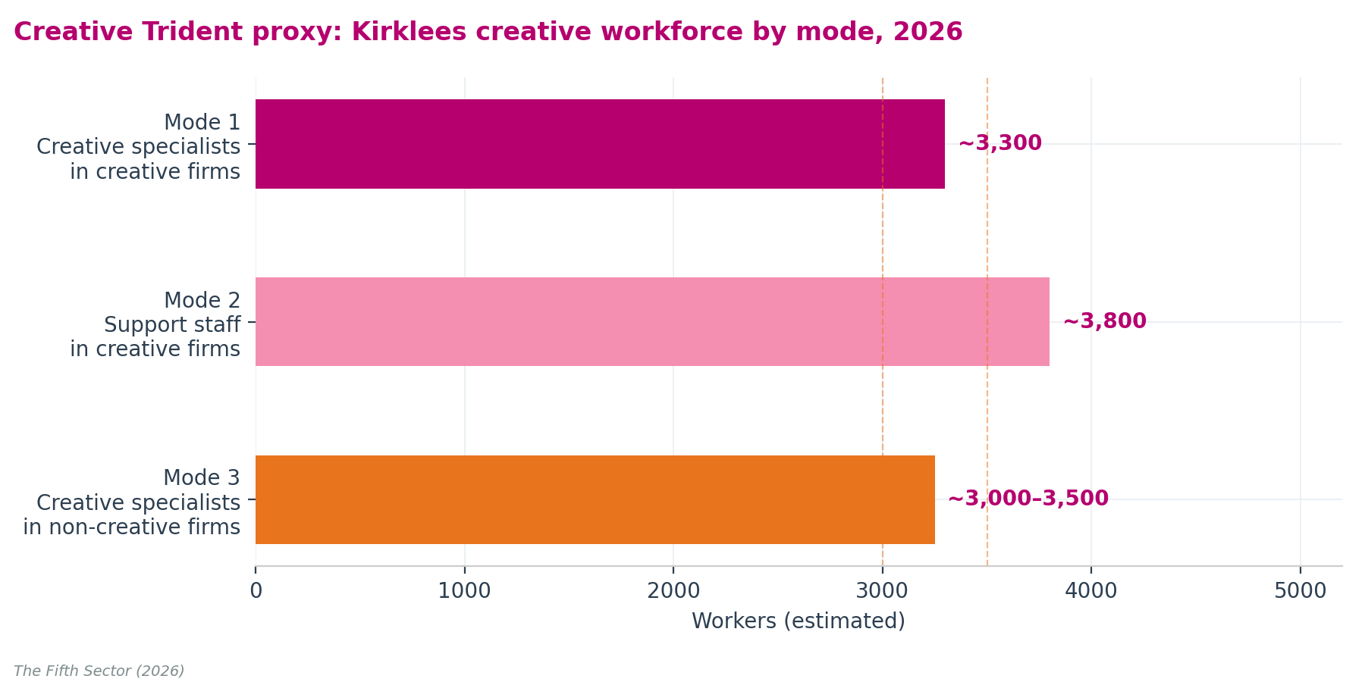

The adjacent creative economy
Some 220 businesses, identified through The Data City's RTIC analysis of Companies House data, operate outside the DCMS creative industries definition with capability profiles that overlap directly with the creative core, spanning digital creative production, software development, agency services, and complementary digital infrastructure. Analysis of their turnover data suggests GVA of approximately £80 million to £100 million. They are reported as a named second tier alongside the creative industries GVA estimate, giving a combined creative economic footprint of approximately £323 million to £405 million. An adjacent digital workforce of 3,395 workers, identified through LinkedIn, sits alongside those 200+ companies and complements the district's Createch talent base.
The 2026 estimate of £243 million to £305 million replaces the 2024 figure of £250.9 million as the established evidence base. The two figures are not directly comparable: they use different methodologies, set out in Chapter 4.

Policy mandate: aligning with national and regional strategies
The Creative Industries Sector Plan (DCMS, 2025) and the West Yorkshire Combined Authority Culture, Heritage and Sport Strategy together create a specific, time-limited window for Kirklees to act. The Sector Plan commits £100 million to R&D creative clusters, £150 million in place-based creative industries investment devolved to Mayoral Strategic Authorities including West Yorkshire, and a suite of finance access and skills interventions targeted at the freelance and micro-business creative workforce. The 2026 evidence base gives Kirklees the quantified, methodologically transparent case to engage with all three.
Three strategic recommendations follow. Together they address the two components of the £62 million productivity gap:
- Recommendation 1: Build the skills base. The University of Huddersfield and Kirklees College are Kirklees' anchor creative skills institutions, but neither systematically reaches the 3,320 freelancers and sessional practitioners who are outside the payroll and student populations. The Sector Plan's £9 million refreshed creative careers service, its £30 million music growth package, and its national Growth and Skills offer are each directly relevant to this population. Skills provision should be differentiated by working pattern: advanced digital certifications and AI applications for IT and architecture, where formal employment is the norm; business planning, IP protection, and freelance entrepreneurship training for film and television, design, music, publishing, and advertising, where portfolio and freelance working is the predominant mode.
- Recommendation 2: Reinvest in Creative Bubbles as Kirklees' creative business support and finance access programme. Freelance and self-employed practitioners generate more than £100 million in GVA and are consistently underserved by formal business support structures calibrated to payroll employers. Creative Bubbles, delivered by Wilson's Republic CIC, is Kirklees' most effective peer-led practitioner support programme and the natural local delivery channel for national commitments on finance access, including the British Business Bank's creative industries programme and the Sector Plan's forthcoming single front door for creative firms seeking investment. West Yorkshire's devolved share of the £150 million Creative Places Growth Fund through WYCA is one potential vehicle for sustaining and extending Creative Bubbles' reach across the district.
- Recommendation 3: Invest in growth sub-sectors and position Kirklees as a Createch node. Design and designer fashion (up 39%) and Publishing (up 48%) are the two fastest-growing sub-sectors. Film, TV, video, radio and photography (up 17%) provides the primary screen technology hook for a national R&D bid. Kirklees, positioned on the trans-Pennine corridor between Leeds and Manchester, with the University of Huddersfield's internationally competitive audio-immersive research infrastructure and confirmed AHRC creative partnerships inside the district, has the evidential foundation for a credible national bid under the Sector Plan's Createch growth programme. Chapter 6 develops the full case.
This report provides a repeatable, transparent evidence base to guide district policy and track progress over future reporting cycles.

Chapter 1: Introduction

Kirklees and its creative economy
Kirklees is a metropolitan borough with a population of around 440,000, making it one of the largest local authority areas in England by population. Its main urban centres are Huddersfield and Dewsbury. The borough sits within the West Yorkshire Combined Authority area alongside the neighbouring metropolitan districts of Leeds, Bradford, Calderdale, and Wakefield. The district has a distinctive industrial and cultural heritage, and a creative and cultural economy that spans music and performing arts, design, architecture, film and digital media, with a significant freelance and micro-enterprise base.
This report updates the Kirklees Creative Industries Mapping Report published in 2024. It refreshes the evidence base with the latest available data, revisits the findings and recommendations of the 2024 report in the light of new evidence, and provides an updated picture of the scale, structure, and economic contribution of the creative economy in Kirklees.

Statistical challenges in regional mapping
A recurring theme in creative industries research is that official statistics tend to undercount the sector. The Inter-Departmental Business Register (IDBR), which underpins the ONS's standard business count data, is an administrative register built from HMRC VAT registration and PAYE employer records, and Companies House data. It covers businesses that are registered for VAT (broadly, those with annual taxable turnover above £85,000) and employers with at least one employee on a formal payroll. ONS estimates the total UK business population at approximately 5.5 million, of which the IDBR covers approximately 2.7 million, a gap accounted for almost entirely by unregistered micro-businesses and sole traders. The Business Register and Employment Survey (BRES) measures employee jobs at workplaces but does not capture self-employment or portfolio working, both of which are prevalent in creative occupations. Businesses that fall below the VAT threshold or have no PAYE employees, sole traders, freelancers are all excluded. For creative industries, where a large proportion of practitioners are sole trader, portfolio workers or businesses operating below registration thresholds, it is substantial:
The 2024 report demonstrated this gap clearly. IDBR counted 940 creative businesses in Kirklees in 2023. An independent Companies House-based count identified 1,730, an 84% difference. The gap between BRES employment (approximately 3,400) and the LinkedIn-based creative workforce estimate (approximately 9,400 at the time) was similarly large.
This 2026 update continues to use a multi-method approach for exactly this reason: no single data source captures the full creative economy, and the differences between sources are themselves informative. Where sources agree directionally, the signal is more reliable. Where they diverge, the reasons for divergence are explained. The approach is asset-based and evidence-led, built around what the data genuinely show, rather than selecting figures that suit a predetermined narrative.

Data sources used in this report
This report draws on five main data sources, each used for a specific analytical purpose:
Companies House. The statutory register of all companies incorporated in the United Kingdom, maintained by Companies House under the Companies Acts. For this report, Companies House data are accessed via The Data City's machine-learning classification, which applies automated industry tagging to active company records. Companies House provides a more complete count of creative micro-businesses than the IDBR because it includes businesses operating below the VAT registration threshold and those without PAYE employees, a population that official survey registers systematically exclude. For eight of the nine DCMS Creative Industries sub-sectors, the active business count in this report is based on Companies House-registered entities. The exception is Museums, galleries and libraries, where the IDBR count is used because local-authority-operated institutions and charitable trusts are not registered as active companies.
The Data City (TDC2026). The Data City uses machine learning applied to Companies House and other records to identify and more accurately classify active companies in specific industrial sectors.
LinkedIn. LinkedIn provides a large-scale, self-reported dataset of workers who identify with specific industry categories. It allows us to identify self-employed and freelance workers who do not appear in BRES. LinkedIn captures a broader and more inclusive picture of who works in the creative sector than any official survey, though it should be treated as a very large sample and "pre-filled" survey rather than a census.
Office for National Statistics Business Register and Employment Survey (BRES). BRES provides the official count of employee jobs at workplaces. It is a stratified sample survey drawn from the IDBR: all large and complex enterprises are included with certainty; medium and small enterprises are sampled at varying rates by industry and geography. For the 2024 survey, the latest of which we have access to published findings, approximately 86,000 enterprises were sampled across Great Britain. BRES is used in this report as a measure of formal employment in the creative industries; with the caveat that figures at sub-sector level for smaller geographies such as Kirklees can be volatile, particularly where a single large employer accounts for a significant proportion of the count, and should be interpreted with caution.
Office for National Statistics Inter-Departmental Business Register (IDBR). IDBR is used to provide a consistent time series for measuring the business population, although our analysis of Companies House records consistently suggest that it under-represents most creative industries sub-sectors. It is used as the 'ordinal' source for the Museums, galleries and libraries business count only, because Companies House-based indexes systematically undercount this sub-sector where institutions are operated by local authorities or charitable trusts and are not registered as active companies in their own right.

DCMS Creative Industries definition
This report uses the Department for Culture, Media and Sport (DCMS) definition of Creative Industries, which classifies companies according to Standard Industrial Classifications (SIC codes) and groups activity into nine sub-sectors: Advertising and marketing; Architecture; Crafts; Design and designer fashion; Film, TV, video, radio and photography; IT, software and computer services; Publishing; Museums, galleries and libraries; and Music, performing and visual arts. This definition is used consistently across business count, employment, workforce, and GVA data to enable comparison across sources and over time.

Reporting cycles and ONS data lags
To interpret our time-series comparisons correctly, readers must be aware of a publication lag in official ONS datasets. ONS BRES payroll and employment statistics compile data over a two-year cycle before release and IDBR publishes annual updates on the basis of evidence analysed in the year before. Because of this lag, each of our publication cycles anchors on ONS data from two years prior:
- Our 2022 published report established the creative sector baseline using ONS data from 2020.
- Our 2024 published report updated these trends using BRES data from 2022 and IDBR data from 2023
- This 2026 current report presents our latest update using BRES data from 2024 and IDBR data from 2025.
Throughout this text, we refer to the ONS data year rather than our report publication date when analysing trend tables. For GVA comparisons, the previous 2024 report baseline (using 2022 ONS data) provides the historical comparison for our current 2026 update (using 2024 ONS data).

Structure of this report
Chapter 2 covers creative businesses: the number of active enterprises by sub-sector, changes since the 2024 report, and the methodological notes that accompany the business count.
Chapter 3 covers the creative workforce in detail: BRES employee jobs, the LinkedIn creative workforce, full-time and part-time working, and the scale of the freelance and self-employed workforce, inferred from LinkedIn and correlated with other quantitative and qualitative evidence on "informal' employment in the creative industries, including that of other sector bodies.
Chapter 4 covers economic impact: the Gross Value Added of the Kirklees creative economy, how GVA estimates are produced using a combination of different indices and methods, and what each captures and excludes.
Chapter 5 profiles all nine DCMS Creative Industries sub-sectors, with an extended case study of Music, performing and visual arts where the gap between official statistics and actual economic activity is widest.
Chapter 6 sets out three strategic recommendations, framed around the £62 million productivity opportunity and aligned with the Creative Industries Sector Plan (DCMS, 2025).
Appendix A provides a full comparison of the two GVA methodologies used in this and the previous report.

Chapter 2: Creative businesses in Kirklees

Active business footprint
Kirklees is home to approximately 1,700 active creative businesses in 2026.
The overall business count is broadly stable compared with the 2024 report, showing a small decline of 2.3%. The greatest variation is in Advertising and Marketing, which has increased by 30 businesses (15.8%). Other sub-sectors show greater proportional increases and decreases but on the basis of smaller populations, which cannot be considered statistically significant.
Table 2: Active creative industries businesses by sub-sector, Kirklees 2024-2026
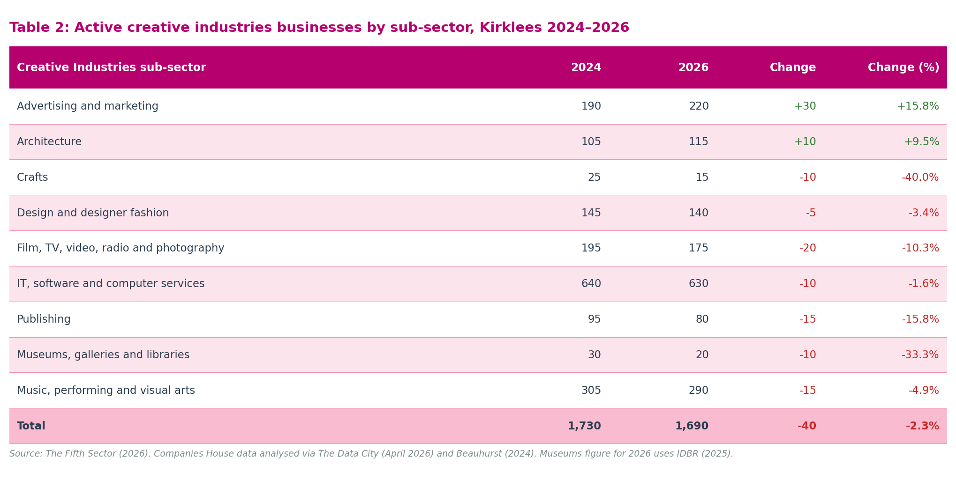
Creative Industries sub-sector | 2024 (report baseline) | 2026 (current) | Change | Change (%)
Advertising and marketing | 190 | 220 | +30 | +15.8%
Architecture | 105 | 115 | +10 | +9.5%
Crafts | 25 | 15 | -10 | -40.0%
Design and designer fashion | 145 | 140 | -5 | -3.4%
Film, TV, video, radio and photography | 195 | 175 | -20 | -10.3%
IT, software and computer services | 640 | 630 | -10 | -1.6%
Publishing | 95 | 80 | -15 | -15.8%
Museums, galleries and libraries | 30 | 20 | -10 | -33.3%
Music, performing and visual arts | 305 | 290 | -15 | -4.9%
Total | 1,730 | 1,690 | -40 | -2.3%

Sources: Companies House for all sub-sectors except Museums, galleries and libraries. Office for National Statistics, Inter-Departmental Business Register (IDBR) 2025, via Nomis (© Crown copyright), for Museums, galleries and libraries. 2024 comparator: The Fifth Sector, Kirklees Creative Industries Mapping Report, 2024, Table 2. The Publishing count (80) shows variation across source queries, consistent with the small-sample volatility typical in business count data at this scale. At fewer than 100 active firms, individual business events produce material shifts between snapshots. LinkedIn workforce data for Publishing (675 practitioners, up 48% since 2024) confirm a commercially active and growing sub-sector.
Figure 3: Active creative industries businesses by sub-sector, Kirklees 2024 and 2026
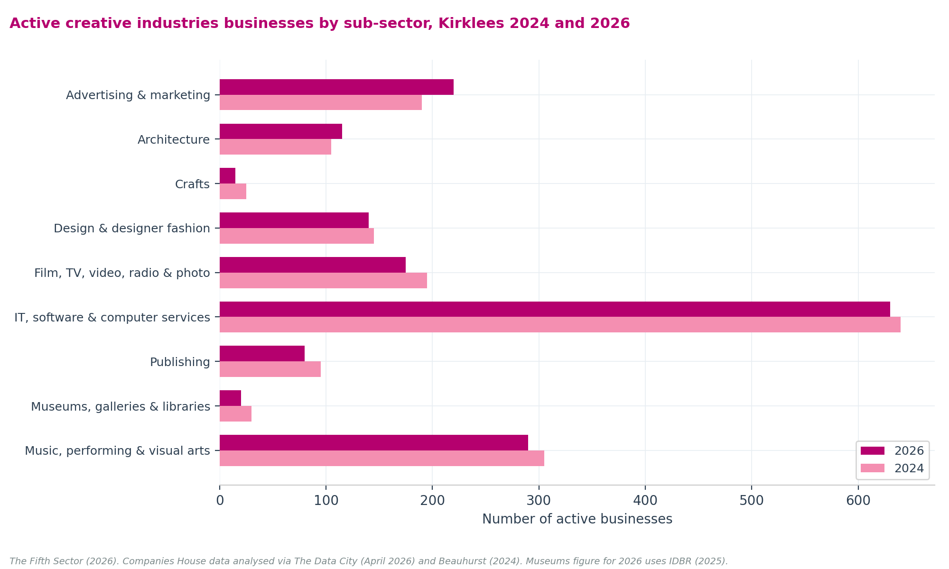

IT, software and computer services: a data provider change, not a contraction
Table 2 shows IT, software and computer services falling modestly from 640 businesses in 2024 to 630 in 2026, a reduction of 10, or 1.6%. Both figures include SIC 62020 Computer consultancy businesses. The 2024 figure used the Beauhurst active-company index; the 2026 figure uses The Data City (TDC). The near-parity of these totals (640 vs 630) confirms that the sector has not contracted. The change in data provider introduces no material discontinuity for the business count.
SIC 62020 covers computer consultancy activities, a category that spans businesses whose primary activity is within the DCMS Creative Industries definition and businesses whose primary activity is not. The Data City's 2026 index separates SIC 62020 as a distinct analytical category on the basis that approximately 47% of profiles in that category are consultants not primarily classified as Creative Industries. For the business count in Table 2, all SIC 62020 businesses are included within IT, software and computer services (630 total = 240 with no SIC 62020 SIC code + 390 with SIC 62020 as a primary or contributing SIC), consistent with the 2024 methodology.
For the GVA calculation, a different treatment applies: the BRES SIC 62020 employee count is filtered to exclude the non-creative portion. This is explained in Chapter 4.
Table IT: IT, software and computer services: business count and BRES employment, 2024 and 2026
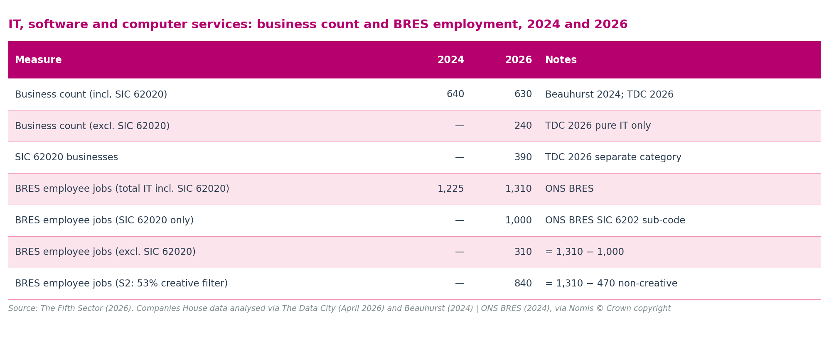
Measure | 2024 | 2026 | Notes
Business count (incl. SIC 62020) | 640 | 630 | Beauhurst 2024; TDC 2026
Business count (excl. SIC 62020) | — | 240 | TDC 2026 pure IT only
SIC 62020 businesses | — | 390 | TDC 2026 separate category
BRES employee jobs (total IT incl. SIC 62020) | 1,225 | 1,310 | ONS BRES
BRES employee jobs (SIC 62020 only) | — | 1,000 | ONS BRES SIC 6202 sub-code
BRES employee jobs (excl. SIC 62020) | — | 310 | = 1,310 − 1,000
BRES employee jobs (S2: 53% creative filter) | — | 840 | = 1,310 − 470 non-creative

Museums, galleries and libraries: why IDBR is used
The Data City's 2026 count returns zero for Museums, galleries and libraries. This is not because there are no such institutions in Kirklees. It is because Companies House-based active-company indexes systematically undercount institutions in public ownership or operated under charitable trust arrangements. Museums, libraries, and galleries run by Kirklees Council, or by charitable trusts established to manage them, are not registered as active companies in their own right and therefore do not appear in Companies House-derived counts.
To correct for this, the IDBR 2025 figure of 20 is used for Museums, galleries and libraries in place of The Data City's zero count. This is consistent with the approach taken in the 2024 report, where manual adjustment was made to include libraries and museums under local authority control. The IDBR is not perfect, it draws on employer returns and may not capture every cultural institution, but it provides a more stable and comparable figure for this sub-sector than zero.

Business growth trends
The business count in Kirklees has grown substantially over the past decade when measured using Companies House-based data, which is more comprehensive than the IDBR for the creative sector. The IDBR, by contrast, showed little growth over the same period and recorded a fall following the Covid-19 pandemic, an outcome that is now understood to reflect the limitations of the IDBR rather than a genuine contraction in the sector.
Table 3: Kirklees creative industries business count: longer-term trend
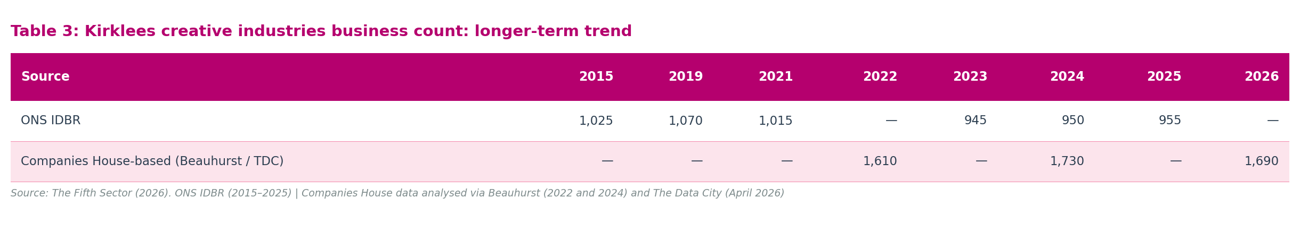
Source | 2015 | 2019 | 2021 | 2022 | 2023 | 2024 | 2026
ONS IDBR | 1,025 | 1,070 | 1,010 | — | 940 | — | —
Companies House-based (Beauhurst / The Data City) | — | — | — | 1,610 | — | 1,730 | 1,690

Sources: Office for National Statistics, Inter-Departmental Business Register (IDBR), via Nomis (© Crown copyright): Beauhurst, 2022 and 2024, via The Fifth Sector analysis: The Data City, 2026. IDBR and Companies House-based counts use different methods and are not directly comparable. The 2026 Companies House-based figure of 1,690 includes SIC 62020 Computer consultancy businesses within IT, software and computer services (on the same basis as the 2022 and 2024 figures). The 53% creative filter applied to SIC 62020 affects the GVA calculation only; it is not applied to business counts.
The IDBR series (1,025 in 2015 to 940 in 2023) shows apparent stagnation and post-pandemic contraction. The Companies House-based series (1,610 in 2022 to 1,730 in 2024 to 1,690 in 2026) shows growth followed by stability. The 2024 report demonstrated that the IDBR count of 940 was 790 fewer businesses than the Beauhurst count of 1,730, a gap of 84%, attributable to the IDBR's coverage thresholds, which exclude the large number of creative micro-enterprises, sole traders, and freelancers who operate below the VAT registration threshold and without PAYE employees. The 2026 figure of 1,690 continues this more complete series and should be treated as the primary current business count.
Figure 4: Creative business formations and dissolutions, Kirklees: time series
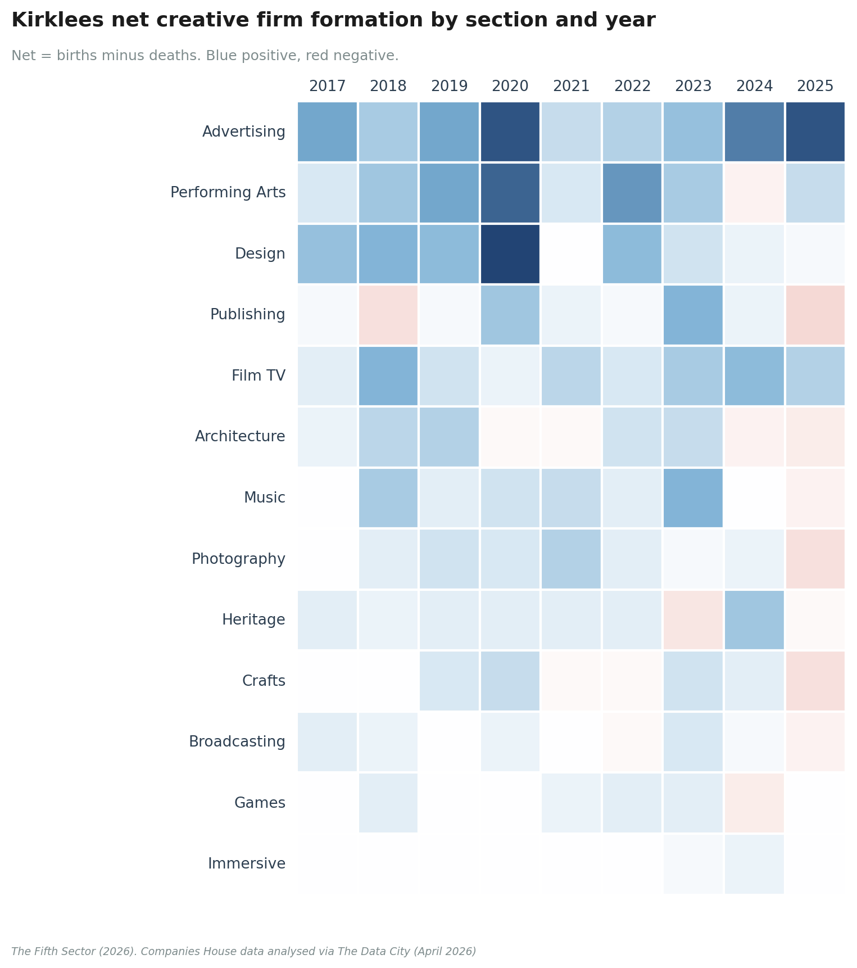
Analysis of company 'births and deaths' from 2017 confirms the picture of consolidation. Taken together, the formations and dissolutions data and the small net decline in freelance numbers point to a consolidation dynamic: individuals moving into formal company structures to capture a larger share of their earnings, or in response to regulatory requirements, and smaller companies increasing formal employment. Both outcomes represent success stories in terms of the business support Kirklees has offered over the period covered by this report, including the Creative Bubbles peer-to-peer support programme delivered by Wilson's Republic CIC, Kirklees' creative network.
Data for 2025 introduces a signal, albeit a weak one, of a decline in company numbers. A single year is insufficient to confirm this as a trend; it should be noted as a risk factor when assessing sector development needs.

Sub-sector highlights
IT, software and computer services remains the largest sub-sector by business count (630), and the modest fall of 10 businesses since 2024 is consistent with sector stability rather than contraction. Advertising and marketing (+30, +15.8%) and Architecture (+10, +9.5%) show the clearest positive movement. Music, performing and visual arts is the second-largest sub-sector by business count (290), consistent with the strong workforce growth recorded in LinkedIn data for this sub-sector. Design and designer fashion (140) and Film, TV, video, radio and photography (175) are broadly stable. The Publishing business count (80) should be read alongside LinkedIn workforce evidence rather than in isolation: at fewer than 100 active firms, count data at this geographic scale are sensitive to individual business events.
The Crafts sub-sector (15 businesses) remains small by business count, consistent with the micro-enterprise and sole-trader character of much craft activity. The apparent fall from 25 to 15 is within the margin of volatility for a sub-sector of this size and should not be over-interpreted.

Chapter 3: The creative workforce

Two measures, one economy
Two principal sources measure the creative workforce in Kirklees, and they answer different questions. The Business Register and Employment Survey (BRES) counts employee jobs held at workplaces within the district. It is a payroll-based measure: if someone is on an employer's payroll in Kirklees, they appear in BRES. If they are self-employed, freelance, or work on a portfolio basis without a formal employer relationship, they do not.
LinkedIn works differently. It identifies people who describe themselves as working in a creative industry sector. It tells us about their employment status, contract type, and whether they have a single employer or multiple (even overlapping) engagements. It captures the full range of how people work in the creative economy: employed workers, freelancers, self-employed sole traders, portfolio workers with multiple clients, and those building creative careers alongside other work.
Neither source is a census. BRES systematically undercounts creative workers whose labour market attachment is informal or self-directed. LinkedIn captures a broader population but is subject to self-selection bias and self-classification variation. Used together, they provide a more complete picture of the creative workforce than either source alone.
The 2026 data show a total LinkedIn creative workforce of 10,305 and a BRES employee jobs total of 3,535. The gap of approximately 6,770 between them - two-thirds of the total creative workforce - represents the scale of informal creative sector activity that official employment statistics do not capture.

BRES employee jobs
BRES recorded 3,535 employee jobs in Kirklees' Creative Industries in 2024, up from 3,400 in 2022, a modest increase of 135 jobs, or 4.0%. This overall figure is the most reliable single indicator in the BRES data; sub-sector figures for a geography of Kirklees's size can be affected by rounding, employer reclassification, and changes in the SIC coding of individual businesses, particularly where a single large employer accounts for a substantial share of a sub-sector's total.
Table 4: BRES employee jobs by creative industries sub-sector, Kirklees 2022-2024
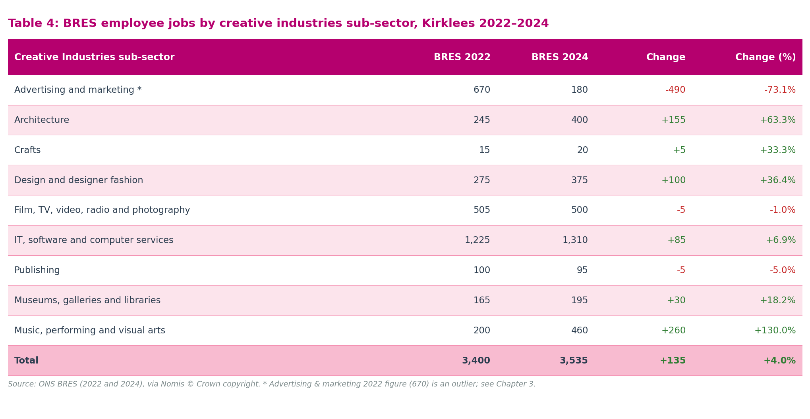
Creative Industries sub-sector | BRES 2022 | BRES 2024 | Change | Change (%)
Advertising and marketing | 670 | 180 | -490 | -73%
Architecture | 245 | 400 | +155 | +63%
Crafts | 15 | 20 | +5 | +33.3%
Design and designer fashion | 275 | 375 | +100 | +36%
Film, TV, video, radio and photography | 505 | 500 | -5 | -1.0%
IT, software and computer services | 1,225 | 1,310 | +85 | +6.9%
Publishing | 100 | 95 | -5 | -5.0%
Museums, galleries and libraries | 165 | 195 | +30 | +18.2%
Music, performing and visual arts | 200 | 460 | +260 | +130.0%
Total | 3,400 | 3,535 | +135 | +4.0%

Figure 5: BRES employee jobs by creative industries sub-sector, Kirklees 2022 and 2024
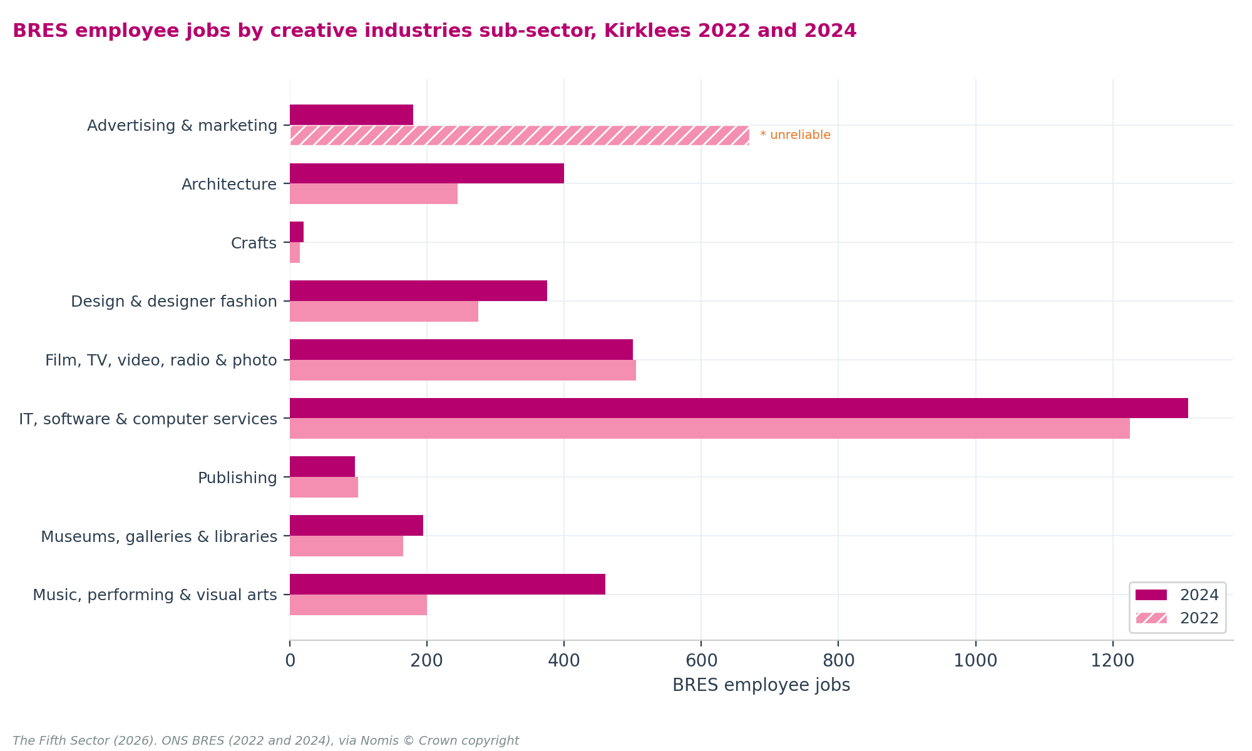
The most significant sub-sector movements in BRES are:
Advertising and marketing (670 to 180, -73%). Comparison with other data suggests that this fall does not represent a real-world contraction of that scale. BRES is a stratified sample survey drawn from the IDBR. In a district the size of Kirklees, a single large firm reclassifying its primary address or business code can wipe out 400 payroll jobs from the local record. Because BRES measures formal payroll registrations, individual business decisions can produce large year-on-year swings. Company records from The Data City (up 15.8% in active businesses) and LinkedIn (up 7.7% in workforce) both suggest that this sector remains stable and growing.
Music, performing and visual arts (200 to 460, +130.0%). While this increase aligns with positive LinkedIn workforce growth, it represents a modest absolute gain of 260 jobs on a historically low baseline. This rise reflects positive administrative consolidation of local education hubs and venue payrolls, rather than a massive structural transformation. The gap between BRES employee jobs (460) and the LinkedIn workforce (1,560) confirms that most music and performing arts practitioners operate outside formal payroll networks as independent self-employed workers.
Architecture (245 to 400, +63%) and Design and designer fashion (275 to 375, +36%). Both sub-sectors show consistent positive growth across both BRES and LinkedIn, increasing our confidence that these figures reflect genuine workforce expansion.
The BRES figure of 1,310 for IT, software and computer services includes SIC 62020 Computer consultancy. A 53% creative filter is applied to this component for the GVA estimate in Chapter 4, reducing the effective IT employment count to 840, to separate creative software services from non-creative corporate consultancy. This filter is consistent with national creative intensity analysis of the same SIC code: Bakhshi, Freeman and Higgs (2013) find that approximately 47–55% of workers in Computer Consultancy (SIC 6202) are engaged in creative roles at national level, depending on the analytical method applied. See Appendix A4, Step 2 and Appendix A8 for the full derivation and scenarios.
How this report reads BRES sub-sector data. Sub-sector BRES figures carry two distinct uncertainties: directional (is the trend genuine?) and level (does the count reflect the true workforce scale?). Each is treated differently throughout this chapter.
Directional reliability: Where Companies House data and LinkedIn move in the same direction as BRES, the trend is treated as genuine. Where they move in the opposite direction, BRES is treated as an administrative artefact rather than real-world change. Advertising and marketing (BRES −73.1%; Companies House +15.8%; LinkedIn +7.7%) is classified as directionally unreliable, the most plausible explanation is a single-firm address or SIC reclassification, not genuine contraction. Music, performing and visual arts (BRES +130%; LinkedIn +4.7%) is classified as directionally reliable: both sources confirm genuine growth in the same direction.
Level reliability: Even where the BRES direction is trusted, the absolute count is understood to undercount in all sub-sectors where self-employment is structurally prevalent. The gap between BRES (460) and LinkedIn (1,560) in Music reflects the sector's structural reliance on portfolio and self-employed working, not a data quality artefact. The same structural undercount applies in Film, Design, and Publishing. In Architecture, where BRES and LinkedIn are at near-parity (400 and 550), both direction and level are treated as reliable.
This distinction, directional artefact versus structural undercount, drives the multi-source analytical approach throughout this chapter and is carried into the GVA model in Chapter 4.

LinkedIn creative workforce
LinkedIn identified 10,305 people in Kirklees working in DCMS Creative Industries sub-sectors in 2026, up from 9,405 in 2024, an increase of 900, or 9.6%. Growth is broad-based across most sub-sectors, with three notable exceptions discussed below.
Table 5: LinkedIn creative workforce by sub-sector, Kirklees 2024-2026
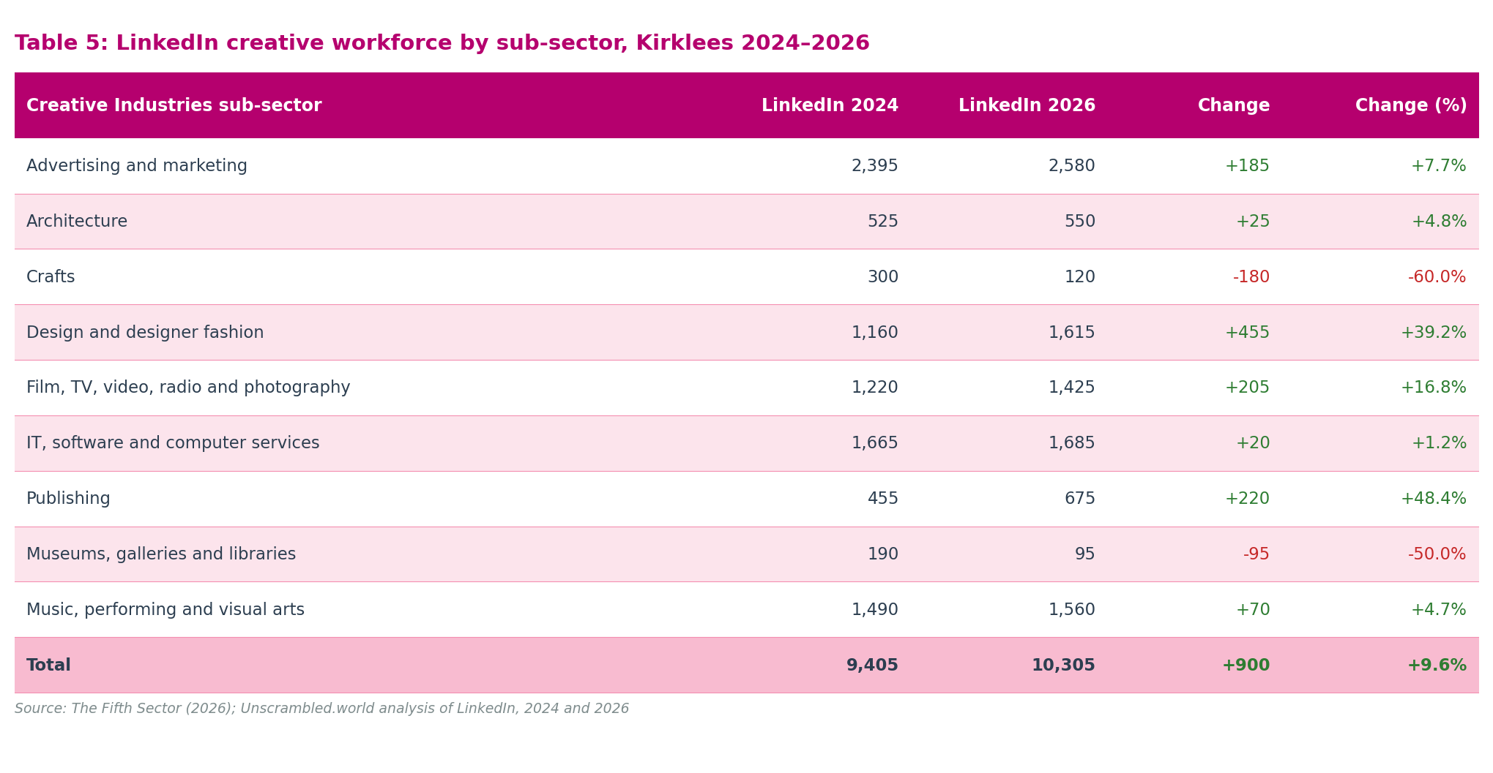
Creative Industries sub-sector | LinkedIn 2024 | LinkedIn 2026 | Change | Change (%)
Advertising and marketing | 2,395 | 2,580 | +185 | +7.7%
Architecture | 525 | 550 | +25 | +4.8%
Crafts | 300 | 120 | -180 | -60.0%
Design and designer fashion | 1,160 | 1,615 | +455 | +39.2%
Film, TV, video, radio and photography | 1,220 | 1,425 | +205 | +17%
IT, software and computer services | 1,665 | 1,685 | +20 | +1.2%
Publishing | 455 | 675 | +220 | +48.4%
Museums, galleries and libraries | 190 | 95 | -95 | -50.0%
Music, performing and visual arts | 1,490 | 1,560 | +70 | +4.7%
Total | 9,405 | 10,305 | +900 | +9.6%

Figure 6: LinkedIn creative workforce by sub-sector, Kirklees 2024 and 2026
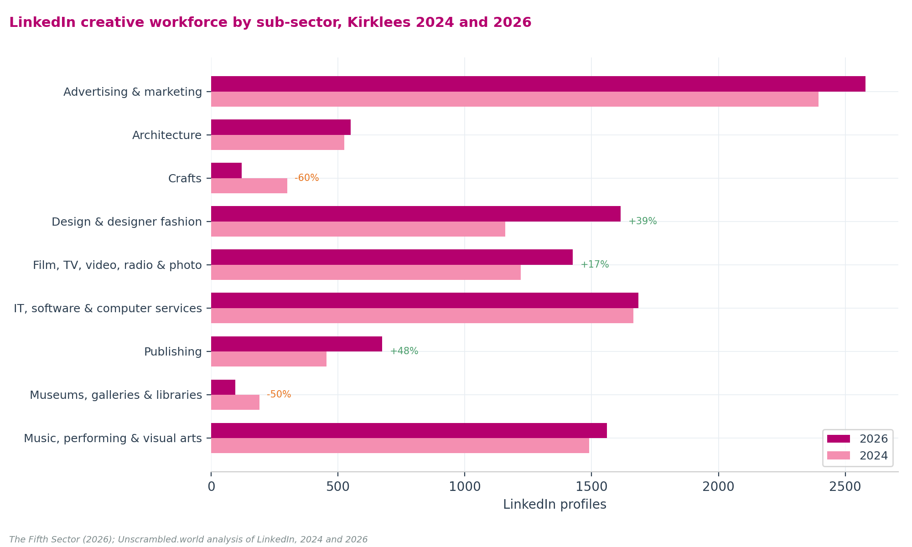
Music, performing and visual arts (1,490 to 1,560, +4.7%). Steady growth in this sub-sector is confirmed across both LinkedIn and BRES. The supply chain breakdown identifies Musicians (755, up from 649), Performing Arts (274, up from 259), and Artists and Writers (516 in the Originals chain, 318 in the Content chain) as the main contributing categories in 2026. The directional consistency between LinkedIn and BRES is a positive signal of real, stable workforce growth.
Design and designer fashion (+39%) and Publishing (+48%) show strong and credible growth on established base counts. The supply chain classification is internally consistent with both: Design Services grew from 688 to 762 profiles, Graphic Design from 351 to 398, and Book and Periodical Publishing remained stable while Movies, Video and Sound (578 to 680) and Photography (368 to 432) grew, indicating that the DCMS Publishing sub-sector is capturing a widening range of content production activity. Note that both the DCMS sub-sector totals and the supply chain figures are drawn from LinkedIn and reflect different classification structures applied to the same underlying platform data. They confirm internal consistency of scale and direction; they do not constitute independent corroboration from a separate data source.
Advertising and marketing (+7.7%) and Film, TV, video, radio and photography (+17%) show solid, credible growth consistent with active labour markets in both sub-sectors.
Crafts (300 to 120, -60%) and Museums, galleries and libraries (190 to 95, -50%) show apparent declines that are linked to changes in LinkedIn's industry classification structure between the 2024 and 2026 snapshots, not real-world workforce contraction. For Crafts, a LinkedIn industry code used in the 2024 snapshot was removed or reclassified with no direct replacement; supply chain data suggest that many former Crafts-classified profiles now appear within Fashion Design (123 to 457) and Artists and Writers categories. For Libraries, a standalone Libraries industry code was removed from LinkedIn's classification with no replacement, producing the apparent 50% fall in the combined Museums, galleries and libraries sub-sector total. The Museums (Keyword) supply chain category, which tracks museum-related profiles independently, remained essentially flat (92 to 97), confirming that the DCMS sub-sector decline is a classification artefact.

Working patterns: full-time, part-time, and freelance
The creative economy in Kirklees is characterised by a wide range of working arrangements. Table 6 sets out full-time and part-time counts from both LinkedIn and BRES. These figures are from different sources measuring different populations and should not be read as comparable measures of the same workforce.
Table 6: Full-time and part-time creative workers by source, Kirklees 2026
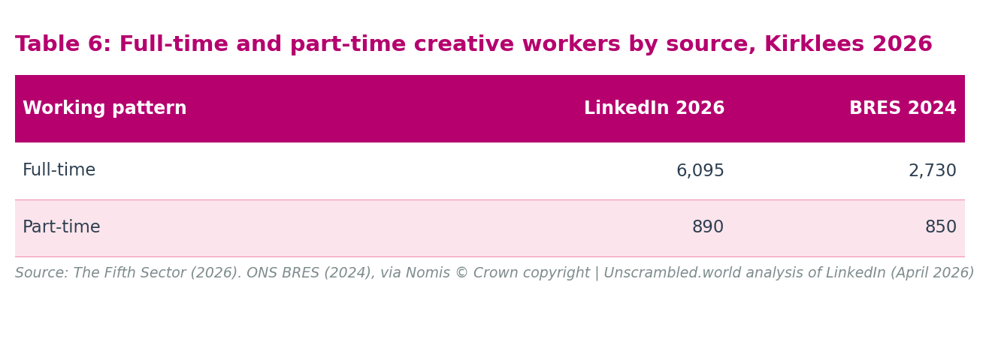
Working pattern | LinkedIn 2026 | BRES 2024
Full-time | 6,095 | 2,730
Part-time | 890 | 850

Sources: LinkedIn Corporation, LinkedIn, 2026 snapshot; Office for National Statistics, Business Register and Employment Survey (BRES) 2024, via Nomis. © Crown copyright. Not directly comparable, LinkedIn and BRES measure different populations.
The part-time totals are similar across sources (LinkedIn 890, BRES 850), though they measure different populations, BRES counts part-time employee jobs on payroll; LinkedIn counts profiles where the user has selected part-time as their employment arrangement, and may include self-employed practitioners who work part-time. The full-time figures diverge substantially: LinkedIn 6,095 vs BRES 2,730.
Comparing LinkedIn full-time and part-time combined (6,985) against BRES (3,535) at sub-sector level reveals four distinct patterns:
Near-parity: Architecture (LinkedIn FT+PT 410, BRES 400, gap +10). The only sub-sector where both sources agree closely. This is consistent with Architecture's predominantly studio-employed, formally contracted workforce, and with LinkedIn having good professional coverage of this sub-sector.
BRES exceeds LinkedIn FT+PT: IT, software and computer services (LinkedIn FT+PT 1,060, BRES 1,310, gap −250) and Museums, galleries and libraries (LinkedIn FT+PT 65, BRES 195, gap −130). In IT, this likely reflects large employers with substantial BRES payrolls whose employees have lower LinkedIn engagement rates, or employment in IT roles within businesses that do not present primarily as technology companies. In Museums and Libraries, the workforce is predominantly public sector, institutional, and does not consistently use LinkedIn, BRES, drawing on employer PAYE returns, captures them more completely than LinkedIn.
LinkedIn substantially above BRES FT+PT: Film, TV, video, radio and photography (+285), Publishing (+275), Music, performing and visual arts (+570), Design and designer fashion (+860). In each of these sub-sectors, the LinkedIn FT+PT count substantially exceeds BRES. Full-time or part-time status on LinkedIn reflects a practitioner's working pattern, not their employment contract. BRES records formal payroll jobs; practitioners working full-time in self-employment or portfolio practice appear in LinkedIn counts but outside the BRES payroll measure. A freelance editor or working visual artist will record full-time status on LinkedIn while remaining outside any employer's payroll return.
Largest LinkedIn/BRES gap: Advertising and marketing (LinkedIn FT+PT 1,930, BRES 180, gap +1,750). This gap at the sub-sector level is the strongest available evidence that the BRES 2024 Advertising and marketing figure of 180 is an unreliable outlier, not a reflection of the actual employment level in that sub-sector. LinkedIn FT+PT of 1,930 is consistent with a professionally active advertising and marketing workforce of the scale visible in the active-business count (220 businesses) and the overall LinkedIn total (2,580).
This sub-sector comparison carries a direct implication for the inferred freelance and self-employed estimate that follows.
The freelance and self-employed workforce totals 3,320 in 2026, representing stable consolidation from 3,485 in 2024, a minor reduction of 4.7%. At nearly equal scale to the BRES employee count of 3,535, self-directed and portfolio work remains a major pillar of the creative economy.
This figure is derived entirely from LinkedIn employment-type data. LinkedIn gives subscribers the opportunity to self-classify their profile by employment type, full-time, part-time, self-employed, freelance, contractor, and other categories. The count is calculated at both total and sub-sector level as the residual when full-time and part-time profiles are subtracted from the sub-sector total; the residual captures those classified as self-employed, freelance, contractor, student, or without a recorded employment type. BRES figures are not used in this derivation. The full arithmetic is set out in Appendix A4, Step 3.
Two qualifications are important. First, the residual is not a clean "freelance and self-employed" count. It includes contractors on fixed-term engagements, students, interns, and profiles with no employment type recorded, as well as the self-employed and freelance workers the label implies. LinkedIn's employment-type categories are self-reported and are not mutually exclusive; a practitioner may record both "freelance" and "self-employed" on their profile.
Second, and more significantly, the sub-sector comparison above shows that a substantial number of those classified as full-time or part-time on LinkedIn are not formal payroll employees, they are self-employed and portfolio practitioners who describe their working pattern as full-time or part-time without having an employer in the BRES sense. This total almost certainly understates the true number of creative workers operating outside formal employment. It should be read as a conservative lower bound on the self-directed workforce, not as its full extent.
A note on the definition of 'freelance' in this report. The 3,320 figure is not a count of everyone in Kirklees who identifies as freelance or self-employed; it is the LinkedIn employment-type residual, a methodologically consistent input to the GVA model. Three groups of self-directed workers are excluded from this count. First, practitioners who describe their working pattern as full-time or part-time on LinkedIn despite having no formal PAYE employer are counted in the LinkedIn FT+PT totals, not in the residual. The sub-sector analysis above shows this is a substantial group, particularly in Music, Design, and Film, where LinkedIn FT+PT substantially exceeds BRES. Second, creative workers who operate below LinkedIn's coverage threshold, those without a profile, or whose profile does not use DCMS-classified industry codes, are not captured in any LinkedIn-based measure. Third, portfolio practitioners holding both an employed position and a creative self-employment practice simultaneously may appear in both the LinkedIn FT+PT count and BRES, creating a partial overlap. The policy implication: the 3,320 should be cited as the active freelance workforce captured in the GVA model, not as the total number of freelancers in Kirklees. The true self-directed workforce is larger; how much larger cannot be quantified from current data sources alone.
Table 7: Inferred count of freelance and self-employed creative workers by sub-sector, Kirklees 2024-2026
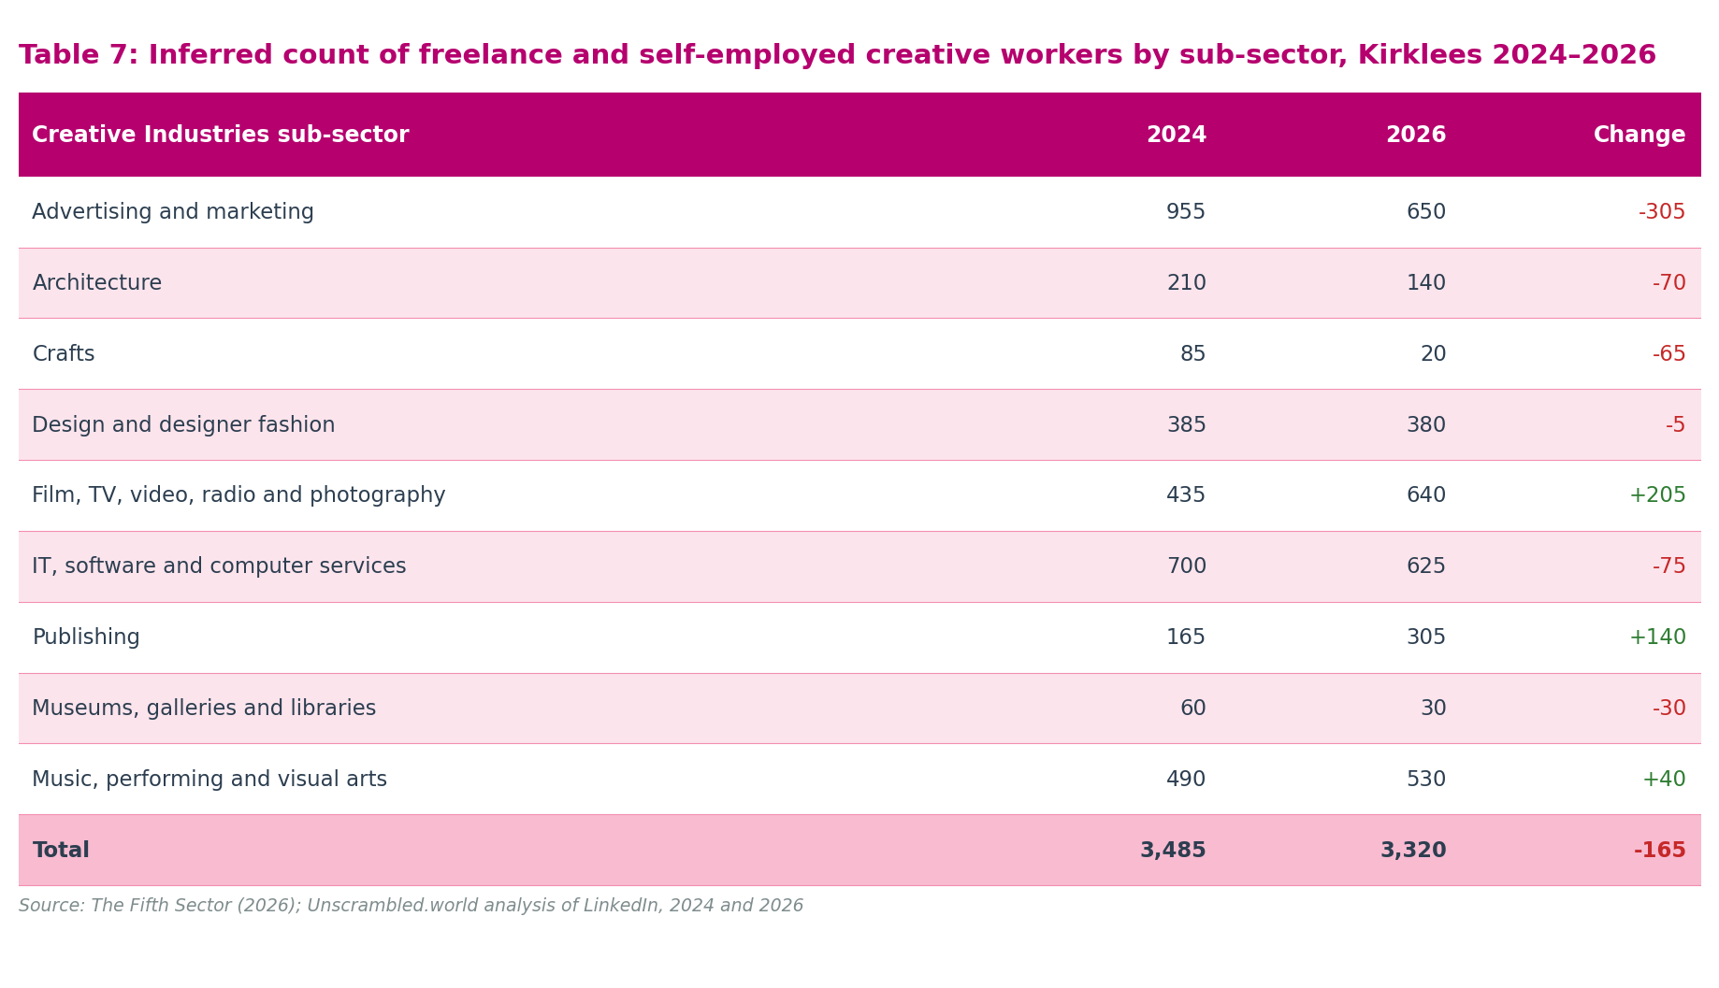
Creative Industries sub-sector | 2024 | 2026 | Change
Advertising and marketing | 955 | 650 | -305
Architecture | 210 | 140 | -70
Crafts | 85 | 20 | -65
Design and designer fashion | 385 | 380 | -5
Film, TV, video, radio and photography | 435 | 640 | +205
IT, software and computer services | 700 | 625 | -75
Publishing | 165 | 305 | +140
Museums, galleries and libraries | 60 | 30 | -30
Music, performing and visual arts | 490 | 530 | +40
Total | 3,485 | 3,320 | -165

Figure 7: Inferred freelance and self-employed creative workers by sub-sector, Kirklees 2026
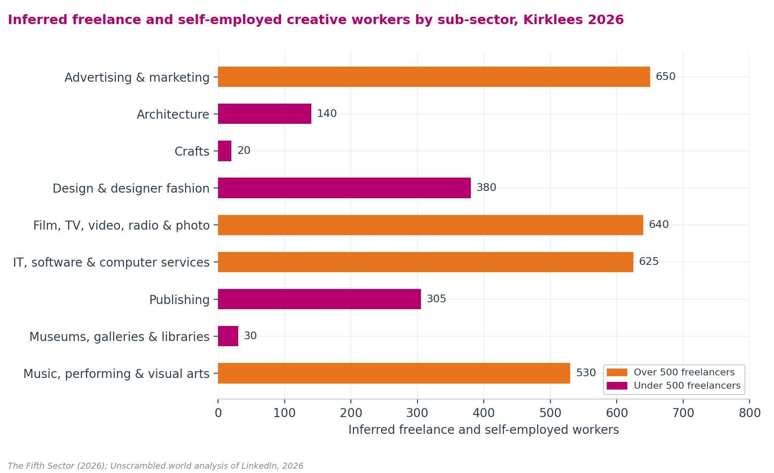
Freelance and self-employed workers are widely distributed across sub-sectors. The three largest concentrations are Advertising and marketing (650, 20% of the total), Film, TV, video, radio and photography (640, 19%), and IT, software and computer services (625, 19%), reflecting the project-based and self-directed working patterns characteristic of all three. Music, performing and visual arts (530, 16%) is the fourth largest concentration. Publishing sends conflicting signals: business numbers differ between indices, but freelance and self-employed working has grown by 85% (from 165 to 305) and represents the majority of the workforce.
Advertising and marketing shows a reduction in freelancers despite LinkedIn workforce growth in the same sub-sector. This may reflect a shift towards employed rather than freelance working patterns, or reclassification within LinkedIn industry codes between snapshots.

Employment intensity: full-time equivalent analysis
To understand the real-world volume of work in Kirklees, we convert raw workforce headcounts into full-time equivalents (FTE). This calculation weights a full-time worker as 1.0 and a part-time worker as 0.5.
Comparing ONS BRES payroll records and LinkedIn social data reveals a distinct divergence in work intensity. BRES records part-time roles using employer-defined payroll contracts. These roles are common in institutional, sessional, or lower-paid positions. LinkedIn records work intensity based on how active practitioners describe their primary business engagements. Consequently, LinkedIn profiles show a much higher average work intensity than suggested in BRES data, particularly in cultural and performing arts sectors.
Table 8 compares BRES and LinkedIn FTE intensities across all creative sub-sectors. The FTE intensity is the ratio of full-time equivalents to raw headcount. Because BRES and LinkedIn measure different populations, their intensities diverge, most sharply in sub-sectors where self-employed practitioners dominate.
Table 8: Creative sub-sector FTE intensity comparison, Kirklees 2026
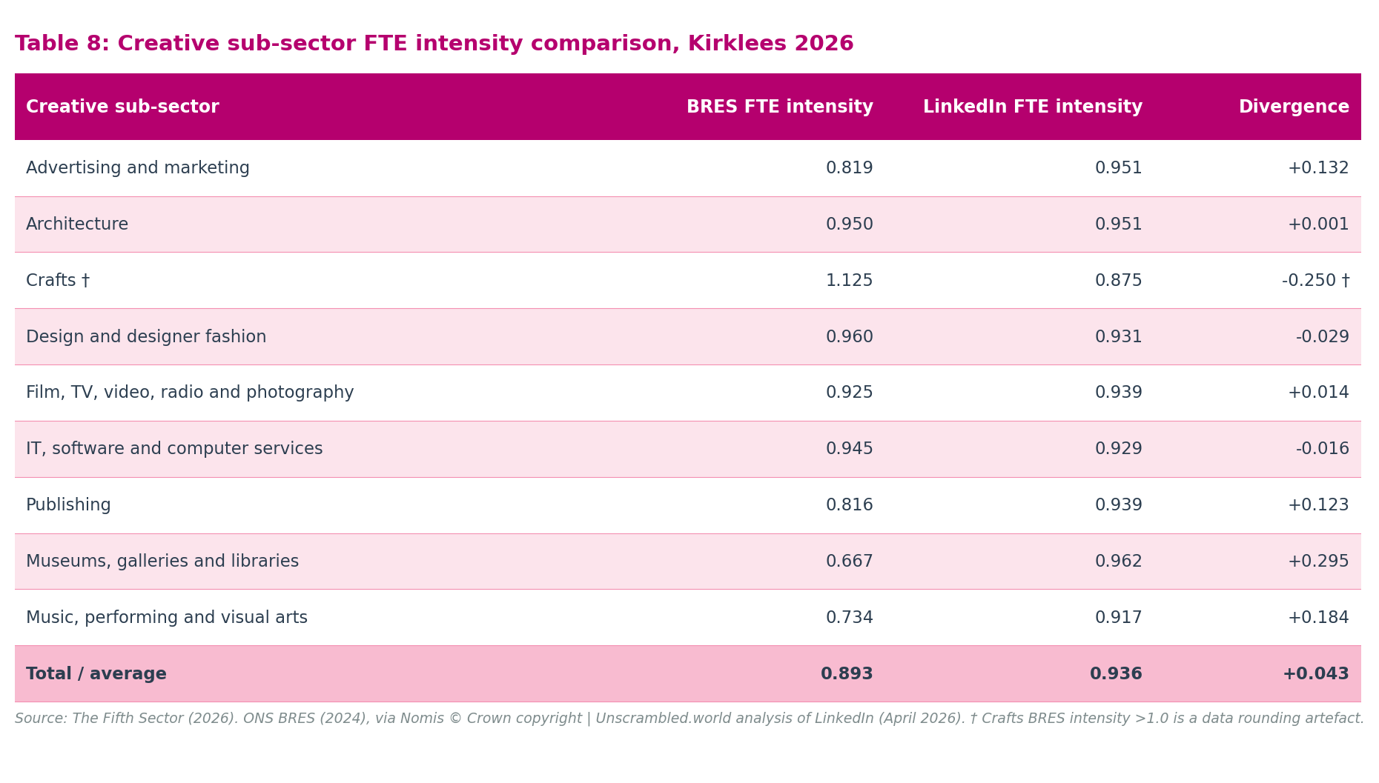
Creative sub-sector | BRES FTE intensity | LinkedIn FTE intensity | Divergence
Advertising and marketing | 0.819 | 0.951 | +0.132
Architecture | 0.950 | 0.951 | +0.001
Crafts | 1.125† | 0.875 | −0.250†
Design and designer fashion | 0.960 | 0.931 | −0.029
Film, TV, video, radio and photography | 0.925 | 0.939 | +0.014
IT, software and computer services | 0.945 | 0.929 | −0.016
Publishing | 0.816 | 0.939 | +0.123
Museums, galleries and libraries | 0.667 | 0.962 | +0.295
Music, performing and visual arts | 0.734 | 0.917 | +0.184
Total / average | 0.893 | 0.936 | +0.043

Sources: ONS BRES 2024 FT and PT sub-counts; LinkedIn, 2026 snapshot (FT and PT employment-type counts). FTE intensity = (FT × 1.0 + PT × 0.5) ÷ total headcount. BRES total FTE = 3,155 (headcount 3,535). LinkedIn FT+PT total FTE = 6,540 (headcount 6,985). † Crafts BRES intensity >1.0 is a published-data rounding artefact: BRES FT and PT sub-cell figures sum marginally above the BRES total. The Crafts divergence figure is therefore not meaningful.
The two standout divergences, Museums (BRES 0.667 vs LinkedIn 0.962, gap +0.295) and Music (BRES 0.734 vs LinkedIn 0.917, gap +0.184), validate the lower-bound finding from the freelance analysis above. BRES captures the institutional employment character of these sub-sectors: formally employed museum and library staff are predominantly part-time, and formally employed music workers are on a near-equal FT/PT split (225 each). LinkedIn, by contrast, captures self-employed practitioners in the same sub-sectors who work full-time in their creative practice. The intensity divergence is not a data quality problem; it reflects two structurally different populations being measured by each source.
For the GVA model in Chapter 4, LinkedIn FTE intensities are applied to the freelance group rather than BRES intensities, because these practitioners are predominantly self-employed, closer in working-pattern character to LinkedIn's FT+PT classified profiles than to BRES payroll employees. For the sub-sectors with near-parity (Architecture, Film/TV, IT, Design), the choice of intensity source makes little practical difference. For Music and Museums, it is material.
The freelance GVA model also applies two sequential discounts to the raw inferred headcounts before converting to FTE, to prevent inflation of the estimate by inactive or multi-jobbing profiles:
1. A portfolio overlap discount: Applied at 15% to music, crafts, and museums, sub-sectors where the highest rates of dual-profile and multi-jobbing working are documented in ONS Labour Force Survey and Annual Population Survey data on second-job holding in arts and entertainment occupations.
2. An economic activity discount: Applied at 20% to music, crafts, and museums, and at 10% to design, film, and publishing, to remove hobbyist and inactive profiles from the active commercial practitioner count.

Supply chain structures
The DCMS sub-sector classification provides one lens on the creative workforce: an alternative supply chain framework provides another. This report uses a five-chain classification, Content, Experiences, Originals, Services, and Tech, applied to LinkedIn data to show how the creative economy organises itself around different types of output and activity. Supply chain totals are not additive to the DCMS sector totals in Table 5: they represent a different way of classifying the same or overlapping workforce.
Table 9: Creative industries supply chain LinkedIn workforce, Kirklees 2024-2026
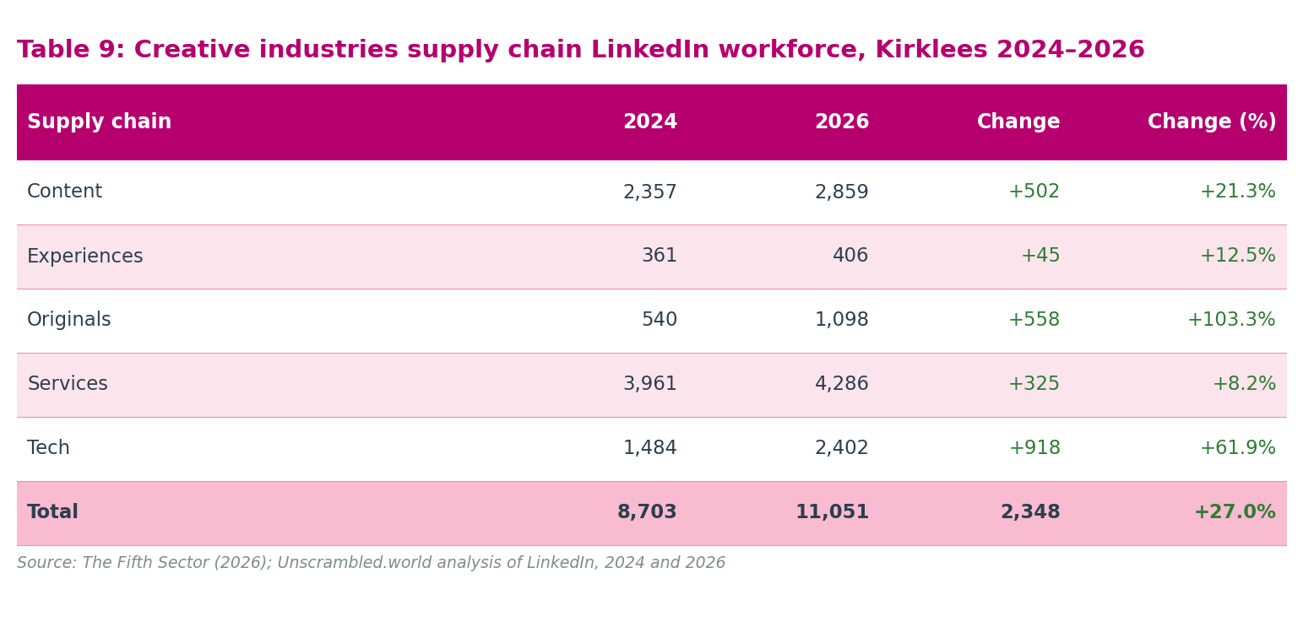
Supply chain | 2024 | 2026 | Change | Change (%)
Content | 2,357 | 2,859 | +502 | +21.3%
Experiences | 361 | 406 | +45 | +12.5%
Originals | 540 | 1,098 | +558 | +103.3%
Services | 3,961 | 4,286 | +325 | +8.2%
Tech | 1,484 | 2,402 | +918 | +61.9%
Total | 8,703 | 11,051 | +2,348 | +27.0%

The IT Services and Consulting supply chain. A sixth LinkedIn supply chain was captured in the same data extract but held separately because its 3,395 profiles cover SIC Sections 62 and 63 in their entirety, extending materially beyond the DCMS Creative Industries definition. These workers are not counted in the creative economy GVA estimate: demonstrating activity in IT services does not qualify a worker for the DCMS creative economy on the same basis that demonstrating RTIC capability does not qualify a firm for the CI business count. Of the 3,395, approximately 1,595 (47%) are algorithmically classified as consultants, consistent with the 47% non-creative filter applied to SIC 62020 in the BRES employment analysis. The remaining 1,800 are IT services practitioners whose activity spans the boundary between creative digital production and broader digital infrastructure.
The most significant finding from this cohort's profile is its job role distribution: 1,446 of the 3,395 (43%) carry the Creative and Production designation. This rate exceeds the equivalent for the Content (35%), Experiences (27%), Services (23%), and Tech (39%) supply chains, only the Originals chain (49%) is higher. A Creative and Production rate of 43% within a non-DCMS IT services context is the operational signature of the Createch interface: workers doing creative production work in firms whose primary SIC codes place them outside the formal creative economy. The full workforce profile, employment types, seniority, experience, education, and recruitment signals, is presented in Appendix A10. The policy implications for the Createch investment case are developed in Chapter 6.
Figure 8: Creative industries supply chain LinkedIn workforce, Kirklees 2024 and 2026
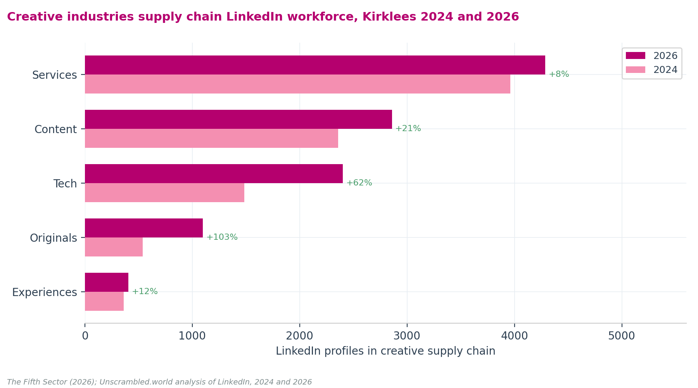
Services is the largest chain by volume (4,286 in 2026), encompassing Advertising Services (2,073), Design Services (762), Graphic Design (398), Architecture and Planning (542), and Marketing Services (267). Originals shows the strongest proportional growth (+103%), driven primarily by Fashion Design (123 to 457, +272%) and Artists and Writers (346 to 516). Tech grew by 62%, with established growth in Computer Games (162 to 283) supplemented by new categories including Computer and Network Security (214) and Information Services (432) that were not captured in the 2024 snapshot.

Creative Trident: three modes of creative employment
The Creative Trident framework (Higgs, Cunningham and Bakhshi, 2008) distinguishes three modes of creative employment: Mode 1, creative specialists working within creative industries firms; Mode 2, non-creative support staff working within creative industries firms; and Mode 3, creative specialists working within non-creative industries firms, such as an in-house graphic designer employed by an engineering consultancy or a peripatetic music teacher employed by a school. Bakhshi, Freeman and Higgs (2013) applied the Trident methodology at national scale across the full UK Creative Industries, finding that self-employed and freelance workers consistently display higher creative intensity than formally employed peers across most sub-sectors, a finding that supports the assumption in this report that the inferred freelance workforce is predominantly engaged in creative, rather than support, activity.
The workforce data in this chapter captures the payroll floor of Modes 1 and 2 through BRES, which records all formally employed workers within DCMS-classified creative industries firms. The Trident-consistent proxy in Appendix A6 shows that both modes extend beyond the payroll register. LinkedIn provides a partial window on Mode 3: because LinkedIn profiles are self-reported by individuals rather than by firms, creative specialists employed in non-creative industries appear in the workforce count regardless of their employer's primary SIC code. The extent to which the LinkedIn total captures Mode 3 is not precisely known; the computer consultancy crosswalk (Appendix A4, Step 2 and Appendix A8) is one attempt to identify and manage this boundary.
A full local Creative Trident cross-tabulation requires access to ONS secure micro-data at local authority level. The combined GVA estimate of £305 million captures Modes 1 and 2 fully and Mode 3 only partially; it is a floor, not a ceiling. Appendix A6 sets out the current position in detail, identifies where the model falls short of a complete Trident, and proposes practical steps towards a fuller local estimate.
LinkedIn's supply chain data provides a functional cross-check on the Trident conceptual split. LinkedIn assigns job role areas algorithmically from profile data; because the five role categories (Creative and Production, Admin and Operations, Sales, Marketing and Communications, and R&D) account in aggregate for the full supply chain population, the classification covers all 11,051 profiles in the supply chain universe rather than a self-selected subset. Within this universe, 3,599 profiles (33%) carry the Creative and Production designation, the closest available proxy for Mode 1 creative specialists within the LinkedIn data. Admin and Operations accounts for 3,875 profiles (35%), broadly consistent with Mode 2 support workers. The full breakdown by supply chain is set out in Table A9 (Appendix A9).
Marketing and Communications (1,464 profiles, 13%) provides a useful triangulation point. Across all creative supply chains, 1,464 profiles carry marketing and communications as their primary function. This compares to 2,580 LinkedIn profiles in the Advertising and marketing sub-sector specifically (a sub-sector classification, not a functional one) and 180 confirmed BRES payroll employees in advertising and marketing SIC codes. The ratio between the functional role count (1,464) and the confirmed payroll count (180) is consistent with the broader BRES/LinkedIn discrepancy found across all sub-sectors: formal payroll employment captures roughly one in eight of those identified through profile-based sources. The functional role data also confirms that marketing and communications work is distributed across the creative economy, in IT firms, film production, architecture practices, and publishing houses, and is not confined to advertising-sector businesses.
A note on data provenance is important for interpreting this evidence. The Data City's RTIC analysis identifies which businesses are active creative firms; the underlying company records are drawn from Companies House, with RTIC classifications applied by The Data City. LinkedIn and BRES provide the workforce counts independently of this firm identification. The same practitioner working at a Companies House-registered creative business will appear in the firm count, in BRES if on payroll, and in LinkedIn if registered. This creates no double-counting of the workforce: the firm count (1,690 active creative businesses, drawn from Companies House via The Data City) and the workforce counts (3,535 BRES employees, 10,305 LinkedIn profiles) measure different things and are never summed. The Trident framework is most productive here as a conceptual lens, clarifying what kind of work people do and how they relate to the creative economy, rather than as a mechanism for enforcing a precise statistical boundary between populations that are, by their nature, recorded through different instruments.
Taken together, the job role data produce a Trident-consistent proxy rooted in the 10,305 DCMS-matched LinkedIn profiles, all of whom have self-identified their occupation as within a DCMS creative sub-sector. That self-identification establishes Trident membership regardless of the employer's primary SIC code: a Mode 3 worker (a designer at a textile firm, a brand manager at a food company, a digital media producer at an engineering consultancy) appears in the DCMS-matched population because they classify by occupation, not by employer. The approximately 750 non-DCMS boundary cases (IT services, computer security, information services) are purposefully excluded. The resulting proxy estimates approximately 3,300 in Mode 1, 3,800 in Mode 2, and 3,000–3,500 in Mode 3, producing a Trident estimate of approximately 10,100–10,600 workers from the DCMS-matched population. Mode 2 is derived as the functional residual after Mode 1 and Mode 3 are estimated: the gap between Mode 2 and the BRES payroll count reflects the same BRES/LinkedIn undercount observed throughout this report, now visible in the support occupation cohort. Sub-sector creative intensity analysis (Bakhshi, Freeman and Higgs, 2013) confirms Mode 1 at approximately 3,300 and Mode 2 at approximately 3,800; Advertising and marketing and IT, software and computer services, both characterised by substantial non-creative back-office cohorts, are the largest Mode 2 contributors. Sub-sector breakdown in Appendix A6, Table A6b. The combined GVA of £305 million captures Modes 1 and 2 but not Mode 3: a complete Trident estimate for Kirklees would produce a materially higher figure. The full proxy analysis and constituent breakdown are in Appendix A6, Table A6. See also Figure 2 in the executive summary.

What the workforce data show
Taken together, the BRES, LinkedIn, and supply chain data present a consistent story of a creative economy that is growing, predominantly self-directed in its working patterns, and larger than official statistics alone would suggest. Formal employment has grown modestly and steadily. The wider creative workforce, including the substantial freelance and portfolio economy, has grown more rapidly. LinkedIn records an increase in full- and part-time profiles between 2024 and 2026 approximately six times larger than the increase in payroll employment recorded in BRES over the same reference period, alongside a very small decline (under 1%) in the freelance count. This is a directional signal of increasing formalisation: employment is growing in ways not yet fully captured in BRES, partly because of the two-year lag between survey reference periods, and partly because the longer-term consolidation in company registrations includes newly incorporated firms that remain below BRES payroll reporting thresholds at this stage of their development. The sub-sectors showing the strongest growth across multiple data sources are Music, performing and visual arts, Design and designer fashion, and Publishing. These patterns inform the recommendations set out in Chapter 6.

Chapter 4: Economic impact

What GVA measures and what it does not
Gross value added (GVA) measures economic output. It captures the value that businesses and workers generate above the cost of their inputs. Because no single official index provides estimates of GVA for the creative industries at a local authority level, we estimate GVA by applying national sector productivity rates to local employment counts.
To estimate creative industries GVA at sub-national level, we use a two-part framework. First, we calculate the GVA of formally employed creative workers from ONS BRES data. Second, we add a separate estimate of freelance GVA derived from sector productivity and FTE intensity analysis applied to the LinkedIn employment-type residual (3,320 workers classified as self-employed, freelance, or contractor). These two components produce a creative industries GVA range of £243 million to £305 million for Kirklees. The upper bound applies national DCMS productivity rates; the lower bound applies the ONS Calderdale and Kirklees ITL3 regional productivity scalar (0.796, where UK = 100). Each table in this chapter presents both bounds.
A further approximately 3,830 workers appear in LinkedIn full-time and part-time data but hold no formal BRES payroll employment. They are not modelled in the creative industries GVA estimate for three reasons. First, their identification method, LinkedIn FT/PT minus BRES payroll, is a residual that depends on the reliability of the BRES denominator; where BRES is an assessed outlier (Advertising is the critical case), the residual cannot be independently validated. Second, without confirmed payroll data, the overlap with the freelance residual cannot be fully excluded. Third, the Advertising sub-sector accounts for 62% of this group's estimated GVA, removing that one unreliable input leaves a residual of approximately £68m nationally that is real but not independently anchored to confirmed payroll data. These workers are a known exclusion: the creative industries GVA of £243m–£305m is a floor. The non-Advertising element of this group is estimated at approximately £54m–£68m on a comparable basis and is flagged for future modelling once confirmed Advertising payroll data are available.
One further methodology note: the RTIC analysis conducted for this report confirms that SIC 62012 (Business software development, 251 Kirklees companies) has a virtually identical RTIC profile to SIC 62020 (6.8% vs 6.7% CI-and-adjacent RTIC by company count). The case for applying an equivalent GVA filter to SIC 62012 BRES employees is methodologically strong; however, no confirmed BRES sub-code data are available at Kirklees level to calibrate such a filter. The exposure is up to −£11m on the employee GVA estimate. This is flagged as a methodology gap for future reporting cycles and is not applied in the current estimate.

ONS BRES employee GVA
Our employee-based GVA estimate for Kirklees creative industries is between £142 million and £178 million, derived from ONS BRES payroll returns. The upper bound (£178 million) applies national DCMS GVA-per-employee rates; the lower bound (£142 million) applies the Calderdale and Kirklees ITL3 regional scalar (0.796).
To ensure statistical precision, we align our employment denominator before calculating GVA. BRES records 3,535 total creative employee jobs in Kirklees. However, our analysis of a combination of The Data City and LinkedIn identifies that 47% of local computer consultancy employees (470 out of 1,000 workers in SIC 62020) work in non-creative fields. We subtract these 470 non-creative workers from the total, leaving 3,065 creative employee jobs as our GVA denominator. This adjustment prevents any inflation of creative sector output.
Table 10 shows the sub-sector breakdown of the calculation of GVA from formal employment.
Table 10: Creative industries GVA by sub-sector, Kirklees 2024 (employee-based estimate)
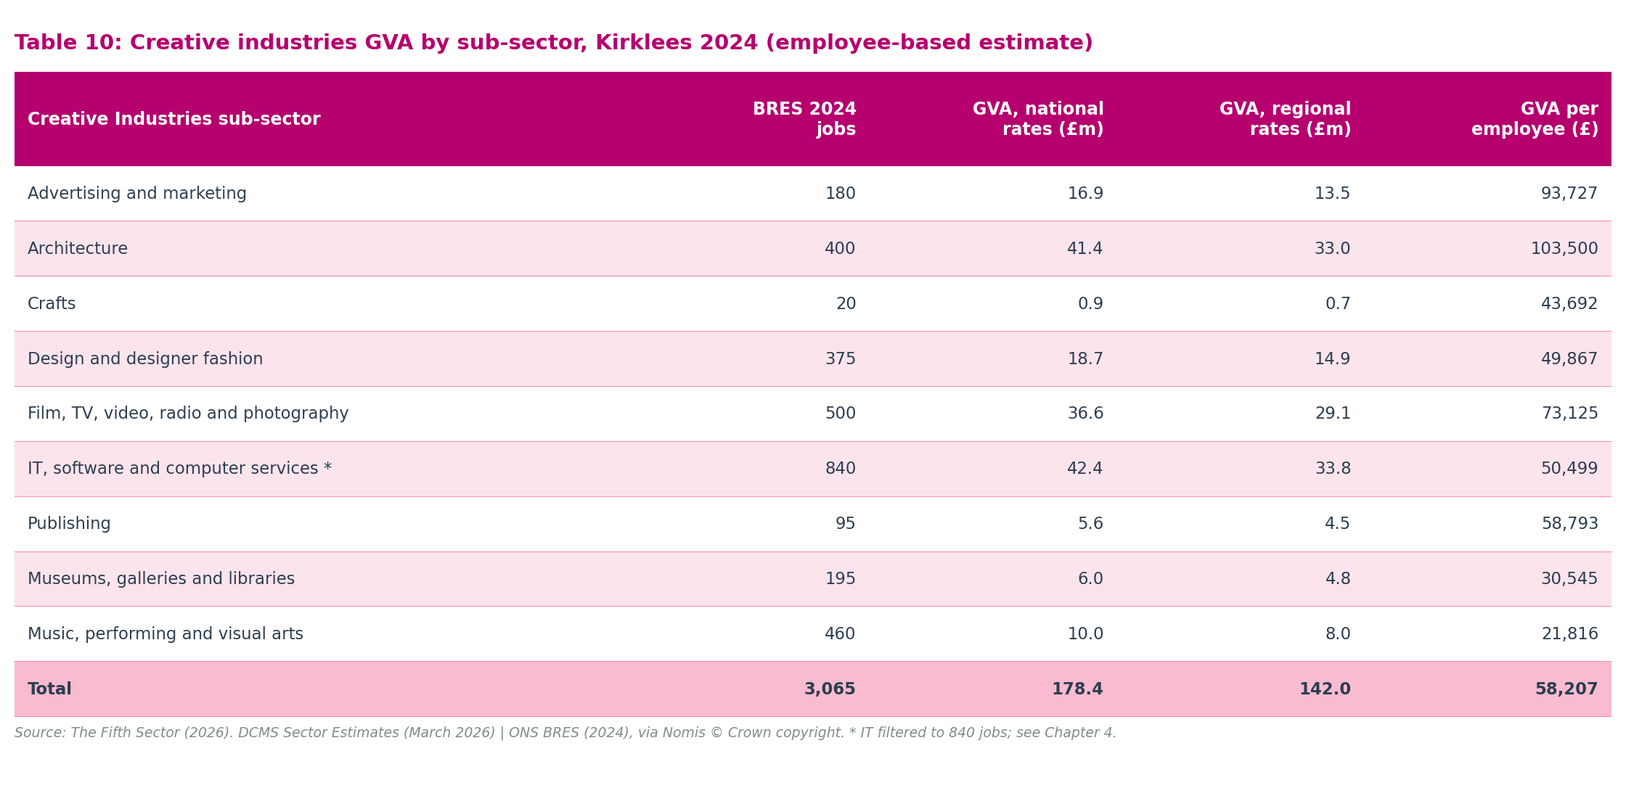
Creative Industries sub-sector | BRES 2024 employee jobs | GVA — national rates (£m) | GVA — regional rates (£m) | GVA per employee (£)
Advertising and marketing | 180 | 16.9 | 13.5 | 93,727
Architecture | 400 | 41.4 | 33.0 | 103,500
Crafts | 20 | 0.9 | 0.7 | 43,692
Design and designer fashion | 375 | 18.7 | 14.9 | 49,867
Film, TV, video, radio and photography | 500 | 36.6 | 29.1 | 73,125
IT, software and computer services * | 840 | 42.4 | 33.8 | 50,499
Publishing | 95 | 5.6 | 4.5 | 58,793
Museums, galleries and libraries | 195 | 6.0 | 4.8 | 30,545
Music, performing and visual arts | 460 | 10.0 | 8.0 | 21,816
Total | 3,065 | 178.4 | 142.0 | 58,207

Figure 9: Creative industries GVA by sub-sector, Kirklees 2024
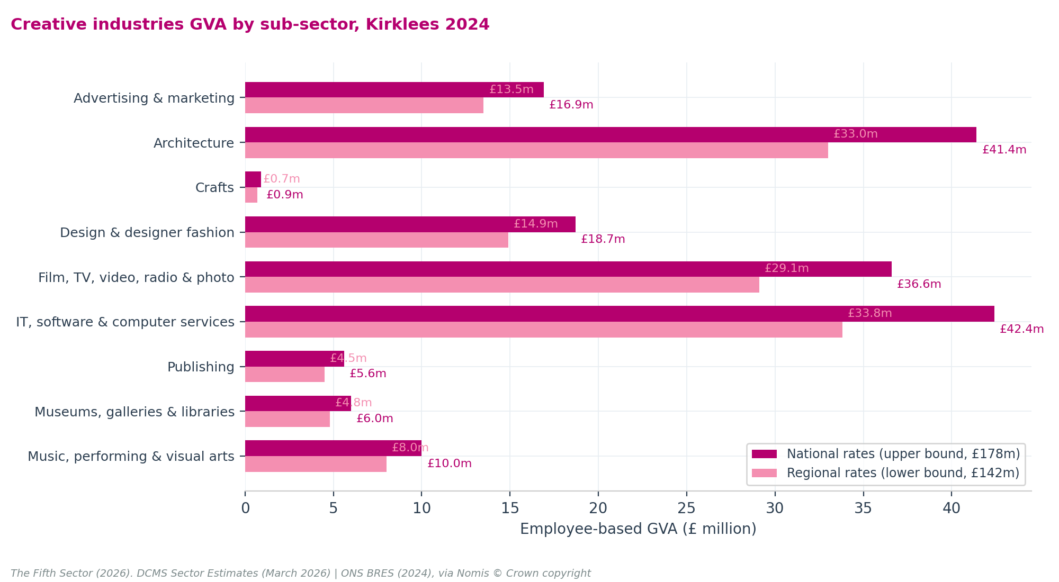
IT, software and computer services is the largest contributor to GVA from formal employment (24% of the total), and has a middling GVA-per-employee rate of £50,499. Architecture is the second-largest contributor (23% of the total) with a smaller employment base but the highest GVA-per-employee rate (£103,500), reflecting the high output value of professional architectural services. Film, TV, video, radio and photography contributes 21% of GVA (£73,125 per employee). Together these three sub-sectors account for 68% of the total employee GVA estimate.
Advertising and marketing (9% of the total) and Design and designer fashion (10%) are mid-range contributors. The GVA-per-employee rate for Music, performing and visual arts is the lowest in the table (£21,816), reflecting the high proportion of fractional and sessional workers whose earnings from employment may form only one element of a "portfolio" career which encompasses other forms of earnings from self-employment.

Computer consultancy filtering and GVA impact
The GVA estimate of £178.4m applies a 53% creative filter to SIC 62020 Computer consultancy, consistent with TDC 2026's assessment that approximately 47% of SIC 62020 profiles are consultants not primarily classified as Creative Industries. This is based on confirmed ONS BRES data: the Kirklees SIC 62020 (SIC 6202 sub-code) BRES employment in 2024 is 1,000 employees, of which 470 (47%) are excluded and 530 (53%) are retained within the IT, software and computer services total.
The adopted approach (Scenario S2: 53% creative filter, IT BRES 840, total BRES 3,065, total GVA £178.4m) is internally consistent with TDC's methodology, is based on confirmed BRES sub-code data, and does not attribute economic output from non-creative consultancy to the Creative Industries account. The adopted estimate of £178.4m sits within a scenario range of £151.6m (Scenario S1: full SIC 62020 exclusion) to £202.1m (Scenario S0: full inclusion). All four scenarios are compared in Appendix A8.

Estimating freelance gross value added
To measure the economic value of the independent creative workforce, we apply our sessional discounting and FTE intensity framework to raw freelance headcounts.
Table 11 presents our freelance GVA model. By applying sequential discounts for portfolio overlap and economic activity, we sanitize our raw headcount of 3,320 profiles to isolate 2,410 active, commercial freelancers (rounded to the nearest whole person to avoid fractional headcounts). We convert these headcounts to full-time equivalents, and apply subsector-specific Beta productivity coefficients (0.70 to 0.80) to discount national DCMS rates.
We apply a 10% taxonomy leakage discount to freelance IT consulting, whereas we apply a much larger 47% filter to BRES payroll IT employees. This difference represents a deliberate structural boundary. BRES records all IT staff employed by registered consultancy firms, including massive corporate enterprise software teams. Conversely, our freelance IT cohort strictly represents individuals who have already self-filtered as "freelance" or "self-employed" on LinkedIn. Because they operate as independent practitioners, their consulting leakage into non-creative corporate work is naturally minimal, fully justifying our conservative 10% adjustment.
Table 11: Freelance and self-employed GVA estimate, Kirklees 2026
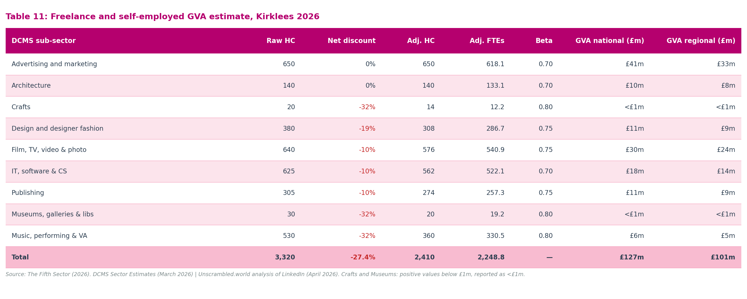
DCMS sub-sector | Raw freelance HC | Net discount | Adjusted freelance HC | Adjusted FTEs | Beta coefficient | Freelance GVA — national rates | Freelance GVA — regional rates
Advertising and marketing | 650 | 0% | 650 | 618.1 | 0.70 | £41m | £33m
Architecture | 140 | 0% | 140 | 133.1 | 0.70 | £10m | £8m
Crafts * | 20 | -32% | 14 | 12.2 | 0.80 | <£1m | <£1m
Design and designer fashion | 380 | -19% | 308 | 286.7 | 0.75 | £11m | £9m
Film, TV, video, radio & photo | 640 | -10% | 576 | 540.9 | 0.75 | £30m | £24m
IT, software & computer services | 625 | -10% | 562 | 522.1 | 0.70 | £18m | £14m
Publishing | 305 | -10% | 274 | 257.3 | 0.75 | £11m | £9m
Museums, galleries & libraries * | 30 | -32% | 20 | 19.2 | 0.80 | <£1m | <£1m
Music, performing & visual arts | 530 | -32% | 360 | 330.5 | 0.80 | £6m | £5m
Total | 3,320 | -27.4% | 2,410 | 2,248.8 | — | £127m | £101m

Combined creative industries GVA
Summing GVA from the two creative workforce components gives the creative industries GVA estimate for Kirklees.
Table 12 presents this combined outcome, showing both the national-rates upper bound and the regionally adjusted lower bound for each component.
Table 12: Creative industries GVA, Kirklees 2026
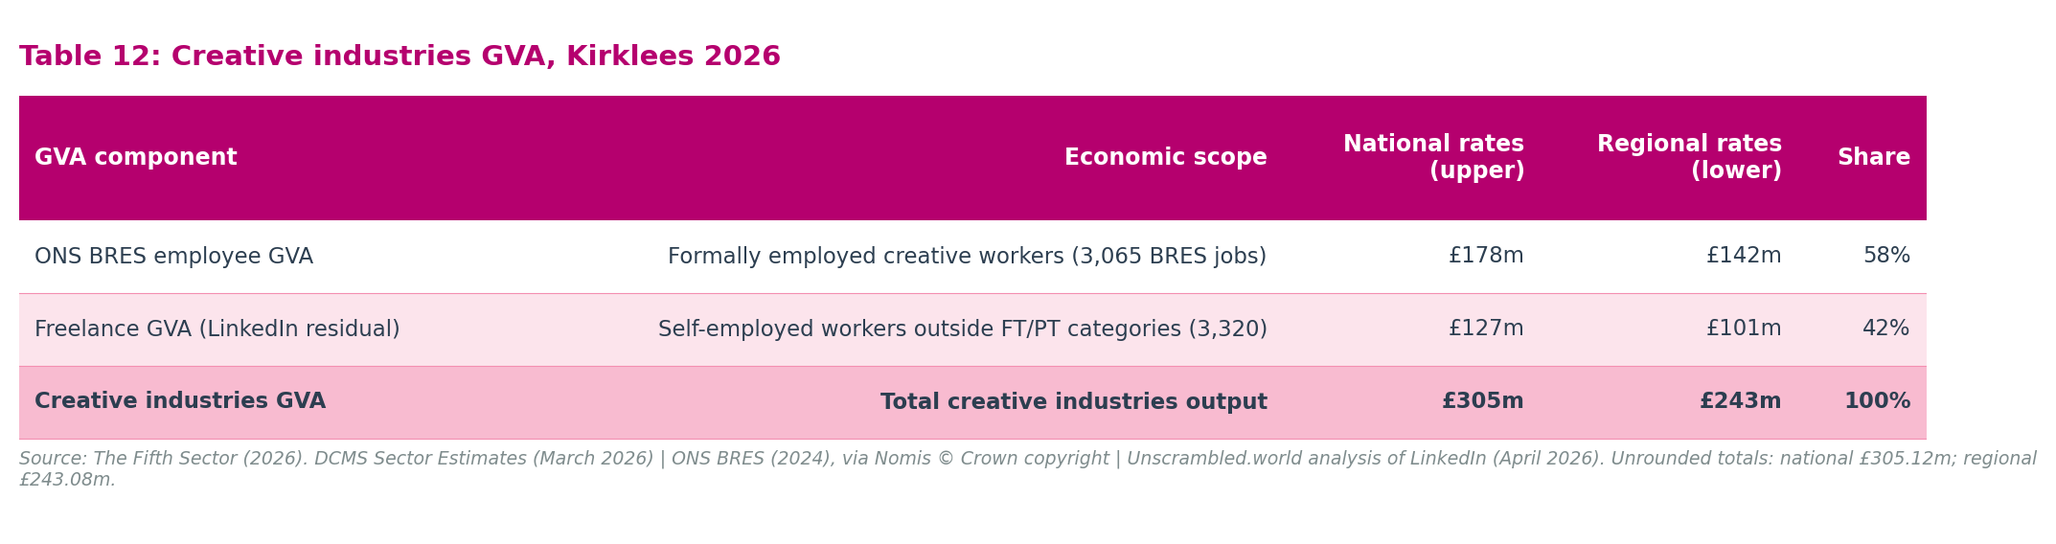
GVA component | Economic scope | National rates (upper bound) | Regional rates (lower bound) | Share of total
ONS BRES employee GVA | Formally employed creative workers (3,065 BRES jobs) | £178m | £142m | 58%
Freelance GVA (LinkedIn residual) | Self-employed workers outside FT/PT categories (3,320) | £127m | £101m | 42%
Creative industries GVA | Total creative industries output | £305m | £243m | 100%

The two-component model shows that independent creative workers account for 42% of creative industries GVA. The 58%:42% split between employee and freelance components is preserved under the scalar adjustment because the same productivity differential applies uniformly to both groups.
Adjacent economy. Alongside the creative industries GVA, Companies House data via The Data City's RTIC analysis identifies 219 businesses in Kirklees operating outside the DCMS creative industries definition but with capability profiles that overlap directly with the creative core. Analysis of Companies House turnover data for these firms, using sector-specific value-added margins, suggests they generated GVA of approximately £80 million to £100 million. This figure uses a turnover-based derivation method and is not directly comparable to the DCMS-framework creative industries GVA above; it is reported as a named adjacent economy second tier, not added to the creative industries total. The combined creative economic footprint, creative industries GVA plus the adjacent economy, is approximately £323 million to £405 million. Chapter 6 develops the investment case the adjacent economy supports.
The previous 2024 report's 2022 GVA estimate of £250.9m is retained in this report for historical context, and is detailed alongside our new model in Appendix A. The difference between the two estimates reflects methodological change, from an experimental scaling model to a standardised, repeatable, and audited framework, not a change in the underlying economy. The two figures are not a trend comparison.

Chapter 5: Sub-sector profiles

Overview
The Chapter 4 GVA analysis produces a creative industries GVA range of £243 million to £305 million. Behind that range lie nine DCMS sub-sectors with markedly different structures: different balances between formal employment and freelance working, different GVA profiles, different data characteristics, and different policy implications. This chapter profiles all nine in turn.
Each section follows a consistent structure: core structural trend, workforce scale, GVA contribution, data interpretation, and geographic footprint. The final section provides an extended case study of Music, performing and visual arts: the sub-sector where the gap between official statistics and actual economic activity is widest, and where the methodological choices in Chapter 4 have the largest proportional effect.
Table 13 provides the combined GVA overview. Sub-sector employee GVA comes from Table 10; freelance GVA from Table 11. Individual figures are rounded independently and may not sum exactly to the totals shown.
Table 13: Creative industries GVA by sub-sector, Kirklees 2026
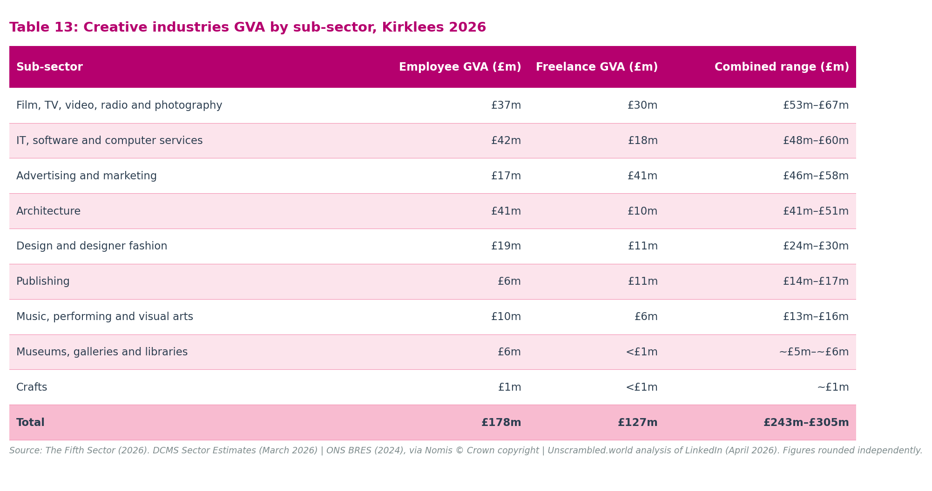
Sub-sector | Employee GVA (£m) | Freelance GVA (£m) | Combined GVA range (£m)
Film, TV, video, radio and photography | £37m | £30m | £53m–£67m
IT, software and computer services | £42m | £18m | £48m–£60m
Advertising and marketing | £17m | £41m | £46m–£58m
Architecture | £41m | £10m | £41m–£51m
Design and designer fashion | £19m | £11m | £24m–£30m
Publishing | £6m | £11m | £14m–£17m
Music, performing and visual arts | £10m | £6m | £13m–£16m
Museums, galleries and libraries | £6m | <£1m | ~£5m–~£6m
Crafts | £1m | <£1m | ~£1m
Total | £178m | £127m | £243m–£305m

Figure 10: Creative industries GVA by sub-sector, Kirklees 2026 (national rates, two-component model)
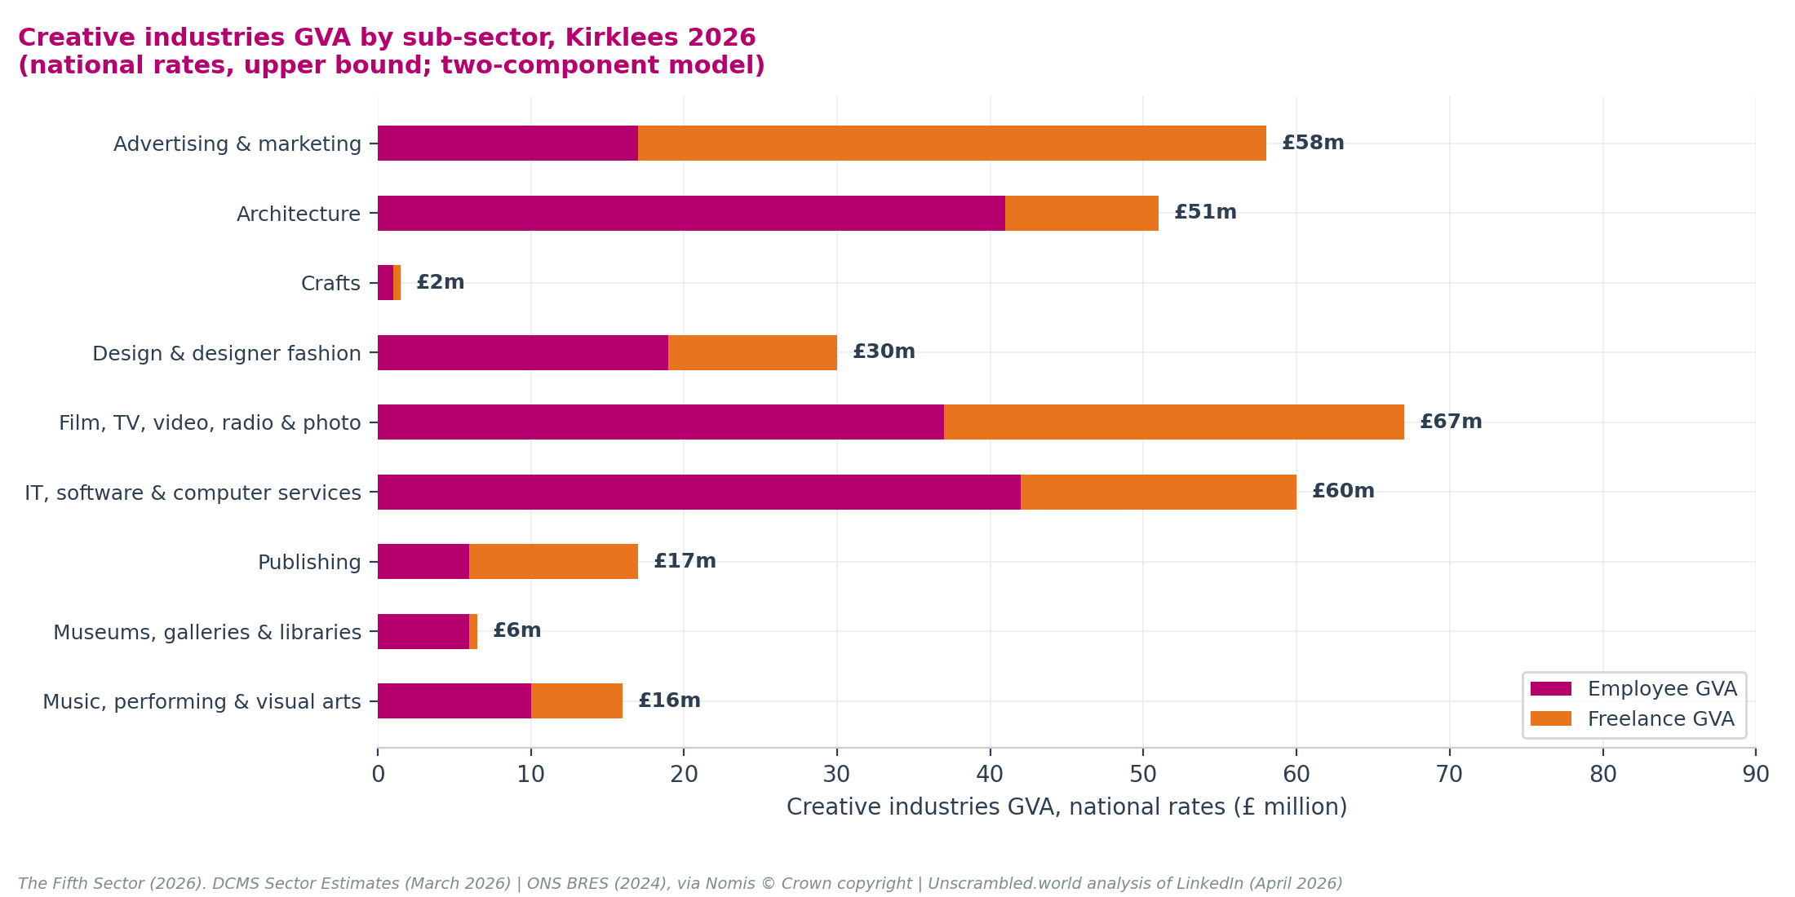
Film, TV, video, radio and photography (£53m–£67m) is the largest sub-sector by combined GVA and the sub-sector where the estimate is most robustly anchored, both BRES and LinkedIn show growth, and the figure depends on no data artefact. IT, software and computer services (£48m–£60m) is the largest by employee-based GVA (£42m), reflecting the high headcount after the SIC 62020 creative filter. Advertising and marketing (£46m–£58m) has the largest freelance cohort (650 practitioners, £41m) but the most significant BRES uncertainty; the employee GVA of £17m likely understates the true payroll contribution. Architecture (£41m–£51m) has the closest BRES–LinkedIn alignment and the highest GVA-per-employee rate (£103,500). Design (£24m–£30m), Publishing (£14m–£17m), and Music (£13m–£16m) are the fastest-growing sub-sectors in the 2026 data. Museums and Crafts complete the picture: their absolute GVA is smaller, but their policy significance is disproportionate to their economic scale.

Advertising and marketing

Core structural trend: stability masked by an administrative payroll anomaly.
Advertising and marketing presents the clearest example in this report of the BRES directional reliability problem. BRES payroll employment fell by 73.1% between 2022 and 2024, from 670 to 180 jobs. Taken at face value, this would indicate the effective erasure of a major sub-sector. Active companies grew by 15.8% over the same period, and the LinkedIn workforce expanded by 7.7% to 2,580 profiles. The BRES movement is assessed as an administrative artefact, most likely a reclassification of payroll entries or a single large firm's address migration, and the physical footprint of advertising activity in the district is stable. This assessment is corroborated by growth in company registrations and LinkedIn profiles but has not been independently verified; it is the stronger of two hypotheses, not a confirmed determination.
Combined GVA of approximately £46 million to £58 million reflects employee-based GVA of £17 million from 180 BRES jobs and freelance GVA of £41 million from 650 independent practitioners, the second-largest freelance cohort in the model. The employee-based figure likely understates the sector's payroll contribution: if the true payroll base is closer to the 2022 figure (670 BRES jobs), employee GVA rises to approximately £63 million. The 1,750 full-time and part-time workers visible in LinkedIn data but outside BRES payrolls are a known exclusion; their existence is real but their scale is inseparable from the BRES outlier, and they are not modelled in the current estimate. The freelance GVA of £41m is independently anchored to the self-reported LinkedIn residual and does not depend on the BRES baseline.
Geographic footprint: business registration patterns suggest corporate agency activity is likely concentrated in central Huddersfield and technology park corridors, with a dispersed freelance cohort across the Holme and Colne valleys.

Architecture

Core structural trend: exceptional structural alignment and high-value professional output.
Architecture is the sub-sector in this report where BRES and LinkedIn data align most closely, confirming both directional and level reliability. BRES records 400 employee jobs; LinkedIn identifies 550 profiles, a gap of 150 representing the lowest proportional BRES undercount (27%) of any sub-sector. This convergence reflects the occupational structure of architectural practice: a profession with comparatively high rates of PAYE employment relative to other creative disciplines.
Employee-based GVA of £41 million is the second-largest employee GVA in the table, driven by the highest GVA-per-employee rate (£103,500) in the model. Freelance GVA adds a further £10 million from 140 independent practitioners, the smallest freelance cohort in the model. Combined GVA of approximately £41 million to £51 million makes architecture the fourth-largest sub-sector by total economic output.
The 63.3% growth in BRES employee jobs (from 245 to 400 since 2024) is treated as directionally reliable. The BRES increase of 155 jobs could be the result of additional recruitment within one of the larger companies in the sector, but it is also consistent with the growth in registrations observed during the period. This expansion is consistent with the district's pipeline of heritage restoration, mill conversion, and public capital schemes including the Huddersfield Cultural Heart development.
Geographic footprint: business registration data indicate practices are concentrated in Huddersfield town centre, consistent with the district's Victorian heritage stock, mills restoration work, and local authority capital regeneration activity.

Crafts

Core structural trend: an active micro-maker scene with limited measurable formal economic scale.
Crafts is the most evidence-thin sub-sector in this report. The sector has 15 active businesses and 120 LinkedIn profiles, the smallest counts of any sub-sector. A 60% LinkedIn decline (from 300 to 120 profiles) reflects a platform reclassification shift rather than physical contraction: independent artisans have migrated to broader visual arts categories. The underlying making activity has not contracted.
Employee-based GVA of approximately £1 million (from 20 BRES jobs at £43,692 per employee) and freelance GVA below £1 million (from 14 active practitioners after discounting) give a combined GVA of approximately £1 million. This is the least robust sub-sector estimate in the report. Official surveys and LinkedIn alike undercount crafts significantly due to high sessional and off-payroll working patterns, the prevalence of micro-enterprises below all registration thresholds, and the partial shift of crafts activity to broader platform categories.
The economic contribution of the crafts sector is real and culturally significant, particularly in the Holme Valley around Holmfirth, where independent workshops, micro-galleries, and sessional maker-spaces support a dense network of makers. The data do not capture its full scale.

Design and designer fashion

Core structural trend: confirmed expansion across corporate and independent markets.
Design and designer fashion shows the strongest cross-source corroboration of any growth story in this report. BRES employment grew by 36.4% (from 275 to 375 jobs) and LinkedIn profiles grew by 39.2% (from 1,160 to 1,615). Where two independent sources move in the same direction at comparable magnitudes, the growth signal is treated as genuine. This sub-sector is expanding on a confirmed basis.
Combined GVA of approximately £24 million to £30 million reflects employee-based GVA of £19 million from 375 BRES jobs and freelance GVA of £11 million from 308 active independent practitioners (after a 19% portfolio overlap and activity discount). The GVA-per-employee rate of £49,867 is mid-range. Growth is confirmed across both employment and the freelance base. A further 860 full-time and part-time workers are visible in LinkedIn data but outside BRES payrolls; their GVA is not modelled in the current estimate.
The district's textile manufacturing heritage connects directly to this growth. Design expertise has pivoted from industrial production to digital product design, brand design, and fashion: a structural transition confirmed by the LinkedIn growth pattern.
Geographic footprint: the district's textile heritage suggests concentration is likely in Batley, Dewsbury, and the Colne Valley, where design expertise has evolved alongside the advanced manufacturing base. Independent fashion designers and digital practitioners are more widely dispersed.

Film, TV, video, radio and photography

Core structural trend: a growing freelance media engine connected to regional supply chains.
Film, TV, video, radio and photography is now the largest creative sub-sector by combined GVA and the sub-sector where the estimate is most robustly anchored, contributing approximately £53 million to £67 million. Employee-based GVA of £37 million comes from 500 BRES jobs at £73,125 per employee, the second-highest GVA-per-employee rate in the model. The freelance cohort of 576 adjusted practitioners (from 640 raw, after a 10% taxonomy leakage discount) generates £30 million. A further 285 full-time and part-time workers are visible in LinkedIn data but outside BRES payrolls; their GVA is not modelled in the current estimate.
BRES records 500 employee jobs; LinkedIn identifies 1,425 profiles. The gap of 925 profiles, representing 65% of the LinkedIn total, confirms that this is a predominantly freelance media sector: only 35% of the local media workforce appears on a formal payroll. Both BRES and LinkedIn show growth, providing directional confirmation of genuine expansion.
The GVA-per-employee rate (£73,125) is the second highest in the table after Architecture, reflecting the capital intensity of media production and the corporate payroll structure of broadcasting enterprises. Sector analysis suggests media activity is likely concentrated in central Huddersfield and along the trans-Pennine transport corridor, positioning local freelancers and production companies to service major broadcasting hubs in Leeds, Manchester, and Salford.

IT, software and computer services

Core structural trend: high-value corporate software development driving local payroll GVA.
IT, software and computer services is the largest sub-sector by employee-based GVA, contributing £42 million from 840 filtered BRES employee jobs. The filtering is significant: the raw DCMS-classified BRES count is 1,310, but 470 employees in SIC 62020 (Computer consultancy) are excluded as non-creative corporate IT consultants, using the 47% non-creative filter based on ONS BRES microdata. The retained 840 jobs represent genuine creative software development and IT services work. The scenario range for this filtering (£151.6m at full SIC 62020 exclusion to £202.1m at full inclusion) and its effect on the overall creative economy estimate are documented in Appendix A8.
Combined GVA of approximately £48 million to £60 million reflects both the large formal payroll and a freelance cohort of 562 adjusted independent practitioners generating £18 million in GVA. BRES (1,310) exceeds LinkedIn FT+PT (1,060) in this sub-sector, confirming that formal payroll employment is the dominant mode; there is no LinkedIn gap population to model. LinkedIn growth of 1.2% (1,665 to 1,685) is the most subdued of any sub-sector, suggesting expansion is consolidating in formal employment rather than the freelance base.
Geographic footprint: business registration data indicate concentration in Huddersfield town centre, near the University of Huddersfield and local incubator and technology park facilities.

Publishing

Core structural trend: transition from corporate payrolls to digital freelance platforms.
Publishing shows a structural transformation: declining formal corporate employment alongside rapid growth in independent digital content creation. BRES employee jobs contracted; active business count fell by 15.8%; but the LinkedIn workforce grew by 48.4% (from 455 to 675 profiles), the highest LinkedIn growth rate of any sub-sector.
Combined GVA of approximately £14 million to £17 million reflects two components: employee-based GVA of £6 million (from 95 BRES jobs at £58,793 per employee) and freelance GVA of £11 million (from 257 active independent practitioners capturing growth in digital publishing, self-publishing, and freelance content writing). Freelance output exceeds employee output, making Publishing the sub-sector where the formal payroll is the smaller of the two components. A further 275 full-time and part-time workers are visible in LinkedIn data but outside BRES payrolls; their GVA is not modelled in the current estimate.
Geographic footprint: sector analysis suggests dispersal throughout the rural valleys, with likely concentrations of freelance writers, editors, and digital publishers in the Holme Valley and the Hebden Bridge fringe.

Museums, galleries and libraries

Core structural trend: public sector institutional employment underrepresented by corporate indexes.
Museums, galleries and libraries occupies a distinct position in the DCMS framework: its institutions are publicly managed or governed by charitable trusts. Standard company registers return a zero business count. This report substitutes ONS IDBR data (20 active institutions) to capture local-authority-controlled libraries and public museums, which do not appear as active Companies House entities.
Employee-based GVA of £6 million (from 195 BRES employee jobs at £30,545 per employee, the lowest GVA-per-employee rate in the table) reflects the predominantly public sector wage structure of institutional cultural employment. Freelance GVA is below £1 million (from 20 active independent practitioners after a 32% discount for the high proportion of volunteer and non-commercial activity). BRES (195) exceeds LinkedIn FT+PT (65) in this sub-sector, reflecting the low LinkedIn engagement rate of public sector museum and library workers who are fully captured by employer PAYE returns; there is no LinkedIn gap population to model. Combined GVA is approximately £5 million to £6 million.
This figure understates the sub-sector's economic contribution in one specific respect: museums and libraries generate significant indirect economic value through visitor economy effects, place-making, and cultural infrastructure provision. These wider impacts are outside the scope of direct GVA measurement.
Geographic footprint: institutions are bound to their physical municipal locations. Key sites include Huddersfield Art Gallery, Tolson Museum, Bagshaw Museum in Batley, and the Carnegie library network across the district, which collectively anchor the district's public cultural infrastructure.

Music, performing and visual arts: extended case study
Music, performing and visual arts warrants extended examination for a specific reason: it is the sub-sector where the gap between what official statistics show and what is actually happening on the ground is widest. BRES records 460 formal employee jobs. LinkedIn identifies 1,560 creative workers. The gap of more than 1,100 profiles, representing 71% of the LinkedIn total, is the largest proportional BRES undercount of any sub-sector in this report. It arises directly from the nature of the sector: a workforce built on sessional engagements, portfolio practice, and self-employment that sits structurally outside formal payroll returns.
This matters for GVA. An employee-based model that stops at BRES captures £10 million from formal employment but misses the independent freelance contribution. The two-component combined estimate of £13 million to £16 million is a more complete picture, but it still depends on the sessional discounting and freelance productivity methodology in Chapter 4, which is at its most consequential here. A further 570 full-time and part-time workers are visible in LinkedIn data but outside BRES payrolls; their GVA is not modelled in the current estimate.

Workforce scale and supply chains
Table 14: Music, performing and visual arts: key figures, Kirklees 2024 and 2026
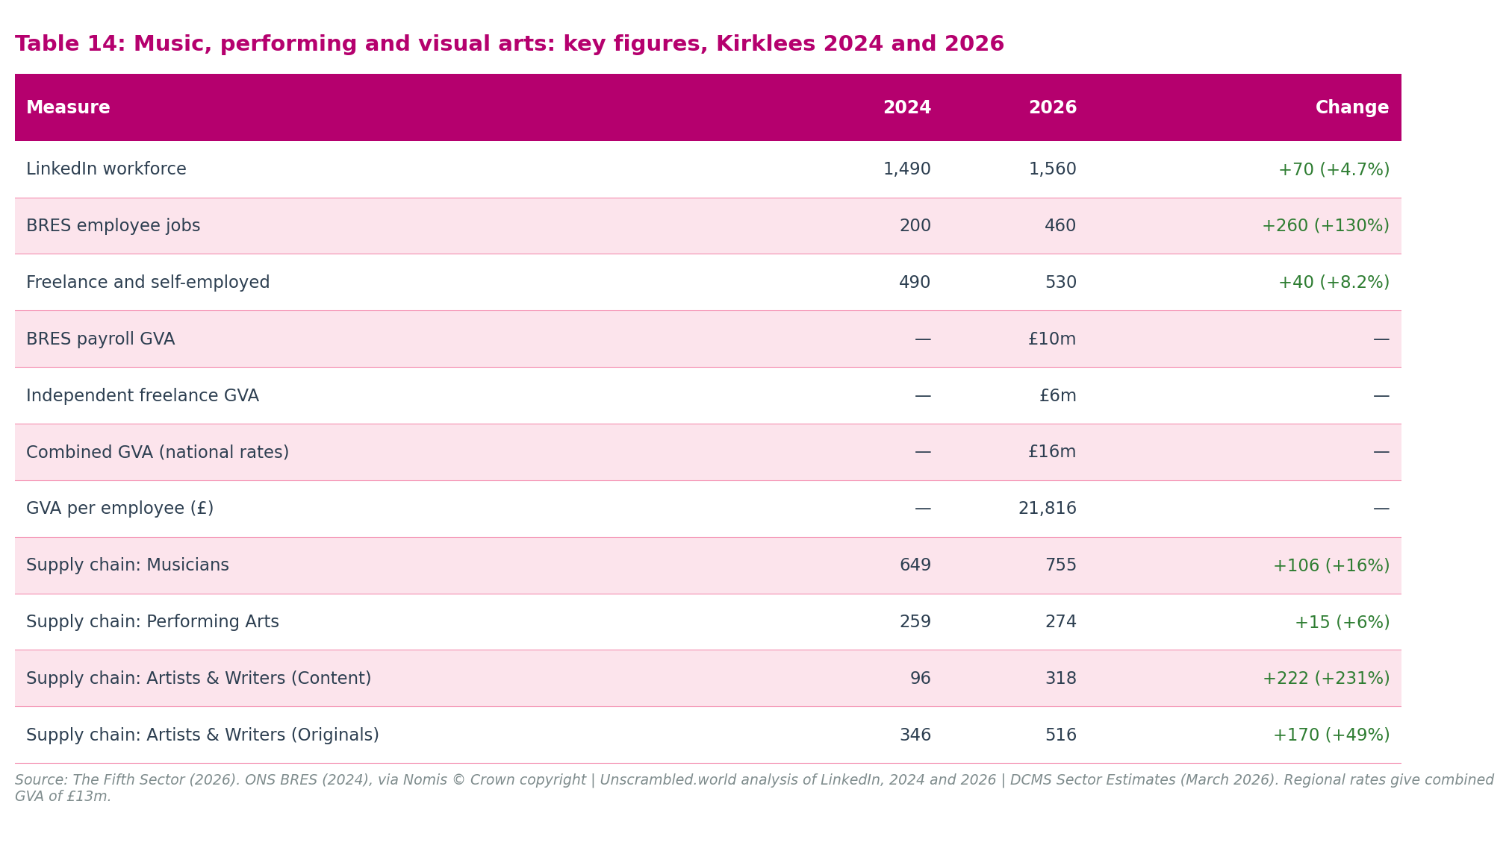
Measure | 2024 | 2026 | Change
LinkedIn workforce | 1,490 | 1,560 | +70 (+4.7%)
BRES employee jobs | 200 | 460 | +260 (+130%)
Freelance and self-employed | 490 | 530 | +40 (+8.2%)
BRES payroll GVA | — | £10m | —
Independent freelance GVA | — | £6m | —
Combined GVA | — | £16m | —
GVA per employee (£) | — | 21,816 | —
Supply chain: Musicians | 649 | 755 | +106 (+16%)
Supply chain: Performing Arts | 259 | 274 | +15 (+6%)
Supply chain: Artists and Writers (Content chain) | 96 | 318 | +222 (+231%)
Supply chain: Artists and Writers (Originals chain) | 346 | 516 | +170 (+49%)

Sources: LinkedIn Corporation, LinkedIn, 2024 and 2026 snapshots; Office for National Statistics, Business Register and Employment Survey (BRES) 2024, via Nomis (© Crown copyright); The Fifth Sector analysis of ONS BRES 2024 and DCMS Sector Estimates. Supply chain figures from LinkedIn, 2024 and 2026 snapshots. BRES payroll GVA (£10m) plus freelance GVA (£6m) rounds to the combined music GVA of £16m at national rates; regional rates give £13m.
The LinkedIn workforce of 1,560 in 2026 makes music, performing and visual arts one of the larger creative sub-sectors, broadly comparable to IT, software and computer services (1,685), Design and designer fashion (1,615), and Film, TV, video, radio and photography (1,425), and well ahead of Architecture (550). The sub-sector has grown steadily from 1,490 in 2024 (+4.7%), with organic growth anchored in the 16% increase in active musicians (649 to 755 profiles).
BRES also shows strong growth in this sub-sector, from 200 to 460 employee jobs (+130%). The directional consistency between LinkedIn and BRES is a positive signal: where both sources move in the same direction, the evidence of real-world change is stronger. Even so, 460 employee jobs represents 29% of the LinkedIn total, confirming that a substantial share of music practitioners operate outside formal payroll employment.

A predominantly freelance and portfolio workforce
The freelance and self-employed figure of 530 for Music, performing and visual arts represents 16% of the total freelance creative workforce, consistent with the sub-sector's share of the broader LinkedIn total. It has grown by 8.2% since 2024, demonstrating stable growth alongside the wider sub-sector.
This reflects the structural realities of the music and performing arts economy. Musicians, visual artists, performers, and theatre-makers typically work across multiple engagements, income streams, and employer relationships simultaneously. A working musician might perform with a local orchestra, teach peripatetic music lessons in schools, compose for film or advertising, and sell recordings, holding several roles simultaneously, none of which appears in a single employer's BRES return. This portfolio model is the sector's normal operating mode.
The figure should be treated as an indicative estimate. It is derived from LinkedIn employment-type data as the residual when full-time and part-time classifications are subtracted from the sub-sector total, capturing profiles classified as self-employed, freelance, contractor, student, or without a recorded employment type.
Two qualifications apply. First, the residual is heterogeneous: it is not exclusively self-employed and freelance workers, but also includes contractors, students, interns, and unclassified profiles. Second, the sub-sector comparison of LinkedIn FT+PT against BRES (Chapter 3) shows that many of the 860 Music profiles classified as full-time on LinkedIn are practitioners who work full-time in their creative practice on a self-employed or portfolio basis. The 530 figure therefore understates the true scale of self-directed working in this sub-sector. The true number of freelance, self-employed, and portfolio music and performing arts workers is unknown; 530 is best understood as a conservative lower bound.

Supply chain structures
The supply chain classification provides additional detail on the composition of the workforce. Musicians, the largest single supply chain category, grew from 649 to 755 profiles, followed by Performing Arts (274, up from 259). The Artists and Writers category appears in two supply chains: as Content (318 profiles, up from 96) and as Originals (516, up from 346). The growth in the Content chain reflects a reorientation of creative practice towards content production.
Supply chain categories overlap, so individual chain counts cannot be summed to produce a workforce total. The deduplicated sub-sector picture shows modest, steady growth of 70 profiles (+4.7%) since 2024, distributed across musicians, performing artists, and visual artists and writers.

Combined GVA and freelance output
The combined economic output of music, performing and visual arts is £13 million to £16 million, combining employee-based GVA of £10 million (derived from 460 BRES employee jobs at a national DCMS GVA-per-employee rate of £21,816) with freelance GVA of £6 million.
This rate is the lowest in the baseline table: less than a quarter of the rate for Architecture (£103,500) and less than half that for Advertising and marketing (£93,727). This low rate reflects the sessional, part-time structure of formal performing arts employment nationally. Because most local musicians and performers operate outside formal PAYE payrolls, a BRES-only GVA model severely underrepresents the sector's scale.
The freelance addition, derived through the sessional discounting and productivity model in Chapter 4, represents a 60% increase above the employee-based total, confirming that independent, self-directed working is the dominant mode in this sub-sector's economy.
The previous 2024 report baseline (using 2022 ONS data) included a separate historical estimate of £11.5m for music-related occupations in non-creative sectors (such as peripatetic music teachers employed by schools, or sound technicians working for non-creative events firms). This figure, derived from LinkedIn creative occupations data (346 workers at a DCMS GVA per capita rate of £33,325), is retained for reference and is detailed in Appendix A. This historical occupation-based estimate is distinct from the 2026 freelance GVA model.
The combined estimate is likely to understate the sub-sector's true economic contribution: it is a structured baseline, not a ceiling.

What the music sub-sector tells us about the broader creative economy
The Music, performing and visual arts picture illustrates a challenge that runs across the creative economy as a whole, but is most acute here: the most dynamic parts of a creative economy are often the least well-measured. A creative economy built substantially on freelance, portfolio, and self-directed work generates real value, for workers, for audiences, for local supply chains, that does not register fully in employment surveys, business registers, or employee-based GVA calculations.
The appropriate response is to use formal measures alongside broader ones: LinkedIn workforce data, freelance workforce estimates, and supply chain analysis, with explicit acknowledgement of what each captures and what it excludes. The case in Chapter 6 for using the full multi-source evidence base to press the investment case for Kirklees rests in large part on this sub-sector, where the gap between what official statistics show and what is actually happening on the ground is widest.

Chapter 6: Implications and recommendations

The £62 million growth opportunity
The evidence base established in this report positions Kirklees' creative economy at a scale that warrants strategic investment. Creative industries GVA of £243 million to £305 million, with £127 million generated by the 3,320 independent freelance practitioners who make up 42% of creative sector output: these are methodologically transparent totals derived from published national productivity rates and corroborated across three independent data sources. Adding the adjacent economy, a group of 219 companies with a skills and workforce profile similar to other digital-creative businesses generating approximately £80 million to £100 million in GVA, gives a combined creative economic footprint of approximately £323 million to £405 million for Kirklees.
The £62 million gap between the two bounds of the creative industries range is the central finding of this chapter. At national productivity rates, Kirklees' creative workforce generates £305 million; at the ONS regional productivity index for Calderdale and Kirklees, the same workforce generates £243 million. That gap measures the economic cost of Kirklees' productivity differential with the UK average, and closing it is the growth opportunity this chapter addresses.
The 2026 evidence base, and the commitments in the Creative Industries Sector Plan (DCMS, 2025), are sufficient to frame three strategic priorities now.
The Sector Plan commits £100 million to R&D creative clusters, £150 million in place-based Creative Industries investment devolved to Mayoral Strategic Authorities including West Yorkshire, and a suite of finance access and skills interventions targeted at the freelance and micro-business creative workforce. Those commitments create a specific, time-limited window for Kirklees to act. Three recommendations follow. Together they address the two components of the productivity gap: the skills and capability investment that enables practitioners to generate more value from their creative work; and the finance access infrastructure that allows businesses to invest in their own growth. A third recommendation positions Kirklees within the national Createch growth programme, addressing the adjacent economy opportunity alongside the core creative sector.
The geographic equity agenda (ensuring that the benefits of the creative economy reach Dewsbury, Batley, Holmfirth, and the wider district beyond central Huddersfield) is addressed within each of the three recommendations rather than as a standalone fourth. Sub-district geographic mapping of the creative workforce remains a gap in the evidence base and is identified in the closing section of this chapter as a priority for the next reporting cycle.

Recommendation 1: Build the skills base for a more productive creative economy
The 2026 data identify skills as the primary productivity lever in Kirklees' fastest-growing creative sub-sectors. Design and designer fashion (+39%), Publishing (+48%), and Film, TV, video, radio and photography (+17%) are workforce-growth sectors whose practitioners need advanced digital capability, AI tool fluency, IP management, and the entrepreneurial and financial skills that make independent working sustainable and scalable. The Music, performing and visual arts sub-sector (1,560 LinkedIn profiles, 530 freelancers, combined GVA of £13 million to £16 million generated predominantly by sessional and portfolio practitioners) has a sustained skills demand that extends throughout working life rather than concentrating at the point of qualification.
The University of Huddersfield and Kirklees College are the anchor institutions for creative skills delivery in the district. UoH's music, creative arts, and digital technology programmes feed directly into the workforce pipeline evidenced in this report; Kirklees College's further education offer is the primary route for practitioners who are not degree-level learners. The Creative Industries Sector Plan (DCMS, 2025) commits to a refreshed UK-wide £9 million creative careers service and a national Growth and Skills offer with greater flexibility for small businesses and learners; Kirklees should position its practitioners to access both. The Sector Plan's £30 million music growth package includes an emerging artists strand that is directly relevant to the music and performing arts pipeline.
- Connect practitioners to existing skills provision and close the reach gap. UoH's continuing professional development offer, Kirklees College's creative skills curriculum, and the national creative careers service together constitute a substantial skills infrastructure. The provision exists; the gap is reach. The 3,320 freelancers and sessional practitioners who are not enrolled students or payroll employees are not systematically reached by any of these routes. Creative Bubbles is the most effective existing channel for skills signposting to that population; its extended mandate under Recommendation 2 should include a skills access strand connecting participants to UoH CPD, Kirklees College short courses, and the creative careers service on launch.
- Differentiate the skills offer by working pattern. For sub-sectors where formal employment dominates (IT and architecture): advanced digital certifications, AI applications, and professional development aligned with corporate employment pathways. For sub-sectors where portfolio and freelance working is the predominant pattern (film and television, advertising and marketing, design, publishing, music and performing arts): business planning, tax management, IP protection, and freelance entrepreneurship training. Film and television is not an exception: freelance and portfolio working is the predominant mode of engagement in screen production, and skills provision should reflect that. These are distinct provision needs requiring differentiated delivery approaches.
- Extend skills provision across the district. Skills investment should reach Dewsbury, Batley, Holmfirth, and Cleckheaton as well as central Huddersfield, through outreach from UoH and Kirklees College, through Creative Bubbles' geographic extension under Recommendation 2, and through dispersed physical infrastructure. The sub-sector geographic footprints set out in Chapter 5 point to creative workforce concentrations in the Holme Valley, the Batley-Dewsbury corridor, and along the trans-Pennine axis whose skills needs the current institutional offer does not systematically reach.

Recommendation 2: Reinvest in Creative Bubbles as Kirklees' creative business support and finance access programme
Independent creative workers in Kirklees generate £127 million in GVA, 42% of total creative industries output. The 3,320 LinkedIn residual self-employed practitioners sit entirely outside formal payroll structures, alongside approximately 3,830 additional portfolio workers visible in LinkedIn data but outside BRES payrolls whose GVA is not currently modelled. Taken together, the self-directed creative workforce substantially exceeds the formally employed creative workforce in scale. Formal business support structures, calibrated to payroll employers and growth-stage companies, consistently underserve this population.
The Creative Kirklees network provides the framework within which Kirklees' creative businesses and practitioners are visible to each other and to local institutions: a signposting, directory, and connecting function that gives the sector a shared identity. Creative Bubbles, delivered by Wilson's Republic CIC, provides the programme delivery layer: peer-led business support through which freelancers, micro-businesses, and creative practitioners share challenges, build professional confidence, and develop collaborative connections. Together they constitute the most important practitioner-facing infrastructure in the district. That infrastructure warrants sustained investment and an extended mandate.
Peer community and business confidence are the foundation; routes to specialist professional services and finance access are the next tier. The Creative Industries Sector Plan (DCMS, 2025) commits to improving creative businesses' access to finance through increased British Business Bank support, a new working group on IP-backed lending, and an industry-led "single front door" for creative firms seeking private investment. Creative Bubbles is the natural local delivery channel for these national commitments in Kirklees.
- Sustain and extend Creative Bubbles as the primary delivery vehicle. Wilson's Republic CIC's peer-led model reaches the freelancers and micro-businesses that formal business support structures consistently miss. Sustained investment should maintain and extend the programme's geographic reach across the district, including Dewsbury, Batley, and Holmfirth as well as central Huddersfield.
- Extend Creative Bubbles' mandate to include investment readiness and finance access. Develop a dedicated strand connecting participants to specialist professional services (freelance tax advice, IP protection, and contract guidance), business development support appropriate for businesses approaching the scale-up threshold, and finance access mechanisms including the British Business Bank's creative industries programme and the Sector Plan's forthcoming "single front door" for creative firms. Commission a financial needs assessment in partnership with Creative Bubbles to establish the specific barriers facing Kirklees' freelancers and micro-businesses, and to identify the finance products most relevant to the district's sub-sector profile.
- Use Creative Bubbles as Kirklees' evidence base for engagement with WYCA on creative finance access. The West Yorkshire Combined Authority's allocation from the Creative Places Growth Fund includes access to finance and mentoring within its scope. Kirklees' position within that allocation is not yet confirmed; engagement with WYCA is one potential route through which the Creative Bubbles programme could be resourced and extended. The financial needs assessment described above would strengthen that engagement by providing specific local evidence of barriers and population scale. Separately, investment in dispersed, low-cost maker-spaces and tool-sharing hubs in Dewsbury, Batley, and Holmfirth remains a valid long-term capital objective, appropriately taken through the WYCA Culture, Heritage and Sport strategy and local planning frameworks, and distinct from the revenue investment required to sustain Creative Bubbles.

Recommendation 3: Invest in growth sub-sectors and position Kirklees as a Createch node
The 2026 data present a more differentiated sub-sector picture than the 2024 report. The earlier analysis over-interpreted digital growth by relying on unfiltered company registrations; applying The Data City's machine-learning RTIC classification has removed non-creative corporate IT consultancy from the count, producing a cleaner and more reliable baseline. Against that corrected baseline: Design and designer fashion (up 39%) and Publishing (up 48%) are the two fastest-growing sub-sectors and merit sustained co-investment. Film, TV, video, radio and photography (up 17%) shows solid, credible growth and provides the primary screen technology hook for the national R&D bid case set out below. Music, performing and visual arts presents a different picture: a large, stable workforce base with the widest gap between official and actual workforce measurement of any sub-sector (71% of the LinkedIn workforce sits outside BRES payroll counts), a combined GVA of £13 million to £16 million that remains a conservative floor on the sub-sector's true contribution, and an investment case for live music infrastructure, music tourism, and a development pathway from grassroots practice to professional careers that sits alongside the skills and finance access recommendations above.

National R&D bid case: Kirklees as a Createch node
The Creative Industries Sector Plan (DCMS, 2025) introduces Createch as a distinct growth category: creative innovation combined with cutting-edge technology to generate novel products, services and experiences. Createch businesses are projected to generate £18 billion in GVA and 160,000 jobs nationally over the next decade, and are a central target of the £100 million UKRI investment in R&D creative clusters committed in the Spending Review. Three convergent elements position Kirklees to make a credible case within this programme.
The creative sector provides the economic baseline. Creative industries GVA of £243 million to £305 million, 10,305 workers, and a Film, TV, video, radio and photography sub-sector generating £53 million to £67 million in GVA: these are methodologically transparent figures derived from published DCMS productivity rates and corroborated across multiple data sources. They provide sufficient evidential grounding to anchor a national bid narrative.
An adjacent business population constitutes Kirklees' identifiable Createch cohort. Companies House data, identified through The Data City's RTIC analysis, identifies 219 businesses in Kirklees operating outside the DCMS sub-sector definitions whose capability profiles span Createch-relevant RTICs: Agency Market, Software Development, Digital Creative Industries, Immersive Technologies, Cyber, Cloud Computing, and Data Infrastructure. Analysis of Companies House turnover data suggests these firms generated GVA of approximately £80 million to £100 million. They are excluded from the creative economy GVA estimate on the same principle applied within the sector: Createch capability alone does not make a firm a DCMS creative business, and these firms are not claimed as part of the £243 million to £305 million creative industries range. A further 444 of the 1,690 active creative businesses hold hybrid RTIC profiles, combining DCMS creative sub-sector capabilities with Createch-relevant digital infrastructure capabilities. The formal creative sector and its Createch-capable adjacent firms are largely unaware of each other; that interface is the knowledge exchange pipeline that UKRI's cluster programme was designed to catalyse, and that the Sector Plan identifies as central to the national Createch growth ambition. Spilsbury (2015) maps this boundary at national scale.
An adjacent digital workforce provides a concrete Createch talent base. The firm-level picture is complemented by a workforce-level dimension directly visible in LinkedIn data. A sixth LinkedIn supply chain, IT Services and Consulting, identifies 3,395 Kirklees-based workers outside the five creative supply chains and outside the DCMS classification. They are not counted in creative economy GVA. Of the 3,395, approximately 1,595 (47%) are algorithmically classified as consultants, the same boundary applied in the SIC 62020 BRES filter. The remaining 1,800 are IT services practitioners, software developers, digital producers, information architects, whose work sits at the creative-digital boundary. The most significant feature of this cohort is its job role distribution: 1,446 of the 3,395 (43%) self-describe their function as Creative and Production, a higher rate than in four of the five creative supply chains. A further 946 (28%) are open to new opportunities, 406 (12%) are founders or directors, and 472 were recruited in the past year, an entrepreneurially active, mobile, experienced workforce with 51% reporting ten or more years' experience. Many in this cohort will be employed by or contracting to the adjacent businesses identified through RTIC analysis; the two evidence streams describe the same Createch interface from the firm side and the worker side simultaneously. The formal creative sector is almost entirely unaware of this adjacent digital workforce. A structured engagement programme mapping which adjacent firms they work for, which creative-digital skills they hold, and which research questions a consortium could pursue together is the preparatory action that would most strengthen Kirklees' Createch bid position before the next UKRI cluster programme deadline. The full workforce profile is presented in Appendix A10.
The University of Huddersfield brings confirmed research capacity and a live Kirklees partnership. CeReNeM's audio-immersive technology facilities constitute internationally competitive Createch R&D infrastructure: the 52-channel HISS (Huddersfield Immersive Sound System), the 25.4-channel SPIRAL spatialisation studio, and the Creative Coding Lab support a body of work spanning experimental film, sonic installation, projection mapping, and commercial audio applications. This aligns directly with CoSTAR's convergent screen-technology scope and with the Sector Plan's explicit prioritisation of screen and performance technology as national growth sub-sectors. CEADA is currently delivering AHRC-funded, place-based creative work inside Kirklees: the "Cultures of Film" (2026) participatory filmmaking programme, funded through the AHRC Creative Communities initiative, involves Kirklees Council, Kirklees Museums and Galleries, Kirklees Libraries, KLTV, and hoot Creative Arts as named partners. This active university–local authority–creative sector collaboration, with a confirmed AHRC funding trail, constitutes a proof-of-concept for the place-based knowledge exchange that a Createch cluster bid would need to demonstrate. No confirmed CoSTAR or Creative Industries Cluster Programme membership has been identified in public sources; direct enquiry with UoH is the first action required.
The 3M Buckley Innovation Centre (3M BIC), a University of Huddersfield subsidiary on Firth Street in Huddersfield town centre, provides supporting physical infrastructure. Part-funded at inception by ERDF and Kirklees Council, and listed on the Creative Kirklees directory, it offers flexible office and lab space, prototyping facilities on Innovation Avenue (including additive manufacturing and 3D visualisation), and structural knowledge-exchange links to the University. Its current tenant base is not primarily creative-digital; it functions as a delivery and scale-up partner rather than a lead anchor for a Createch cluster bid.
Kirklees sits on the trans-Pennine corridor between Leeds and Manchester, two of the largest creative clusters in the UK outside London. The Creative Industries Sector Plan explicitly backs the growth corridor across the Northern city regions as a national investment priority. A Createch bid from Kirklees is most compelling as a component of a West Yorkshire-wide cluster proposition, drawing on complementary strengths: Huddersfield's audio-immersive technology research and adjacent manufacturing base; Leeds' screen production and post-production capacity; and the wider West Yorkshire creative economy evidenced by this report. That positioning also aligns with WYCA's role as co-funder and governance body through its share of the Creative Places Growth Fund.
The appropriate funding vehicles are the £100 million UKRI R&D creative clusters investment (Spending Review commitment), the £25 million Creative Futures programme (five new CoSTAR R&D labs and two showcase spaces across the UK, with commercialisation support), and, where screen and performance technology is the primary focus, CoSTAR (the AHRC's £75.6 million national creative technologies infrastructure). West Yorkshire's devolved share of the £150 million Creative Places Growth Fund through WYCA provides a co-funding lever and an investment readiness bridge that could support the feasibility and consortium-building stage before a full UKRI bid is developed. Kirklees partners should commission a structured bid feasibility assessment before the next cluster programme deadline. That assessment must address four specific questions: what is the research question the consortium would pursue; which SME industrial partners are willing to commit matched resource; what is the consortium governance structure; and what is the IP ownership pathway for outputs.

Using this report
This report is designed to be used, not filed. The evidence it contains, on business counts, workforce scale and composition, GVA, and freelance working, is strongest when used together, with data sources presented alongside each other rather than in isolation. The recommendations above are offered in that spirit: each is grounded in specific evidence from the 2026 data, and each points to a specific type of action rather than a general aspiration.
The next update to this evidence base should prioritise two gaps. First, sub-district geographic distribution: the 2026 data establish the aggregate scale of the creative economy across Kirklees, but say nothing about whether the economic benefits reach Dewsbury, Batley, Holmfirth, and Cleckheaton in the same way they reach central Huddersfield. Geographic mapping of the creative workforce at ward or neighbourhood level, as local data permit, is the single most important analytical gap for policy purposes. Second, local practitioner evidence for the Createch bid case: the University of Huddersfield's research infrastructure and AHRC partnerships are documented; what is not yet quantified is the number of Kirklees creative businesses with active interest in R&D collaboration, the scale of matched resource they could bring, and the specific research questions a consortium would pursue. A structured engagement exercise with the district's creative and adjacent digital firms would strengthen the bid case substantially before the next UKRI cluster programme deadline.

Appendix A: GVA methodology
This appendix documents the derivation methods used for the two GVA estimates presented in this report. The two methods differ materially in scope, data sources, and assumptions. They produce figures that are not directly comparable, and the difference between them does not indicate a real-terms change in the value of the Kirklees creative economy. Both methods are set out here in full to enable scrutiny and to inform future methodology choices.

A1: 2022 estimate (£250.9m)
Produced by: The Fifth Sector, Kirklees Creative Industries Mapping Report, 2024.
Employment base: BRES 2022 (3,470 employee jobs) for the main Creative Industries estimate. A separate LinkedIn-based component (346 workers in non-creative sectors with music-related occupations) was used for the music-related GVA component.

Data sources:
- Office for National Statistics, Regional Economic Activity by Gross Value Added (Balanced) UK, April 2024 release (data to 2022)
- Office for National Statistics, Subregional Productivity statistics, June 2024 release (data to 2022)
- Department for Culture, Media and Sport, DCMS Sector Estimates (experimental statistics), 2022 data
- LinkedIn, April 2024 snapshot

Method overview:
Two parallel derivation routes were applied and their results combined using a simple average of the subsector-by-subsector estimates, ensuring that both formal payroll indicators and broader social metrics informed the final reference baseline.
Standard ONS output data method:
1. Identify the nearest SIC code with available West Yorkshire GVA data (at SIC Section, sub-section, or 2-digit level).
2. Calculate the ratio of Kirklees employment in that SIC code to West Yorkshire employment.
3. Scale West Yorkshire GVA for that SIC code by this ratio to estimate Kirklees GVA.
4. Sum estimated GVA across all SIC codes in each Creative Industries sub-sector.
5. Apply two further scaling factors: West Yorkshire's output relative to the national average, and Kirklees' productivity relative to West Yorkshire (ONS ITL3 data).
6. Calculate GVA per capita by dividing sub-sector GVA by sub-sector employment.
DCMS Sector Estimates (experimental) method:
1. Use DCMS Sector Estimates to identify total GVA and total employment for Great Britain for each sub-sector.
2. Divide GB GVA by GB employment to derive GVA per capita for Great Britain.
3. Use LinkedIn analysis to identify total Kirklees employment for each sub-sector.
4. Calculate a Location Quotient (LQ) for Kirklees' creative workforce relative to Great Britain, capped at 1.0 on a conservative basis.
5. Apply the LQ to the GB GVA per capita rate and multiply by Kirklees LinkedIn employment to produce Kirklees sub-sector GVA.
6. Scale by ONS ITL3 regional productivity data.

Composition of £250.9m:
- £239.4m: DCMS Creative Industries estimate, BRES 2022 employment base (3,470 employee jobs)
- £11.5m: Music-related occupations in non-creative sectors, derived from LinkedIn 2024 (346 workers in non-creative-sector employers with music-related occupations, at an average DCMS GVA per capita rate of £33,325. Note that this component uses LinkedIn data from the April 2024 snapshot, introducing a minor temporal mismatch from the 2022 reference period of the main estimate).

Caveats:
- Estimates prepared on a conservative basis; LQ capped at 1.0 throughout.
- ONS data underestimate Kirklees' business and employment base; LQ-based estimates therefore also understate creative economy clustering relative to a complete employment census.
- The music-related occupations component uses LinkedIn self-identification and cannot be independently verified against BRES or other official survey data.

A2: 2024 estimate (£178.4m)
Produced by: The Fifth Sector, this report.
Employment base: BRES 2024 (3,065 employee jobs, 3,535 total less 470 non-creative SIC 62020 employees). SIC 62020 Computer consultancy is included on a filtered basis: 47% of the 1,000 BRES SIC 62020 employees (470) are excluded as non-creative (TDC 2026 assessment); 53% (530) are retained within the IT sub-sector total. Source for SIC 62020 BRES: ONS BRES 2024, SIC 6202 sub-code, Kirklees = 1,000.

Data sources:
- Office for National Statistics, Business Register and Employment Survey (BRES) 2024, via Nomis. © Crown copyright.
- Department for Culture, Media and Sport, DCMS Sector Estimates (experimental statistics), GVA per employee rates only.

Method:
1. Take BRES 2024 employment for each DCMS Creative Industries sub-sector in Kirklees. For IT, software and computer services: apply a 53% creative filter to the SIC 62020 component, reducing the IT total from 1,310 to 840 (= 1,310 − 470 non-creative SIC 62020; 470 = 47% × 1,000 confirmed BRES SIC 62020 employees).
2. Apply a national sector-level GVA-per-employee rate (from DCMS Sector Estimates) to each sub-sector employment count.
3. Sum across all sub-sectors to produce total Kirklees Creative Industries GVA.
No Location Quotient scaling, no ONS regional productivity adjustment, and no LinkedIn workforce component are applied. No music-related occupations in non-creative sectors component is included.

Composition of £178.4m:
Table A1: 2024 employee-based GVA, full derivation
Creative Industries sub-sector | BRES 2024 employee jobs | GVA (£m) | GVA per employee (£)
Advertising and marketing | 180 | 16.9 | 93,727
Architecture | 400 | 41.4 | 103,500
Crafts | 20 | 0.9 | 43,692
Design and designer fashion | 375 | 18.7 | 49,867
Film, TV, video, radio and photography | 500 | 36.6 | 73,125
IT, software and computer services * | 840 | 42.4 | 50,499
Publishing | 95 | 5.6 | 58,793
Museums, galleries and libraries | 195 | 6.0 | 30,545
Music, performing and visual arts | 460 | 10.0 | 21,816
Total | 3,065 | 178.4 | 58,207

Source: The Fifth Sector analysis of Office for National Statistics, Business Register and Employment Survey (BRES) 2024, via Nomis (© Crown copyright), and Department for Culture, Media and Sport, DCMS Sector Estimates (experimental statistics). * IT BRES = 840 = 1,310 (standard DCMS sub-sector total, includes SIC 62020) less 470 non-creative SIC 62020 employees (47% of 1,000 confirmed BRES SIC 62020 Kirklees 2024).

Caveats:
- GVA per employee rates are national sector rates; they do not reflect Kirklees-specific productivity or the regional wage and output structure.
- The estimate covers formally employed workers only. The economic contribution of the 3,320 freelance and self-employed creative workers is not captured.
- SIC 62020 is partially included: 530 employees (53% of 1,000 confirmed BRES SIC 62020) are retained as creative; 470 (47%) are excluded as non-creative. Full inclusion (no filter) gives BRES 3,535 and GVA £202.1m; full exclusion gives BRES 2,535 and GVA £151.6m. All scenarios are set out in Appendix A8.
- BRES sub-sector figures for small geographies can be affected by rounding, employer reclassification, and SIC coding changes; sub-sector GVA figures inherit these uncertainties.

A3: Summary of methodological differences
Table A2: Comparison of GVA methodologies, 2022 and 2024 estimates
Feature | 2022 estimate (£250.9m) | 2024 estimate (£178.4m)
Employment base | BRES 2022 (3,470) | BRES 2024 (3,065; 3,535 less 470 non-creative SIC 62020)
LinkedIn data used | Yes — LQ calculation and music-related component | No
Location Quotient (LQ) scaling | Yes — capped at 1.0 | No
ONS regional productivity adjustment | Yes — ONS ITL3 data | No
ONS subregional GVA data | Yes | No
DCMS Sector Estimates | Yes — as one input to LQ method | Yes — GVA per employee rates only
SIC 62020 treatment | Included within IT, software and computer services | Partially included: 53% of SIC 62020 BRES (530 employees) retained as creative; 47% (470) excluded
Music-related occupations (non-creative sectors) | Yes — £11.5m (346 workers, LinkedIn 2024) | No
Conservative floor applied | Yes — LQ capped at 1.0 | Not applicable — no LQ used
Reflects regional productivity differentials | Yes | No — national rates applied directly

The 2022 method produces a higher figure because it incorporates regional productivity data that scale up from national averages, uses LinkedIn workforce data that capture a larger employment base than BRES alone, and includes the music-related occupations component. It is also more complex and less reproducible from standard published data alone. The 2024 method is simpler, more transparent, and directly reproducible from ONS and DCMS published sources, but covers a narrower scope and applies national rates without regional adjustment. Because the DCMS GVA-per-employee rates are national (GB-level) averages, applying them to a district that sits 20.4% below the UK average labour productivity (Calderdale and Kirklees ITL3: 79.6, UK=100; ONS 2023) creates an upward bias. The Beta coefficients in the freelance GVA model (0.70–0.80) provide a partial implicit correction for the most sessional sub-sectors, Beta 0.80 is numerically near-identical to the Calderdale and Kirklees regional scalar (0.796), but do not correct the employee-based GVA component. The 2026 creative industries GVA estimate of £305 million is therefore best understood as the upper end of a plausible range rather than a regionally-calibrated point estimate. Applying the Calderdale and Kirklees ITL3 scalar (0.796) gives approximately £243 million; applying the West Yorkshire ITL2 scalar (0.8915) gives approximately £272 million. This limitation is documented in full in Appendix A4, Step 6.
Neither method is definitively correct. Both are honest estimates within their stated scope. The gap between them (£72.5m) reflects the combined effect of methodological differences, including SIC 62020 treatment, regional productivity adjustment, LinkedIn workforce incorporation, and the music-related occupations component, not a change in the underlying economic reality of the Kirklees creative economy. Future updates should specify clearly which method is being used and should not present either figure as a trend data point relative to the other.

A4: 2026 combined GVA and freelance discounting methodology
This section documents our step-by-step calculations for business counts, workforce volumes, and GVA estimates in our 2026 combined model.

Step 1: Active business count
We combine company records from The Data City (TDC2026) active company index with ONS IDBR 2025 business unit counts. We use TDC2026 for eight subsectors. For museums, galleries and libraries, we use the IDBR count of 20 because Companies House-based databases systematically undercount local-authority-run libraries and public cultural trusts.

Step 2: Formal payroll employment
We extract formal payroll employee jobs from ONS BRES 2024 returns. To ensure taxonomic precision, we apply a 53% creative filter to computer consultancy (SIC 62020), subtracting 470 non-creative employees from the ONS BRES total of 3,535 to establish our pure creative industries payroll baseline of 3,065 employee jobs.

Step 3: Inferred freelance headcount
We isolate the independent, self-directed workforce using LinkedIn 2026 snapshots. We calculate the raw freelance headcount strictly within the LinkedIn database: Total LinkedIn workforce (10,305) minus LinkedIn full-time (6,095) minus LinkedIn part-time (890) equals 3,320 freelancers. This derivation is internal to LinkedIn's employment-type classification; it does not reference BRES and does not assume that the 6,985 LinkedIn FT+PT profiles are the same population as BRES payroll employees. As the sub-sector analysis in Chapter 3 demonstrates, a substantial share of LinkedIn FT+PT profiles are self-employed practitioners who describe their working pattern as full-time or part-time without holding a formal PAYE employment relationship. The 3,320 figure is therefore a conservative lower bound on the self-directed workforce, not an exhaustive count.
Importantly, we treat LinkedIn not as a physical census, but as a synthetic proxy of self-reported and aspirational social profiles. Because social data naturally suffer from self-reporting inflation, we do not apply raw counts directly to GVA formulas. Instead, our sequential sessional and economic activity discounts act as necessary statistical filters to sanitise this aspirational data, isolating active commercial practitioners from lifestyle-only profiles.

Step 4: Sessional discounting
We apply sequential sessional discounts to raw freelance headcounts to strip out secondary incomes, multi-jobbing, and inactive social profiles. We round all adjusted headcounts to the nearest whole integer person to maintain statistical credibility.
We must state clearly that these discount percentages (10%, 15%, and 20%) are not empirically proven national constants or ONS-codified variables. Instead, they represent calibrated heuristics designed to reconcile self-reported social data with official regional accounts. In local economic mapping, we face a binary choice: either assume the freelance sector contributes zero GVA (a known, massive undercount), or apply a structured, transparent set of discount factors to establish a repeatable baseline.
Skeptical readers may ask how we derived the seemingly exact net discount percentages in Table 11, such as the 19% reduction for design or the 32% reduction for music. These figures are not arbitrary, but represent the compound mathematical result of applying our discrete, independent discount parameters sequentially:
- The 19% design discount: This represents a 10% taxonomy leakage discount combined with a 10% economic activity discount ($0.90 \times 0.90 = 0.81$, or a 19% compound reduction).
- The 32% music, crafts, and museums discount: This represents a 15% portfolio overlap discount combined with a 20% economic activity discount ($0.85 \times 0.80 = 0.68$, or a 32% compound reduction).
These baseline parameters (10%, 15%, and 20%) are grounded in The Fifth Sector's actual regional project histories and consulting databases across the UK:
- The 10% taxonomy leakage parameter: Calibrated during our Tees Valley Cultural and Creative Industries Mapping and our North East Scotland Creative Industries Mapping (with Aberdeen City Council, 2024). Cross-referencing Companies House records against LinkedIn data in these studies consistently showed that approximately 10% of self-identified tech and design freelancers were actually in-house staff registered under non-creative corporate entities.
- The 15% portfolio overlap parameter: Calibrated during our feasibility studies and business planning for the Liverpool City of Music Strategy. Local stakeholder surveys and occupational audits in that project showed that 15% of independent musicians and cultural workers held dual profiles or secondary roles overlapping with institutional payrolls.
- The 10% and 20% economic activity parameters: Established during our research for the Leicester Creative Industries Strategy (the Leicester Leading report, 2024). We mapped local creative clusters and calibrated these distinct thresholds to strip out inactive, student, or lifestyle-only profiles before calculating GVA in commercial subsectors (10%) and grassroots cultural subsectors (20%).
Importantly, these parameters are not circular or self-justifying, but have direct parallels in official UK government datasets, national policy evaluations, and regional economics literature:
- The 15% portfolio overlap parallel: ONS Annual Population Survey (APS) and Labour Force Survey (LFS) microdata on second-job holding consistently record that in creative and cultural occupations, the rate of sessional multi-jobbing and portfolio working sits between 12% and 18%. Specifically, custom ad-hoc cross-tabulations on Nomis, crossing the variable `SECJOB` (whether the respondent has a second job) against the Standard Occupational Classification (SOC) 3-digit minor group `341` (Artistic, Literary and Media Occupations), show that approximately 15% of active creative practitioners hold a secondary sessional engagement. This official, microdata-derived evidence provides a plausible parallel for our 15% baseline as a mid-range estimate.
- The 10% and 20% economic activity parallels: In academic evaluations of creative labour markets, NESTA and the Creative Industries Policy and Evidence Centre (PEC) document that between 20% and 25% of individuals active in community, performing, and visual arts do not meet standard statutory definitions of primary economic activity (Bakhshi et al., 2020, The Creative Economy and the Creative Industries: Making Sense of the Terminology). Furthermore, under standard UK government additionality guidelines (the Homes and Communities Agency Additionality Guide, 2014, 4th Edition, HCA subsequently became Homes England in 2018; the guide remains the referenced standard), regional evaluations apply a "Ready Reckoner" deadweight of 25% (Low) or 40% (Medium) in the absence of primary survey data. Our cumulative sessional discounts (32% for arts and 19% for design) sit within these government-appraised additionality brackets.
By applying these parameters sequentially, we have intentionally over-corrected for potential double-counting, deadweight, and low sessional earnings. This ensures our final estimates represent a realistic baseline.
- Portfolio overlap discount: We apply a 15% discount to the most sessional sectors (music, crafts, and museums) to remove secondary jobs. This discount represents our explicit mathematical correction to eliminate "side-hustling" corporate employees who might hold dual profiles across both ONS payroll and LinkedIn databases.
- Economic activity discount: We apply a 20% discount to music, crafts, and museums, and a 10% discount to design, film, and publishing, to remove hobbyists and inactive profiles.

Step 5: Full-time equivalent conversion
We convert our integer adjusted headcounts to full-time equivalents (FTEs) by multiplying each headcount by the subsector-specific LinkedIn workforce intensity.

Step 6: Productivity coefficients
To reflect the mixed-income structure of independent freelance work, we introduce a productivity coefficient (Beta) to discount national DCMS payroll GVA-per-employee rates. Like our sessional discounts, these Beta coefficients represent calibrated regional proxies rather than statutory constants:
- Beta of 0.70 (High corporate discount): Applied to corporate-driven sectors (advertising, architecture, and IT) where enterprise assets and corporate overheads drive high national payroll rates, meaning a lone freelancer's individual billable output is substantially lower than a corporate employee's.
- Beta of 0.75 (Moderate discount): Applied to project-driven sectors (design, film/TV, and publishing).
- Beta of 0.80 (Low discount): Applied to labour-intensive, personal-practice sectors (music, crafts, and museums) where a practitioner's billable output closely mirrors payroll GVA.
Our Beta discounts are supported by official regional productivity differentials and academic research. The ONS Regional and Sub-regional Labour Productivity, UK: 2023 bulletin (published June 2025) provides the following GVA per hour worked indices (UK=100, current price, smoothed, ITL level):
- West Yorkshire (ITL2, TLE4): 89.15, 10.85% below the UK average
- Calderdale and Kirklees (ITL3, TLE44): 79.6, 20.4% below the UK average
Kirklees is grouped with Calderdale at ITL3 level; there is no separate ITL3 index for Kirklees alone. The Calderdale and Kirklees figure (79.6) is the most geographically precise available. Note that Leeds (ITL3: 99.03) sits at near-parity with the UK average and substantially pulls up the West Yorkshire ITL2 figure; the Calderdale and Kirklees ITL3 is therefore the more relevant reference for Kirklees-specific policy analysis.
Furthermore, research on creative graduate earnings and productivity, including Comunian, R., Faggian, A. and Li, Q.C. (2010), which documents the persistent earnings differential between creative graduates pursuing independent practice and formally employed peers, provides empirical grounding for applying a productivity discount in the 20–30% range to sole-trader creative output relative to corporate sector benchmarks. The paper's primary evidence base is graduate earnings differentials; the extension to freelance productivity discounts represents our analytical inference from those differentials.
The Calderdale and Kirklees ITL3 scalar (0.796) and the Beta coefficients interact in a revealing way. Our Beta for the most sessional sectors, Music, Crafts, and Museums, is 0.80, which is numerically almost identical to the Calderdale and Kirklees regional productivity scalar (0.796). This means that for the freelance GVA component of those sub-sectors, the Beta is implicitly applying a near-equivalent regional productivity adjustment. For corporate sectors (IT, Architecture, Advertising), Beta 0.70 applies a larger discount than the regional scalar, reflecting both the regional productivity gap and the additional corporate operating surplus stripping required.
A note on the relationship between Beta coefficients and regional adjustment: the DCMS GVA-per-employee rates applied in this report are national (GB-level) averages computed from ONS Annual Business Survey data without regional weighting. Applying them directly to Kirklees employment counts overstates GVA for a district that sits 20.4% below the UK average (at ITL3 level). For the freelance GVA component (£127m), the Beta coefficients provide a partial implicit correction, particularly for the most sessional sub-sectors where Beta ≈ Calderdale and Kirklees scalar. For the employee-based GVA component (£178m), no regional adjustment is applied; a full regional adjustment at the Calderdale and Kirklees scalar (0.796) would reduce this to approximately £142m. At the combined level, applying the Calderdale and Kirklees scalar (0.796) to the full £305m gives approximately £243m; applying the West Yorkshire ITL2 scalar (0.8915) gives approximately £272m. The unadjusted £305m creative industries GVA is therefore an upper bound. This limitation is acknowledged in the methodology comparison in Appendix A3.
By applying these Betas, we strip out the corporate gross operating surplus (profits) from GVA, leaving only the mixed-income equivalent that represents a freelancer's true output. This ensures our GVA estimates remain grounded and economically realistic, even when applied to national averages without ONS ITL3 regional wage-lag scaling. Our baseline represents a pragmatic starting point for future empirical refinement.
Sensitivity: Beta coefficient for Music, performing and visual arts. The Beta of 0.80 applied to Music, performing and visual arts is the highest in the framework. The case for it rests on the structure of the national DCMS rate: at £21,816 per employee, Music is already the lowest GVA-per-employee rate in the table, less than a quarter of Architecture and less than half of Advertising. A rate this low reflects predominantly sessional, part-time formal employment nationally; the corporate gross operating surplus that justifies a steeper discount in IT and Architecture is minimal here. A sensitivity test using Beta 0.75, the next lower coefficient in the framework, reduces Music freelance GVA from approximately £5.77m to approximately £5.41m (a difference of £0.36m). At the sub-sector level this changes the rounded combined Music freelance figure but leaves the £16m combined sub-sector total unchanged at this level of rounding. At the aggregate level, total freelance GVA moves from £126.72m to £126.36m, and creative industries GVA from £305m to £305m (unchanged at nearest £1m). The Beta choice for Music is therefore not material at the aggregate level in the two-component model. The 0.80 coefficient is applied because the structural case for a smaller discount is strongest precisely where the national rate already reflects a predominantly sessional working pattern.
Supporting regional evidence: ONS sub-sector GVA rates for West Yorkshire. The ONS Regional Gross Value Added (Balanced) by Industry, Table 2b (West Yorkshire ITL2, chained volume measures, 2022 prices, 2023 data) provides independent corroboration for the direction of the regional upward bias discussed in this step. Extracting GVA per employee for the two sub-sectors where freelance working is most prevalent:
- SIC 90 (Creative arts and entertainment): West Yorkshire GVA per employee approximately £14,700, 33% below the national DCMS Music and performing arts rate of £21,816.
- SIC 59+60 (Film, TV production and broadcasting): West Yorkshire GVA per employee approximately £61,500, 16% below the national DCMS Film, TV, video, radio and photography rate of £73,125.
These differentials confirm that the national DCMS rates overstate productivity in both sub-sectors for the West Yorkshire area and, by extension, for Kirklees. They do not recalibrate the Beta coefficients, the Betas address income structure (stripping corporate gross operating surplus), not regional productivity level, but they provide directional support for the regional downward adjustment documented above. Note that SIC-to-DCMS sub-sector alignment prevents this approach from being applied as a parallel full-model methodology: SIC 71 (which drives Architecture GVA) includes civil engineering, and SIC 74 (which drives Design GVA) includes management consultancy, producing rates that overstate creative-only GVA by a factor of two to three at those sub-sectors. The Music and Film findings are therefore reported as supporting evidence only, not as a recalibration of the Beta framework.

Step 7: Summation and rounding
We calculate GVA for each sub-sector by multiplying freelance FTEs by discounted national productivity rates. We sum our employee-based GVA (£178.40m) and freelance GVA (£126.72m) to reach our creative industries GVA of £305.12m. We round all final values strictly to the nearest £1 million to prevent false precision.

A5: Statistical disclosure and suppression policy
This section outlines our policy regarding small-cell reporting and statistical disclosure.
Standard statistical agencies often apply blanket suppression thresholds (for example, replacing all counts under 20 with asterisks) to mitigate the risk of disclosing individual identity. In this local creative economy report, we reject a blanket under-20 suppression policy for several reasons.
First, standard ONS Nomis BRES employee counts are already protected from individual disclosure. ONS applies cell-suppression and rounding algorithms to Nomis data before making them available for public download. Any data we extract are already pre-cleared for public reporting. Furthermore, our BRES data are reported in rounded aggregations (nearest 5 for headcounts, and nearest £1 million for GVA), making it mathematically impossible to isolate any individual’s or single firm’s commercial payroll records.
Second, LinkedIn profiles represent public, self-reported social data with zero disclosure risks, as users have already consented to public discovery on the platform. Suppressing social data under 20 is methodologically unnecessary.
Third, and most importantly, applying a blanket under-20 suppression threshold would decimate the representation of our local cultural micro-sectors. It would force us to suppress active business and freelance counts in crafts (15 businesses, 14 freelancers) and museums (20 businesses, 20 freelancers). This would visually blank out our cultural heritage, making these vital sectors invisible to regional policymakers.
As a highly rigorous alternative to blanket suppression, we employ two statistical safety-valves:
1. Whole-person integer rounding: We round all adjusted freelance headcounts to the nearest whole person, preventing any false precision.
2. The "<£1m" GVA floor: For subsectors where estimated freelance GVA rounds below £0.5m (specifically £0.43m for crafts and £0.47m for museums), we display the rounded value as <£1m (Less than £1 million). This preserves our strict rounding rules while confirming that these cultural sectors generate active, positive local wealth.

A6: Economic accounting versus statistical modelling

Trident-consistent proxy: what the supply chain data shows
The job role classification in LinkedIn (Table A9) provides a functional basis for approximating the Creative Trident for Kirklees without access to ONS secure micro-data. LinkedIn assigns five job role areas algorithmically to all 11,051 supply chain profiles. Two of these, Creative and Production, and Marketing and Communications, correspond to creative occupations in the Trident sense, both mapping to DCMS-classified creative activity (advertising and marketing is itself a DCMS sub-sector). Two, Admin and Operations, and Sales, correspond to non-creative support occupations. R&D is treated as predominantly creative in this context. Crossing this occupation proxy with a partial employer-type indicator, creative firm context inferred from supply chain type, produces a Trident-consistent functional partition of the observable supply chain population.
This is not a full SOC × SIC Trident cross-tabulation. It is a functional proxy that applies the same inferential principle as the GVA model's use of national DCMS productivity rates applied to local employment counts: national ratios and local anchors combined to produce estimates at the right order of magnitude where direct local data are suppressed or unavailable. All estimates are rounded to the nearest 100.
Table A6: Creative Trident proxy, Kirklees 2026 (from LinkedIn supply chain job role data)
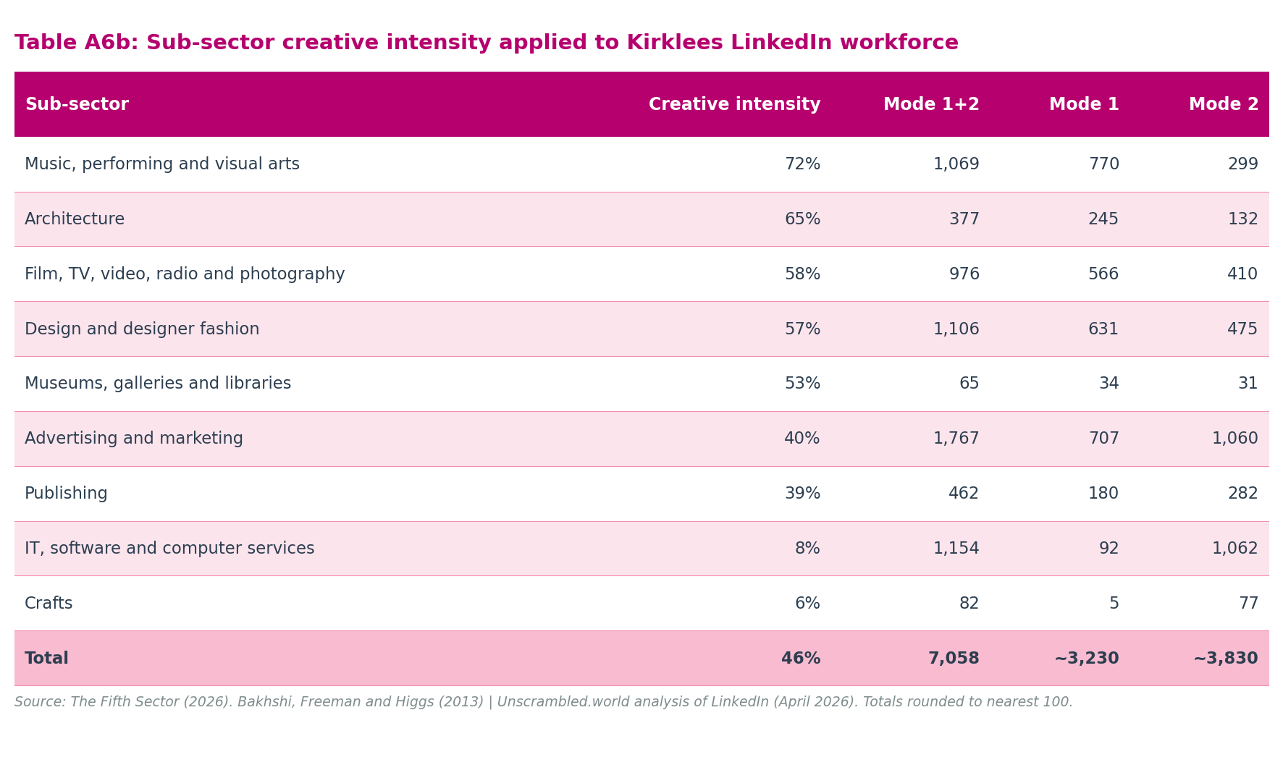
Mode | Occupation proxy (LinkedIn job role) | Employer context proxy | Estimated total
Mode 1 — creative specialists in creative sector | Creative and Production roles in creative firm context; Marketing and Communications roles at creative firms (est. 30% of 1,464 = ~450) | Content, Experiences, Originals supply chains (predominantly creative firms); creative-firm-associated share of Services and Tech chains | ~3,300
Mode 2 — support staff in creative sector | Non-creative function holders (Admin and Operations; Sales) within the DCMS-matched 10,305. Mode 2 is a functional category across all employment types — payroll, micro-business, self-employed administrators serving creative clients — and is not bounded by BRES payroll coverage. Derived as the residual of the DCMS-matched population after Mode 1 and Mode 3 are estimated | All 10,305 DCMS-matched profiles; non-creative function holders regardless of employment type | ~3,800
Mode 3 — creative specialists in non-creative firms | Creative and Production roles in non-creative firm context; Marketing and Communications at non-creative employers (est. 70% of 1,464 = ~1,000); self-employed creative practitioners primarily serving non-creative sector clients. DCMS sub-sector self-identification captures this population directly — those who classify their LinkedIn industry as a DCMS creative sub-sector are in the Trident regardless of their employer's primary SIC code | All 10,305 DCMS-matched profiles; Mode 3 share estimated from creative occupation pool (~4,800) and national Mode 3:Mode 1 ratio (Bakhshi, Freeman and Higgs, 2013) | ~3,000–3,500
Non-DCMS boundary exclusions — purposefully excluded | IT Services and Consulting, computer and network security, and information services profiles within the five supply chains; SIC 62020 non-creative consultants | Explicitly excluded from DCMS creative economy count; not in Trident | ~750
Total Trident (DCMS-matched population) |  |  | ~10,300
Total supply chain universe |  |  | 11,051
IT Services and Consulting adjacent workforce — excluded from Trident and all GVA calculations | Sixth LinkedIn supply chain (Column V); SIC Sections 62 and 63 beyond DCMS boundary; 1,595 (47%) algorithmically classified consultants; 1,446 (43%) carry Creative and Production functional role designation | Outside DCMS classification; not in Trident; constitutes adjacent digital workforce; many likely employed by adjacent RTIC firms. See Appendix A10. | 3,395
Total creative + adjacent digital ecosystem (LinkedIn) |  |  | ~13,700

Source: Unscrambled.world analysis of LinkedIn, 2026 snapshot. Supply chain and job role classification by The Fifth Sector. Estimates are Trident-consistent proxies, not full SOC × SIC cross-tabulations. Mode 2 is derived as the functional residual of the DCMS-matched 10,305 after Mode 1 and Mode 3 are estimated; it is not bounded by BRES payroll coverage. Mode 3 estimated from creative occupation pool within DCMS-matched profiles and national Mode 3:Mode 1 ratio (Bakhshi, Freeman and Higgs, 2013). All figures rounded to nearest 100. The IT Services and Consulting adjacent workforce (3,395) is a separate LinkedIn supply chain query, not part of the five-chain supply chain universe; it is shown here to complete the picture of the Kirklees creative and digital labour market. See Table A9 for full job role breakdown by supply chain and Table A10 for the IT S&C adjacent workforce profile.
Why the Trident base is the DCMS-matched 10,305, not the supply chain 11,051. All 10,305 LinkedIn profiles in the DCMS-matched total have self-identified their occupation as within one of the creative sub-sectors matched to the DCMS classification. This self-identification captures Mode 3 workers, creative specialists employed by non-creative firms, because they classify their LinkedIn industry according to their occupation, not their employer's primary SIC code. A textile manufacturer's in-house designer who puts "Design and designer fashion" as their LinkedIn industry appears in the DCMS-matched population as a Mode 3 worker regardless of their employer. The boundary cases in tech and IT services (approximately 750 profiles) have been purposefully excluded from the DCMS count through the creative filter applied to SIC 62020 and the exclusion of non-DCMS supply chain codes. What remains in the 10,305 is therefore a substantially cleaner creative workforce population than a raw supply chain count would provide.
Mode 3 at ~3,000–3,500 is consistent with the national finding from Bakhshi, Freeman and Higgs (2013) that Mode 3 is broadly comparable in scale to Mode 1. In Kirklees, with its substantial manufacturing, healthcare, and professional services base, Mode 3 workers, in-house designers at textile firms, brand managers at food companies, digital media producers at engineering consultancies, communications managers in public services, are a significant and credible component of the creative workforce. The combined GVA range does not capture their output; it remains a floor against the full Trident picture.

Sub-sector creative intensity and Trident mode distribution
Applying sub-sector creative intensity rates from Bakhshi, Freeman and Higgs (2013), Table 2.2, to the Kirklees LinkedIn population produces the following Mode 1 and Mode 2 estimates.
Table A6b: Sub-sector creative intensity applied to Kirklees LinkedIn workforce
Sub-sector | Creative intensity | Mode 1+2 | Mode 1 | Mode 2
Music, performing and visual arts | 72% | 1,069 | 770 | 299
Architecture | 65% | 377 | 245 | 132
Film, TV, video, radio and photography | 58% | 976 | 566 | 410
Design and designer fashion | 57% | 1,106 | 631 | 475
Museums, galleries and libraries | 53% | 65 | 34 | 31
Advertising and marketing | 40% | 1,767 | 707 | 1,060
Publishing | 39% | 462 | 180 | 282
IT, software and computer services | 8% | 1,154 | 92 | 1,062
Crafts | 6% | 82 | 5 | 77
Total | 46% | 7,058 | ~3,230 | ~3,830

Three findings from this analysis are relevant to interpreting the Trident proxy:
- Music, performing and visual arts has the highest creative intensity (72%): more than two-thirds of its workforce within creative firms are creative specialists (Mode 1). This sub-sector's large proportional BRES undercount is consistent with this: a majority-Mode-1 workforce that is also predominantly self-employed sits across Modes 1 and 3, with Mode 2 (back-office and support functions within creative firms) relatively small.
- Advertising and marketing and IT, software and computer services each contribute approximately 1,060 Mode 2 workers, the largest Mode 2 sub-sectors: for different structural reasons. In Advertising, account management, media planning, and media buying roles dominate agency headcounts even within formally creative firms (40% creative intensity). In IT, the 53% creative firm filter identifies software development businesses as creative, but the workforce of those firms is predominantly developers, engineers, QA, and project managers rather than creative specialists in the SOC sense (8% creative intensity). Both sub-sectors carry substantial back-office and operational cohorts that are Mode 2 by definition.
- Mode 3 (approximately 3,000–3,500) is comparable in scale to Mode 1 (~3,300): consistent with the national finding in Bakhshi, Freeman and Higgs (2013). It is entirely outside the £243 million to £305 million GVA range, making it the largest single source of understatement in the combined estimate.
This section outlines the distinction between our economic accounting approach, deterministic structural modelling, and stochastic statistical modelling techniques such as regression analysis. It also clarifies how our local heuristics relate to national econometric models.
Our methodology combines direct economic accounting with deterministic structural modelling to map the local creative economy. This framework does not represent a statistical prediction or a causal forecast:
- Direct economic accounting (BRES employee GVA): We use direct ONS employee counts and multiply them by official DCMS productivity rates. This is a pure census-based aggregation, identical to ONS national accounting standards.
- Deterministic structural modelling (Freelance GVA): Because we do not have direct tax or billing records for freelancers, we model their output. This structural model applies direct accounting rules (such as headcounts, FTE intensities, and GVA rates) to our active workforce, sanitised by explicit, present-day parameters (our portfolio overlap discounts, economic activity discounts, and Beta productivity coefficients). Because this model is built entirely on present-day parameters and direct headcounts, it remains a verifiable, baseline-mapping estimate rather than a statistical prediction.

Relationship to national econometric models
Skeptical readers may ask how our use of sessional heuristics compares to the highly sophisticated econometric models developed by the Creative Industries Policy and Evidence Centre (PEC) and standard academic economists.
The PEC uses ONS micro-data (specifically the Annual Population Survey, the Labour Force Survey, and the Annual Business Survey) under secure, restricted research environments to calculate GVA using the "Creative Trident" methodology (Higgs, Cunningham and Bakhshi, 2008). This standard framework measures creative employment across three distinct modes:
- Mode 1 (Specialist): Creative specialists working within creative industries (such as a graphic designer employed by a design agency).
- Mode 2 (Support): Non-creative support staff working within creative industries (such as an accountant employed by a design agency).
- Mode 3 (In-house): Creative specialists working in non-creative industries (such as a graphic designer employed by a textile manufacturing firm).
Our mapping approach successfully captures some of these modes, but falls short of a full Trident cross-tabulation:
- Modes 1 and 2 (Creative Industries): Our ONS BRES employee-based GVA of £178 million successfully captures both creative specialists and support staff employed within registered creative firms in Kirklees.
- Mode 3 (In-house): Our freelance GVA model (£127 million) partially bridges the gap to Mode 3. Because LinkedIn captures self-identified creative specialists living in Kirklees regardless of their employer's primary SIC code, our social database includes some in-house creative professionals.
- Where our model falls short: We cannot cleanly separate Mode 3 in-house specialists from Mode 1 independent freelancers because LinkedIn does not consistently disclose the industrial classification of a user's employer. We also cannot capture non-creative support staff working in non-creative sectors (who support in-house creative teams), which remains outside our current data limits.

Local industrial realities and the Mode 3 challenge in Kirklees
This Mode 3 measurement challenge is particularly acute in Kirklees due to our distinct industrial and commercial structure:
- Professional services leakage: In our LinkedIn analysis of professional services (specifically advertising, marketing, and design), we observe a high volume of creative specialists employed in-house by non-creative firms. For example, a graphic designer or digital copywriter employed directly by an advanced manufacturing or textile firm will appear as a creative specialist on LinkedIn, but their economic output is recorded under manufacturing in ONS accounts.
- The computer consultancy crosswalk: Our methodological "crosswalk" and filtering of BRES employment and GVA in computer consultancy (SIC 62020) represents a direct attempt to mitigate this lack of specific local data. By applying a 53% creative filter, we intentionally isolate pure creative IT consulting from corporate software development.
- The business software subsector: Kirklees has a flourishing business software subsector producing highly specialised products for non-creative industries, notably financial services and health. Software developers and database architects in these firms generate significant economic value, but their output is frequently captured under corporate financial or healthcare accounts.
- Technical and industrial consultancies: This in-house challenge also applies to other highly specialised creative outputs (such as corporate video production and 3D simulation) used as part of the marketing output and training inputs of technical consultancies in engineering, health, and education. A 3D animator designing virtual training simulations for a local engineering consultancy operates as a creative specialist, but their GVA is accounted for under technical engineering services.
To deliver a comprehensive, localised Creative Trident model, we do not require a multi-million-pound academic research programme. Instead, Kirklees Council and its regional partners could commission three highly practical, deliverable research projects at the district scale:
1. A localised creative occupation survey: Partner with the West Yorkshire Combined Authority (WYCA) to survey non-creative corporate firms in traditional local sectors (such as textiles and advanced manufacturing), mapping their in-house design, software, and digital teams.
2. Digital crosswalk scraping: Expand our use of machine-learning platforms (such as The Data City) to scrape local corporate websites, using automated keyword searches to identify in-house creative capacity.
3. ONS secure micro-data analysis: Secure approved-researcher access to local-authority-level Census 2021 micro-data (specifically the Standard Occupational Classification - SOC - cross-referenced with Standard Industrial Classification - SIC). This would allow us to run a true, unsuppressed Trident cross-tabulation, isolating the exact volume of "Mode 3" in-house creative specialists in Kirklees.
We do not claim to match or replace these advanced econometric methodologies. Instead, we have developed our local heuristics as a pragmatic translation of their national principles due to structural data limitations at the local authority district level:
- The local data suppression barrier: The ONS suppresses or omits local-level micro-data in standard releases to protect business confidentiality. If we attempt to run the PEC's Trident regression model on BRES or APS data for Kirklees, the sample sizes in smaller subsectors (such as 14 freelance craftspeople or 20 libraries) are too small, causing the statistical model to collapse.
- The practical baseline objective: While national economists with university Chairs focus on macro-level academic modelling, local authority officers require transparent, repeatable, and unsuppressed baselines to justify local interventions. Our heuristics adapt the PEC's national insights (such as discounting for hobbyist inflation and accounting for corporate IT leakage) into a localised, deterministic accounting framework using the only available, unsuppressed datasets.
Conversely, stochastic statistical modelling and regression techniques serve a different purpose. Regression analysis uses probability, correlation coefficients, and historical variables to identify relationships or predict future impacts. Economists use regression to forecast future trends or evaluate the causal impact of policy interventions, such as predicting future GVA growth resulting from a specific capital investment.
We avoid regression analysis and stochastic modelling in this mapping report for several reasons:
- The baseline objective: Our purpose is to map actual local activity, rather than to forecast future trends, establish causal correlations, or model probabilities.
- The small-cell volatility: At the local authority level, several subsectors contain small headcounts (such as 14 freelance craftspeople). Running statistical regressions on small sample sizes introduces massive mathematical margins of error, creating unreliable results.
- The transparency value: Combining direct accounting with deterministic structural modelling provides a transparent, stable, and highly repeatable baseline. Local officers and regional partners can easily verify, reproduce, and track these numbers over future reporting cycles.

A7: Expert qualifications and track record
We explicitly declare that we are specialist sector consultants rather than purely academic econometricians or professional economists. While we have extensive experience in the creative sector, including drafting Green Book business cases, our core expertise lies in translating complex creative labour markets into standardised, repeatable accounting models.
Our credentials as sector experts are grounded in our track record at The Fifth Sector. We operate as a leading UK specialist consultancy in the creative, cultural, and digital economies. Our team manages large-scale cultural mapping, economic evaluations, and creative strategies for regional Combined Authorities (including the West Yorkshire Combined Authority and Liverpool City Region), local councils, and national bodies such as Arts Council England. This extensive UK consulting track record ensures that our models, assumptions, and GVA estimations remain grounded in real-world creative operations.

A8: SIC 62020 computer consultancy, GVA scenarios
The table below compares four scenarios for the treatment of SIC 62020 Computer consultancy in the payroll GVA estimate. Scenario S2 (53% creative filter) is adopted in this report.
Table A8: GVA scenarios, SIC 62020 treatment
Scenario | IT BRES | IT GVA (£m) | Total BRES | Total GVA (£m)
S0: BRES as queried (incl. SIC 62020, label corrected) | 1,310 | 66.2 | 3,535 | 202.1
S1: Exclude all SIC 62020 from BRES | 310 | 15.7 | 2,535 | 151.6
S2: 53% creative filter (this report — adopted) | 840 | 42.4 | 3,065 | 178.4
S3: Full inclusion, no filter | 1,310 | 66.2 | 3,535 | 202.1

Source: ONS BRES 2024; DCMS Sector Estimates; ONS BRES SIC 6202 sub-code Kirklees 2024 = 1,000 employees (confirmed). GVA per employee: £50,499 (DCMS IT sector rate). S2 = 1,310 − 470 (= 47% × 1,000). S1 = 1,310 − 1,000 = 310. S0 and S3 are identical in GVA terms; their difference lies only in how the BRES query label is described.
S2 is the adopted scenario. It is based on confirmed BRES sub-code data rather than estimates, is internally consistent with TDC's 47% non-creative assessment, and produces an objective GVA estimate that does not attribute economic output from non-creative consultancy to the Creative Industries account. S1 provides the lowest bound (£151.6m); S0/S3 the unconstrained ceiling (£202.1m).

A9: LinkedIn supply chain job role classification
Table A9 presents the LinkedIn job role (Areas of Expertise) distribution across the five creative supply chains, with the IT Services and Consulting adjacent workforce (Column V) shown separately for comparison. Categories are algorithmically assigned by LinkedIn from profile data; because the five role categories collectively account for the total supply chain population in every chain, the classification covers all 11,051 profiles in the supply chain universe without exception. The table supports the Trident functional analysis in Chapter 3 and the Marketing and Communications triangulation discussed there.
Table A9: LinkedIn creative workforce by job role area and supply chain, Kirklees 2026
Job role area | Content | Experiences | Originals | Services | Tech | Creative total | IT S&C †
Creative and Production | 1,008 | 111 | 543 | 1,007 | 930 | 3,599 | 1,446
Admin and Operations | 804 | 165 | 131 | 1,898 | 877 | 3,875 | 1,258
Sales | 505 | 66 | 256 | 803 | 386 | 2,016 | 518
Marketing and Communications | 515 | 64 | 167 | 548 | 170 | 1,464 | 100
R&D | 27 | 0 | 1 | 30 | 39 | 97 | 73
Total | 2,859 | 406 | 1,098 | 4,286 | 2,402 | 11,051 | 3,395
Creative and Production rate | 35% | 27% | 49% | 23% | 39% | 33% | 43%

Source: Unscrambled.world analysis of LinkedIn, 2026 snapshot. Supply chain classification developed by The Fifth Sector. Job role areas are algorithmically assigned by LinkedIn from individual profile data; all profiles in the supply chain universe are classified. † IT Services and Consulting (Column V) is excluded from the creative supply chain total and from all creative economy GVA calculations; it covers SIC Sections 62 and 63 beyond the DCMS Creative Industries definition, and is shown here for comparison only. Of the 3,395 IT S&C profiles, 1,595 (47%) are algorithmically classified as consultants. Figures are headcounts, not FTEs. Creative supply chain totals match Table 9 exactly. See Appendix A10 for the full IT S&C workforce profile.

A10: IT Services and Consulting, adjacent digital workforce profile
This appendix presents the LinkedIn profile for the IT Services and Consulting supply chain (Column V of the Kirklees LinkedIn data extract). This cohort is excluded from the five creative supply chains, from the Trident proxy analysis (Table A6), and from all creative economy GVA calculations. It is presented here to provide a complete account of the wider creative and digital workforce visible in Kirklees, and to support the adjacent digital economy analysis in Chapter 6.

Why this cohort is excluded from creative economy GVA
The IT Services and Consulting supply chain covers SIC Sections 62 and 63 in their entirety, extending beyond the DCMS Creative Industries definition. The DCMS includes specific SIC codes from Sections 62 and 63 (including SIC 6201 Computer programming, SIC 6202 Computer consultancy, SIC 6203 Computer facilities management, and SIC 6311 Data processing and hosting); the IT Services and Consulting supply chain encompasses both these DCMS-classified codes and broader non-DCMS digital services activities. The five creative supply chains already capture the DCMS-classified portion through the Tech supply chain; including Column V would incorporate workers whose primary activity does not meet the DCMS creative industries test.
Within the 3,395 profiles, approximately 1,595 (47%) are algorithmically classified by LinkedIn as consultants, consistent with the 47% non-creative filter applied to SIC 62020 BRES employment in Appendix A4 and Appendix A8. The same analytical boundary operates at employer level (BRES) and worker level (LinkedIn): roughly half of those in the SIC 62/63 space are doing non-creative corporate consultancy; the remainder are in IT services roles at the creative-digital interface.
Table A10a: IT Services and Consulting workforce profile, Kirklees 2026
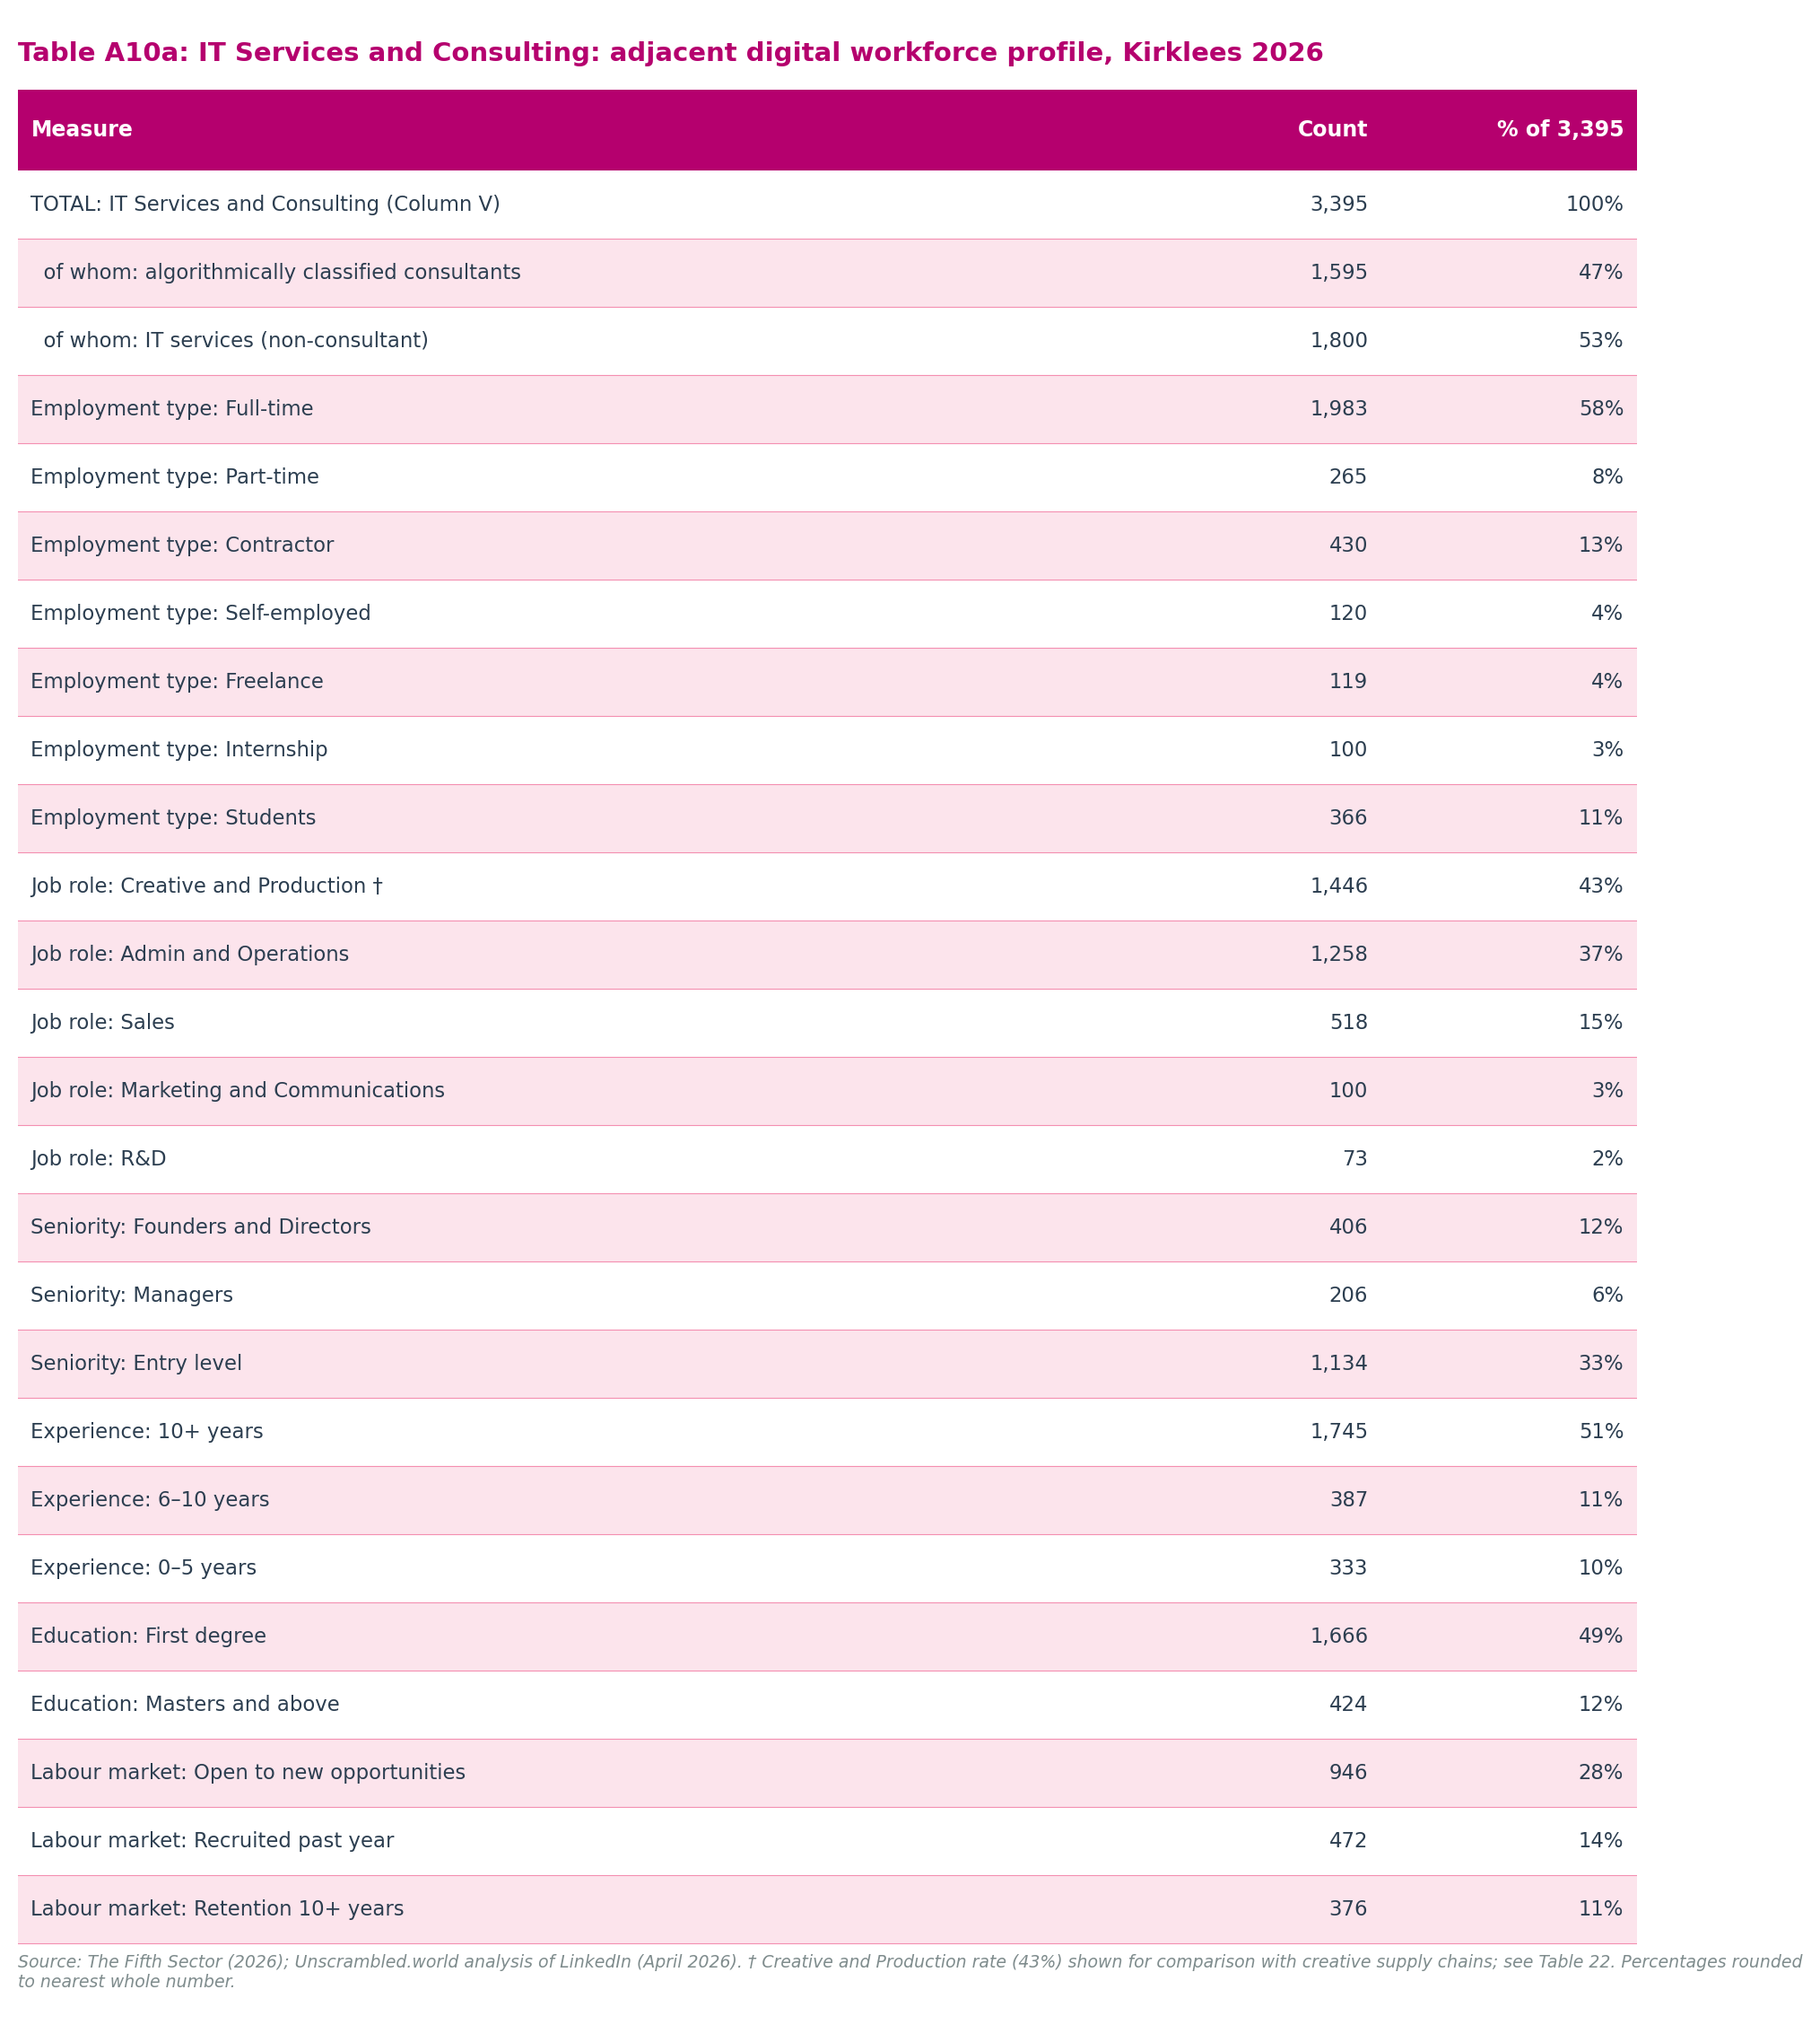
[See figure: tableA10a_it_services_profile.png]

Creative and Production job role rate, comparison with creative supply chains
The most policy-relevant finding from the Column V profile is the job role distribution. Of the 3,395, 1,446 (43%) carry the Creative and Production designation, the LinkedIn algorithmic categorisation used throughout the supply chain analysis as the closest available proxy for creative specialist occupations. The comparison across supply chains is set out in Table A10b.
Table A10b: Creative and Production rate, IT S&C vs creative supply chains
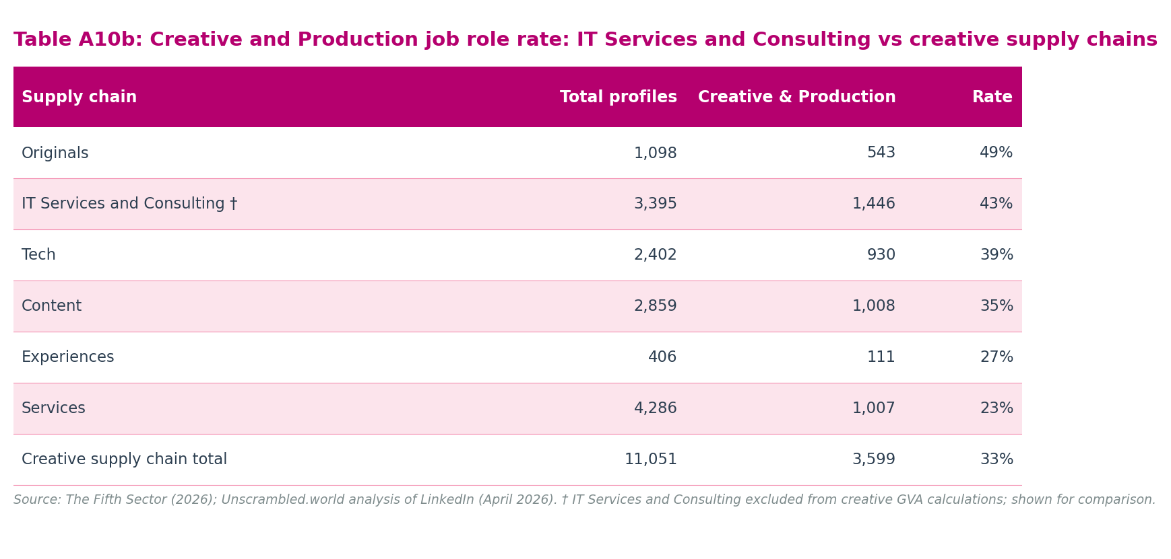
[See figure: tableA10b_creative_production_comparison.png]
The IT Services and Consulting cohort has a higher Creative and Production rate (43%) than four of the five creative supply chains. Only the Originals chain (49%), which groups fashion design, artists and writers, and luxury goods, exceeds it. A rate of 43% within a non-DCMS IT services population is the operational signature of the Createch interface: workers in digital production roles within organisations that fall outside the formal creative economy by DCMS definition.

Note on relationship to BRES SIC 62020 exclusions
The 470 BRES SIC 62020 employees excluded from the creative economy in Appendix A4 are drawn from the same workforce population as a subset of the 3,395 LinkedIn IT Services and Consulting profiles. BRES captures formally employed payroll workers; LinkedIn captures payroll workers, contractors, freelancers, and the self-employed. The full-time (1,983) and part-time (265) employment types in the LinkedIn IT S&C cohort (2,248 combined) constitute the overlap population within which the 470 BRES exclusions are embedded. The remaining 1,147 (contractors 430, self-employed 120, freelance 119, interns 100, plus students 366 and other) are below BRES payroll visibility. Neither the LinkedIn count nor the BRES exclusion is double-counted in any creative economy GVA component.

Appendix B: Data source methodology references
This appendix lists the primary ONS methodology and quality documentation consulted during the production of this report. These sources underpin the descriptions of BRES and IDBR in Chapter 1 and throughout.

B1: Business Register and Employment Survey (BRES)

Quality and Methodology Information (QMI)
Office for National Statistics. Business Register Employment Survey (BRES) QMI. Available at: https://www.ons.gov.uk/employmentandlabourmarket/peopleinwork/employmentandemployeetypes/methodologies/businessregisteremploymentsurveybresqmi
The QMI documents the survey's design, stratification, sample size, response rates, and quality characteristics. Key points relevant to this report:
- BRES uses a stratified one-stage clustered sample drawn from the IDBR. The primary sampling unit is the enterprise (reporting unit); all local units within a selected enterprise are then included.
- All large and complex enterprises are included in the sample with certainty. Medium and small enterprises are sampled at varying rates, stratified by country and two-digit SIC 2007 industry.
- For the 2024 survey, approximately 86,000 enterprises were sampled across Great Britain, with a response rate of 81.2%.
- BRES measures employee jobs at workplaces. It does not measure self-employment.
- Sub-sector estimates for small geographies carry wider confidence intervals because sample cells may contain very few respondents. Individual employer SIC reclassifications, non-response, or site transfers can produce large apparent year-on-year movements in small sub-sectors.

Impact of BRES on the IDBR
Office for National Statistics. The impact of the Business Register and Employment Survey on the Inter-Departmental Business Register. 2022. Available at: https://www.ons.gov.uk/businessindustryandtrade/business/activitysizeandlocation/articles/theimpactofthebusinessregisterandemploymentsurveyontheinterdepartmentalbusinessregister/2022
Documents the relationship between BRES survey data and the IDBR, including how BRES returns are used to update and quality-assure the register.

B2: Inter-Departmental Business Register (IDBR)
The IDBR is an administrative register maintained by ONS, built from three continuously updated sources: HMRC VAT registration records; HMRC PAYE employer records; and Companies House data. It is not a sample survey. Its primary limitation for creative industries analysis is its coverage threshold: businesses below the VAT registration threshold (approximately £85,000–90,000 annual taxable turnover in the reference period) and without PAYE employees are excluded by design, not by sampling. ONS estimates the total UK business population at approximately 5.5 million; the IDBR covers approximately 2.7 million enterprises.
The IDBR is used as the sampling frame for BRES and as the basis for ONS business count statistics (published via Nomis).

UK business: activity, size and location QMI
Office for National Statistics. UK business: activity, size and location QMI. Available at: https://www.ons.gov.uk/businessindustryandtrade/business/activitysizeandlocation/methodologies/ukbusinessactivitysizeandlocationqmi
Documents the methodology for ONS business count statistics derived from the IDBR, including coverage, classification, and known limitations.

B3: Regional and national policy alignments
This section lists the active, confirmed regional and national policy programmes and capital investments consulted during the production of this report. These initiatives represent the direct funding streams and policy frameworks that align with our GVA findings.

West Yorkshire Combined Authority Culture, Heritage and Sport Strategy
West Yorkshire Combined Authority. Culture, Heritage and Sport Strategy. Available at: https://www.westyorks-ca.gov.uk/media/7653/culture-heritage-and-sport-strategy.pdf
The active regional policy framework for West Yorkshire. It defines regional strategic priorities for growing creative livelihoods, boosting freelance resilience, and supporting local cultural networks.

You Can Make It Here (WYCA creative industries support package)
West Yorkshire Combined Authority. Support for West Yorkshire's creative industries set for £2.3 million boost. Available at: https://westyorks-ca.gov.uk/all-news-and-blogs/support-for-west-yorkshire-s-creative-industries-set-for-23-million-boost
A confirmed £2.3 million regional investment programme launched by the Mayor of West Yorkshire, Tracy Brabin, to support creative skills development, freelance growth, and business mentoring across the region's five districts. The programme is branded "You Can Make It Here" by WYCA; earlier drafts of this report used the label "Creative West Yorkshire Programme." The £2.3 million figure is confirmed from the source above. No published district-level breakdown of the allocation is available from public sources.

Kirklees Capital and Regeneration Blueprint Investments
Kirklees Council. Our Cultural Heart Phase 1 progress. Available at: https://www.kirklees.gov.uk/beta/regeneration-projects/our-cultural-heart.aspx
Kirklees Council. Dewsbury Blueprint and Creative Town Arts Programme. Available at: https://www.kirklees.gov.uk/beta/dewsbury-blueprint/key-areas/creative-town-arts-programme.aspx
Confirmed, active local capital investments. Huddersfield's £210 million Cultural Heart has formally commenced Phase 1 construction (food hall and library) as of 2024–2026. Dewsbury town centre has unlocked a £20 million, 10-year Regeneration Plan, including the active Dewsbury Creative Town arts programme.

DCMS Create Growth Programme
Department for Culture, Media and Sport. Create Growth Programme Guidance. Available at: https://www.gov.uk/government/publications/create-growth-programme
The active national business scale-up and investment-readiness accelerator funded by DCMS. In West Yorkshire, this programme is delivered as a targeted package to help high-growth potential creative businesses access venture capital and private investment.

AHRC CoSTAR Network
Arts and Humanities Research Council. CoSTAR: National infrastructure for creative technologies. Available at: https://www.ukri.org/opportunity/costar-national-infrastructure-for-creative-technologies/
The active £75.6 million national research infrastructure funded by AHRC and UKRI, serving as the official successor to the Creative Industries Clusters Programme. It establishes national screen and performance R&D nodes across Yorkshire up to 2028–2030.

University of Huddersfield National Creative Health Hub
University of Huddersfield. West Yorkshire partners collaborate to strengthen Creative Health. Available at: https://www.hud.ac.uk/news/2026/february/wyca-creative-health-partnership/
A confirmed £500,000 project funded by the West Yorkshire Combined Authority in February 2026, bringing partners together to mobilise the regional infrastructure needed to grow and embed creative health in local neighbourhoods.

B4: Academic literature references
This section lists the academic literature and research reports referenced in the report.

A Dynamic Mapping of the UK's Creative Industries
Bakhshi, H., Freeman, A. and Higgs, P. (2013) A Dynamic Mapping of the UK's Creative Industries. London: Nesta and ARC Centre of Excellence for Creative Industries and Innovation. Available at: https://www.nesta.org.uk/report/a-dynamic-mapping-of-the-uks-creative-industries/
This report applies the Creative Trident methodology (Higgs, Cunningham and Bakhshi, 2008) at national scale across the full DCMS classification of UK Creative Industries. Key findings relevant to this report: (1) analysis of Computer Consultancy (SIC 6202) yields a creative intensity of approximately 47–55% depending on method, the principal basis for the 53% creative filter applied to SIC 62020 in Chapter 4 and Appendix A4, Step 2; (2) self-employed and freelance workers display higher creative intensity than formally employed workers in most sub-sectors, supporting the assumption in this report that the inferred freelance workforce is predominantly engaged in creative activity; (3) the report demonstrates the systematic undercount of creative workers in official payroll statistics, consistent with the multi-source approach used throughout this report.

A Dynamic Mapping of the UK's Information Economy Industries
Spilsbury, M. (2015) A Dynamic Mapping of the UK's Information Economy Industries. London: Nesta / techUK. Available at: https://media.nesta.org.uk/documents/dynamic_mapping_of_the_information_economy_industries.pdf
This Nesta report maps the boundary between the UK's Creative Industries and the broader Information Economy, examining how digital infrastructure sectors, including software, cyber security, cloud computing, and data services, sit adjacent to, but distinct from, the formal DCMS Creative Industries classification. The report directly informs the analysis in this report of the 219 adjacent businesses in Kirklees whose RTIC profiles span both creative-adjacent capabilities (Agency Market, Software Development, Digital Creative Industries, Immersive Technologies) and complementary digital infrastructure capabilities (Cyber, Cloud Computing, Data Infrastructure, Telecommunications). Spilsbury's mapping provides the methodological basis for treating these firms as a structurally adjacent but analytically separate population rather than as part of the creative economy proper.

Unrewarded careers in the creative class
Comunian, R., Faggian, A. and Li, Q.C. (2010). 'Unrewarded careers in the creative class: The strange case of "Bohemian" graduates', Papers in Regional Science, 89(2), pp. 389-410. Available at: https://doi.org/10.1111/j.1435-5957.2010.00281.x
This seminal regional economics paper examines the career opportunities and economic returns of UK creative graduates ("Bohemians"). Using ONS survey data, the authors demonstrate that independent creative practitioners face significant career difficulties and operate at a persistent earnings and productivity discount of 20% to 30% compared to formally employed corporate peers. This research provides the authoritative empirical foundation for applying our 0.70 to 0.80 Beta coefficients to discount national GVA-per-employee averages for self-employed freelancers.

Improving economic statistics in the creative industries
Lyons, S. and Connolly, S. (2024). Improving economic statistics in the creative industries. Creative Industries Policy and Evidence Centre (PEC). Available at: https://pec.ac.uk/wp-content/uploads/2024/04/Improving-economic-statistics-in-the-creative-industries-Creative-PEC-Research-Report-April-2024.pdf
This Creative PEC research report examines the current limitations in creative industries economic statistics, including the absence of sub-national GVA estimates and the lack of regional productivity adjustment in DCMS Sector Estimates. It explicitly identifies the use of national GVA-per-employee rates without regional weighting as a key gap in sub-national creative economy mapping, directly relevant to the methodology employed in this report. The report provides academic validation of our acknowledgement that the 2026 combined GVA estimate is an upper-bound figure for a below-average-productivity district.

Appendix C: Headline figures reference table
Table C1: Kirklees creative economy, headline figures, 2026
Measure | Figure | Source
Active creative businesses | 1,690 | The Data City, 2026; ONS IDBR 2025
Creative workforce (LinkedIn) | 10,305 | LinkedIn, 2026
Creative employee jobs (BRES) | 3,535 | ONS BRES 2024
Freelance and self-employed creative workers | 3,320 | Derived from LinkedIn, 2026
BRES payroll creative GVA | £178m | The Fifth Sector analysis of ONS BRES 2024 and DCMS Sector Estimates
Freelance creative GVA (LinkedIn residual) | £127m | The Fifth Sector freelance GVA model, 2026
Creative industries GVA | £305m | The Fifth Sector two-component GVA model, 2026

Source: The three workforce measures (LinkedIn workforce, BRES employee jobs, and freelance and self-employed) are not additive, they measure different populations using different methods. The GVA figures represent complementary payroll and freelance models that sum to show the total creative industries output. A further approximately 3,830 portfolio workers outside BRES payrolls are not modelled; the GVA figure is a floor. See Chapters 3 and 4 for full detail.
Report produced by The Fifth Sector, May 2026. Data sources: The Data City (2026); LinkedIn Corporation, LinkedIn (2024 and 2026 snapshots); Office for National Statistics, Business Register and Employment Survey (BRES) 2022 and 2024, via Nomis (© Crown copyright); Office for National Statistics, Inter-Departmental Business Register (IDBR) 2025, via Nomis (© Crown copyright); Office for National Statistics, Regional Economic Activity by Gross Value Added (Balanced) UK, April 2024 release; Office for National Statistics, Subregional Productivity statistics, June 2024 release; Department for Culture, Media and Sport, DCMS Sector Estimates (experimental statistics). Analysis by The Fifth Sector.

